OCR GCE A-Level

COMPUTER SCIENCE PROJECT

H446-03

Name : MacKenzie Marriott

Candidate Number: <INSERT CANDIDATE NUMBER>

<Institution Name>: Doncaster UTC

Title of Project: Bus Timetable application

H446-03 – Project CONTENTS

Table of Contents

A. Analysis 6

**Project definition:** 6

**Why is the program needed?** 6

**Stakeholders - client interview:** 7

Questions: 7

responses from Miss bradley (the client): 7

**USer survey:** 7

Questions 7

User responses: 8

A summary of user needs: 9

How I will make the system appropriate to their needs: 9

**Other solutions:** 9

**The first bus website:** 9

**Other options:** 11

**List of features:** 11

**Hardware and software requirements:** 12

**Hardware** 12

**Software** 12

**additional libraries or utilities** 13

**Computational methods:** 13

Features that make the problem solvable via computational methods 13

Problem decomposition 13

Use of divide and conquer 14

use of abstraction 14

Heuristics 14

Use of shortest path: 15

**Success criteria:** 15

**Limitations:** 16

B. Design 16

Wireframe and prototype 16

General design choices 16

The navigation bar: 16

Main screen 16

Route information screen 17

Route list / favourite routes 18

Client feedback on designs 19

Pseudocode 23

Main app pseudocode 23

Distance calulator pseudocode 23

Login screen 24

Example code – proof of concept 25

Map in tkinter 25

Systems diagram – breaking down the problem 27

Testing 28

C. Developing the coded solution (“The development story”) 29

Phase 1 Work on the login screen 29

User interface 29

Functionality 30

Client feedback: 32

Phase 2 Work on the User interface 34

User interface 34

Client feedback 39

Phase 3 Work on the Web scraper 39

Beginning my research 39

Beginning my implementation 40

The end product 43

phase 4 Distance calculator 47

geocoding 47

open route service 50

phase 5 – timetabling 52

method planning 52

implementation 55

Client feedback 68

Phase 6 – map display 68

research 69

Implementation 69

Client feedback 71

Validation 72

D. Testing 73

Test table from design 73

Video of test results 73

E. Evaluation 73

criteria met 73

Evidence 73

Limitations of the project 79

Overall evaluation 80

Usability – sample user 81

Areas i succeeded on 81

Areas i could improve 81

Project Appendixes 81

Complete code listing 81

MainApp.py 81

Loginsystem.py 83

distanceCalculator.py 85

configurepage.py 87

routes.py 90

routeScreen.py 90

tables.py 94

webscraper.py 95

Running instructions 97

# A. Analysis

## **Project definition:**

The problem that my project aims to solve is complications with local transport systems. Despite the fact that information is so readily available in the modern day, the transport infrastructure in the UK is lacking compared to other countries like Japan. Busses are often late or if they are simply not running, this is not always reported or reflected on timetables. I aim to create a sophisticated timetabling system which gives you as much information as possible in a well laid out and easy to read manner. This information will come directly from the First Bus API and be displayed in the form of a python-based desktop application.

My stakeholders are teaching staff from the Doncaster UTC, they want to verify the routes that students are coming to school on through the use of bus timetables. However, they currently don’t have the infrastructure to do so. As well as this, one of the stakeholders (Mrs Bradley) has an office in an area of poor WIFI. Whilst other staff may be able to use existing web-based solutions, she cannot load the pages quickly or reliably, meaning she requires an advanced and bespoke solution. They will use this data for when students are late to school or require help planning bus routes, this will show the staff the local bus timetables in order to verify why a student has been late, based on the bus routes and the timetables of these routes.

Current software is slow, unreliable, and is often difficult to navigate to find what information you need in order to plan your journey correctly. As well as this, they require high bandwidth internet to load, due to animations, images, and videos being present on the page. As the stakeholder has poor internet connection, this makes the existing solutions unsuitable for her current needs.

### **Why is the program needed?**

The product in question is a python-based application which monitors the location and status of current, running busses. This includes information about the capacity of any given bus, how many people are on board, if it is on time and whether or not the given bus has broken down. Information about the stops of any route will also be available on the application – this includes what time busses on a given route should arrive and the status of these busses. This application is aimed to provide more accurate and relevant information about local busses using given information for the client, helping them identify why students are turning up late (despite not being able to access the previously required websites). The data I am going to be using is going to be scraped and parsed once per day from various websites with the needed information. The scraping will only occur once per day in order to cut down on WIFI usage given the clients issues. This will draw data between two bounds in order to simulate late busses, amount of people on the bus etc. This information will be drawn from a continuously updated database in order to provide relevant and accurate information about all running busses at a given point in time.

My program aims to allow the staff to be able to access the data and information quickly, reliably, and easily about various bus routes that they need in order to verify students being late due to bus timetables.

## **Stakeholders - client interview:**

### Questions:

1. How often would you need to use the product?
2. How often would students need to access the product?
3. Will this product be deployed on multiple terminals?
4. Are there any specific, currently unmentioned features that you wish to include?
5. What current infrastructure or programs do the school use?

#### Question justification:

1. This would show how often we need to update the data (roughly) so that less bandwidth is used by the machines as updates are called less.
2. This is a generic client needs question, finding out how often our product would be accessed.
3. This question allows the client to understand how often and how regularly the software will be available to students.
4. This question helps me as a developer understand what the client wants more accurately, being able to understand the client needs and ensure that I have all of the features that they want in the final product.
5. This question helps me understand the schools current infrastructure, in order for me to use this as a reference of what they already have, meaning that I am able to make a product that also covers what they already use.

### responses from Miss bradley (the client):

1. “We would use the product whenever a student either turns up late for school or needs help planning a journey without knowledge of bus routes or timetables.”
2. “Our students may access the product whenever they need to plan a journey using the terminals at the school, these terminals will run the program constantly and help students find their way to their destination using the local bus routes.”
3. “There will be around 2 or 3 terminals placed around the school running the software so that multiple students can use it at the same time. We don’t believe we will need more than this as the likelihood of more than 3 students needing to use it at the same time will be quite low.”
4. “We would like the product to have school branding on it if possible.”
5. “Currently, we do not have much of a supported infrastructure, students however currently try and use the first bus website, with varying success. This website is reasonably hard for students to use and doesn’t contain information about all of the relevant busses.”

## **USer survey:**

### Questions

1. What do you currently use to plan your journeys?
2. How often do you take the bus?
3. What companies’ busses do you use?
4. Are you often late to school?
5. What problems do you have with your current solution?

#### Question justification:

1. This question aims to find out what infrastructure students currently use, in order to identify my competitors and alternative solutions for my problem.
2. This will let us know how often people will (roughly) use the application.
3. This will help us collect a comprehensive list of bus companies to track, making our app both relevant and robust in the information and services we provide.
4. This will help show why we need to fix the problem overall and why our product is helpful.
5. This will help us identify areas to focus on us during the development of our project.

### User responses:

#### user 1 – Tom Fernandez (Student):

1. Currently, I use the first bus website and application in order to see bus routes and bus timetables.
2. I take the bus roughly twice per week after school on Tuesdays and Thursdays.
3. I only use first busses, stagecoach do not do busses on the routes that I have to use to get home from school, meaning they’re out of the question.
4. As I do not take the bus to school, I am not often late, instead I am often early or on time as I get a lift from my parents to school every day.
5. Currently, the main problem I have with the application is accuracy, it isn’t updated often enough meaning it could say a bus is running late, when actually it is on time, meaning I miss it altogether, this is very inconvenient and has caused me to miss busses in the past.

#### User 2 – Ben Dyer (Student):

1. I use the UK bus checker application on my phone in order to check the bus times, routes, and the location of stops.
2. I take the bus around 3 times per week after school to go to work on Mondays, Wednesdays, and Fridays.
3. I use either a first bus or a stagecoach bus to get to work, whichever one turns up first (this is generally first busses).
4. As I do not take the bus to school, I am not often late, instead I am often early or on time as I get a lift from my parents to school every day. However, sometimes I am late for work as a result of bus delays or cancellations.
5. My main problem with the app is that it doesn’t alert me to delays, this can cause me to be late to school sometimes as a result of said delays. If I was aware of this, then I would be able to notify my manager at work beforehand.

#### User 3 – Sylwester Albin (Student):

1. Currently, I use the stagecoach website on my phone in order to see bus routes and bus timetables.
2. I take the bus to and from school every day as well as sometimes over the weekend if I need to get anywhere.
3. I mainly use stagecoach busses; however, I use first if stagecoach do not cover where I need to go occasionally.
4. I’m often late as a result of bus delays, or sometimes them just not showing up at all. This causes many problems with school and my attendance.
5. Currently, the main problem I have with the application is that it doesn’t tell me if a bus is cancelled or delayed.

### A summary of user needs:

* Overall, the users need a product which can display multiple local bus routes, as well as being able to see more information about these routes such as where a specific stop is and how to get there.
* They also need to be able to see all bus cancellations in the area in order to properly plan their journeys in relation to the cancellations in order to get where they need to be on time without fail.
* Students also need the information on the application to be up-to-date and accurate in order for them to be able to get the correct busses where needed.
* Ideally, the system should also cover a range of bus services; the primary two I want to cover here are stagecoach and first busses.

### How I will make the system appropriate to their needs:

* As students may have little technical skill, I will make the product as easy to use for both students and staff as possible, meaning that anyone within the school can use the system effectively and to its fullest.
* I also plan to remove need for multiple tabs as you would have if you used a web browser, a web browser would need multiple tabs to track different bus routes, which can often get confusing. The application sees to fix this by keeping track of multiple bus routes at any given time.
* In addition to the above, I also plan to utilise a ‘Kiosk’ interface, which is suitable for school. The school already use a kiosk-based system in order for school to log in to the school, which then lets the school know that students are in the building. As the students are used to using a kiosk, this means that students are familiar with this form of system – which will improve usability.

## **Other solutions:**

The most prominent and obvious alternative solution to my problem is the use of paper timetables or leaflets. These have been used for a very long time already as they are cheap to make, easy to distribute and reliable as there is no required internet connection or location information. There is however a big problem with this – the information cannot be routinely and easily updated. Even if it could be updated regularly, people may not necessarily be aware that a new timetable is coming out, or that changes are being made. Another apparent problem is the clients’ problems with WIFI availability in her office, with it being effectively a dead zone.

### **The first bus website:**

Another solution would be to use the existing first bus timetable website, this is able to give you the current timetables in real time and display. This website however is very complex in use yet basic in given information and requires knowledge of bus routes and stop names in order to be used successfully. However, this website does have the benefit that (as it is not an application) it does not need to be installed on your device, meaning it can run on your device without needing to install anything. This can

be handy if you need information quickly or have a poor, but not unusable internet connection.

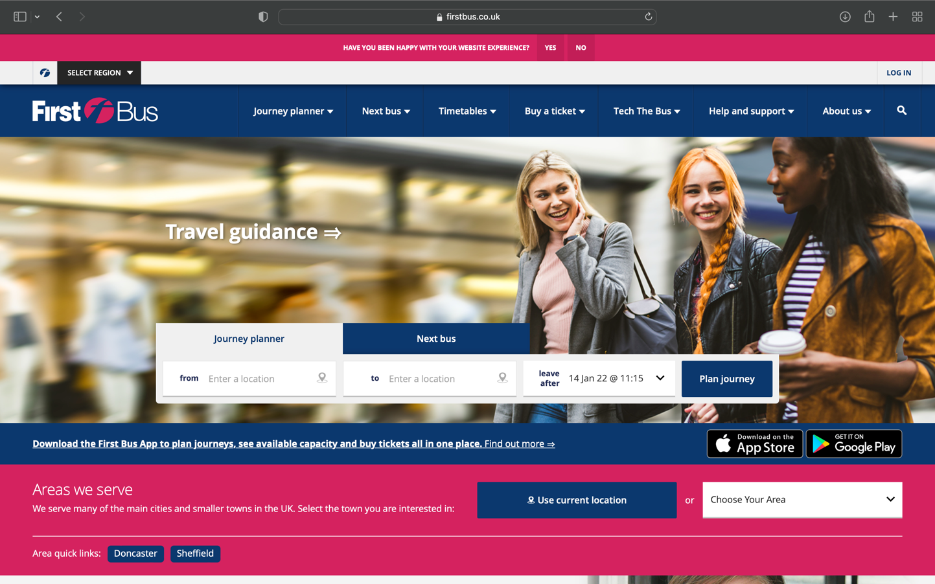

#### **The first bus website homepage:**

Here you can plan journeys and navigate through the various menus on the website. The menus include the journey planner, timetables, the next bus, buying tickets, and a support section. Whilst the features are clearly accessible, the UI seems (to me) quite cramped and disorganised, this I hope to avoid in my app, making it easier for users to navigate the pages and find what they need. Whilst the colours here are consistent on this page, other pages (as seen next) do not follow this colour scheme, which makes the experience feel quite disjointed.

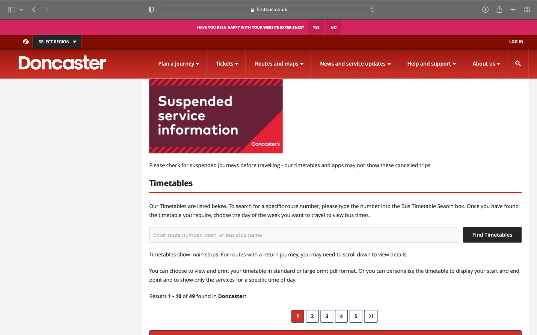

#### **The timetables page:**

This is the main page that I will be focusing on for the website section of my project. This is a reasonably well-designed page from first, however, I believe that there is too much information presented before the actual timetable comes up. People click on this page to view the timetables, yet first opted to explain their timetables first, which I believe is inefficient and overall reduces the user experience. Along with this (as mentioned earlier) this site does not match the colour scheme of the main home page, which makes the experience of navigating between menus feel disjointed and almost foreign compared to other websites with consistent design.

One part of the app that I do like is how they make new and important information stand out. This is seen through the graphic in clear colours at the top that lets users know that there are currently issues with suspended service. This information in itself is clear without obstructing any other information meaning that it can be scrolled past quicky in order to get to the main focus of the page, whilst also getting the point across.

### **Other options:**

Other apps could also be used – such as UK bus checker. This app allows users to track buses from anywhere around the UK. However, many users have left reviews saying that lately the times stated on the app have become unreliable and haven’t been updated frequently enough. This is a problem which my app aims to solve.

#### Justification of my approaches based on the above solutions:

Among the above reasons, the main reason that these solutions are all unsuitable can all be drawn to one common point. This is that the stakeholder is unable to access the internet constantly or reliably. As a result of this, the client is unable to use the above websites or applications. My application aims to solve this by only requiring a weak WIFI connection around once per day in order to scrape the necessary information off of the relevant web pages.

## **List of features:**

|  |  |
| --- | --- |
| **Feature:** | **Justification of the feature:** |
| Able to give a list of times for busses over each weekday, for each individual bus route. | This feature is important as the entire project for the client is supposed to be a working, relevant, and updated timetable system for Doncaster bus systems. |
| Able to tell you if/when busses are running late, and if they are running late, where they are in real time. | This feature is important to the client, as the software will be used to decide whether or not the student is an appropriate amount late or whether they are lying about why they are late. |
| Able to tell you when to leave based on how close you are to a selected bus and time. | This important for journey planning, as it gives you an indication of when you have to be ready in order to set off for the bus stop at an appropriate time. |
| Aggregate content from publicly available sources on the world wide web | My system will scrape content from the First Bus website initially, however in future phases it could easily be adapted to aggregate data from other sources. |

## **Hardware and software requirements:**

### **Hardware**

The following are the hardware requirements for my application:

* Any dual core or better processor to run the application.
* WIFI connectivity for the application once per week in order for it to scrape the data off of the relevant website(s).

#### Justification

The program will be very low powered yet will need a CPU that can “multitask” to an extent, as multiple things may need to be processed at any one given time. In addition to this, dual core processors are very cheap and are realistically below the standard in the modern day. In addition to dual cores being able to handle the program, the processor shouldn’t need to have a particularly high clock speed, as this is a very simplistic program which doesn’t and shouldn’t need much power to run successfully.

WIFI connectivity is a must as part of the project is a web scraper, which requires the internet in order to be able to access and scrape the relevant and necessary websites. Without WIFI connections, the information is liable to become out of date reasonably quickly, which would be against the entire point of the application in general.

### **Software**

The following are the operating system and software requirements for my application:

* The application will need to be run on any computer which can run python 3 based applications, such as Windows 7 PCs or MacOS X or later devices.

#### Justification

The only reason that I have the specifications listed above is that the operating system needs to be modern in order to be capable of running python 3-based solutions. If the software could not do this, then the program would not be able to run, as the entire application is going to be built in python 3. Windows 7 (if properly updated) can run python 3 applications, the same for MacOS X or above mac devices, these devices however come with Python 3 pre-installed, whereas Windows 7 needs python 3 to be manually installed onto the device. Linux has not been chosen as a listed operating system. This is as I can provide limited support for it and can’t run proper tests on it reliably through the development process.

### **additional libraries or utilities**

I will need to import the following modules / libraries:

* TKinter and multiple sub modules such as TK and font in order to create the UI and application body.
* Requests in order to access the API and draw information from it.
* Beautiful soup to parse data
* I may also need to import modules in order to access databases or to create web scrapers to gain additional information.
* Webbrowser module to interact with the default system browser.
* The OS library to work with various directories whilst maintaining the transferability of my code.
* Json is needed in order to interact with my json file which stores the location information needed for route planning.
* Folium will be used in order to plot a chart on a map to show the user how to get from point A to point B via road
* Geopy will be used for my geocoding purposes.

## **Computational methods:**

### Features that make the problem solvable via computational methods

The timetables need to be quickly and comprehensively checked and input into the application on a regular basis. This can’t feasibly be done manually by people, making it very suited to computational methods, specifically scraping, and parsing the information to then validate and input the information. As the program will also check the user’s locational data in comparison to local bus stops and the busses that go through them. Doing this manually would (and does) take lots more time, especially when compared to how quickly a computer could do this. This makes our problem solvable through computational means. In addition to these problems, the timetables are stored here, meaning the information remains constant. However, if this was not solved by a computer, the information may become warped over time as people may forget slight details or alter them in their mind. Even if written down, this information may become warped as people may not be able to read each other’s handwriting. Inputting this data to a computer and application means that it is consistent and easy to read and navigate.

### Problem decomposition

The problem can be broken down into several easily solvable, smaller issues, which can be tackled individually.

The first issue is finding the users location, as well as the locations of various bus stops. To solve this, we will need a list of bus stops in the surrounding area and what busses go through them. We also need the user to either manually input their location, or have it be found automatically.

After solving the first issue, we then need to consider a related issue – calculating the time it should take to get to said bus stop. We can solve this by calculating the walking distance to the bus stop and then dividing it by the average person’s walking pace (3.5 miles per hour). There may need to be conversion here between metres and miles, depending on user preference.

Another problem will be updating the information on the application. To do this, I will need to use as little internet as possible, to make the clients low bandwidth not as big of a problem. In order to solve this issue, I will download the necessary webpages once per week, and then scrape the downloaded webpages using python script daily (to avoid chance of error).

After I have gained the information and it has been parsed and scraped correctly, I need to put this into a format that is easily readable and accessible by users. I will use tables in tkinter to do this. To access these tables, the users will have a searchable list of the various bus routes and be able to click on these in order to access the relevant timetable, with the current information.

Scrape & GUI

### Use of divide and conquer

I will use the divide and conquer design paradigm along with my decomposition in order to divide the already decomposed problem into smaller pairs of problems, in order for me to tackle them one by one. Divide and conquer splits large, difficult to solve problems into smaller, easy to solve problems. This will help me divide the problem up, allowing me to work on individual aspects. This will also allow me to compare progress much closer to the success criteria than if I didn’t divide these problems up.

### use of abstraction

Using abstraction, I will make the data more easily readable and understandable, whilst still being informative. I will remove any unnecessary information in order to make the process simpler and allow the users to find what they need faster than they are currently able to through existing software solutions.

The main way I will be using abstraction is for addresses. The addresses stored on the websites which I will be scraping from are quite long and complex, due to the incorporation of too much information. In order to combat this, I will simplify the data by only including the street name and postcode, the only relevant information that the user needs. By doing this, I am making the user experience for my application more pleasant, also improving the client and user workflow by making information more easily accessible to those who need it.

### Heuristics

I will use heuristics throughout my project for the following functions in my code:

* Finding the distance to stops
* Gathering all the data for relevant timetables
* Managing user access and credentials

Using heuristics for these means that there will be less thought required by the user, making the system easier to use and more user friendly. As functions will also carry out the above tasks, it removes the chance for user error almost entirely (provided the correct data is given).

### Use of shortest path:

In my product, I will make use of the shortest path method to calculate the route from the school to the various bus stops around Doncaster on given routes when walking by path. Though there will likely be built in functions to gather the data necessary for this, I will then have to take the data and plot it onto a map to display the shortest path by road to a bus stop.

## **Success criteria:**

* Run as a standalone application
* Provide user level, password protected access
  + Allow an admin user to add bus routes
  + Allow a student user to view bus routes and how to get to their nearest stop
* Automatically obtain bus times from publicly available data on the First bus website
  + Using a given data set – the app should be able to show the expected location of busses and whether or not they will arrive on time.
  + Should be able to show who the driver of a bus is
  + Should be able to show when to leave to get to the bus on time
  + Should be able to update bus times if the timetable in the database changes
  + The app should be able to interact with a database in order to get reliable and relevant data.
  + The app needs to be able to scrape the required data in order to provide the most recent and most relevant information.

|  |  |
| --- | --- |
| Success criteria | Justify |
| Run as a standalone application | The application needs to be able to run by itself, as in the room the terminals will be, there is not necessarily going to be regularly available WIFI, meaning the functionality of the program should not depend on other sources constantly running in the background |
| Provide user level, password protected access | The application needs to have administrator access within it, which should only be available to the administrators. In order to protect the administrative privileges, I have created a log in system so that a specific username and password is required to access the software. |
| Allow an admin user to add bus routes | The administrator should be the only one able to add bus routes to reduce the chance of user error. In order to facilitate this, there will be a separate admin account which is the only one which can add bus routes. |
| Allow a student user to view bus routes and how to get to their nearest stop | This is the core functionality of the product and is necessary in order to be used fully and correctly. |
| Automatically obtain bus times from publicly available data on the First bus website | This is in order to be able to automatically gather relevant and correct data, speeding up the process of adding tables, whilst also reducing the likelihood of user error. |
| Using a given data set – the app should be able to show the expected location of busses and whether or not they will arrive on time. | This is not necessary yet would greatly improve the usability and overall functionality, meaning that users can plan their journeys even more accurately. |
| Should be able to show who the driver of a bus is | This would help in terms of complaints or feedback as users would be able to give the bus companies feedback on specific drivers or make more relevant complaints about drivers. |
| Should be able to show when to leave to get to the bus on time | This would massively help users plan their journeys, by showing them when they would have to leave, meaning they can see what busses they can take based on when they can actually leave. |
| Should be able to update bus times if the timetable in the database changes | This would be very important as it is necessary to keep the timetables up to date with relevant information. This also would allow for the tables to be accurate enough that users can plan journeys correctly through them. |

## **Limitations:**

There will be a few notable limitations of my project, primarily based on time and budget.

### Time limitations:

* As I only have a limited time, I may struggle getting all of the functionality working in my code, which means that users may be limited as to what they can do.
* I may also struggle with the write up portion of my code if my implementation section runs on longer than expected.

### Budget limitations:

* Due to my budget limit being £0, I have to make cutbacks in various areas, these being the software available to me as well as the design of the overall product.
* I cannot access some data structures and APIs such as googles mapping API as a result of my limited budget.
* I also cannot create professional looking UI elements due to a lack of both time and budget.

### Source limitations

As both bus companies use different websites, with limited online third-party options available, I may be limited in terms of the data I can gather. As a result of my time limitations, I may not be able to build an adaptable enough system to scrape from both sources reliably.

# B. Design

## Wireframe and prototype

### General design choices

#### Colour scheme

For the applications colour scheme, I have chosen purple and yellow for the background and buttons, with the information being displayed on a white background, this is in order to mimic the currently existing software that is in place at the UTC, which also uses purple, yellow, and white. This choice means that software at the UTC is more consistent than it would have been if I used a generic colour scheme, consistency is helpful for students as well as making the school seem more professional.

### The navigation bar:

**The navigation bar:**

The top of the screen will contain a navigation bar which will enable users to navigate the app and find the information that they need as quickly and easily as possible more easily. This navigation bar will have three main areas. The first section will contain the application name and branding (brighter futures bus application). The second element is a button which takes users to a list of favourited routes, routes that are selected by users to be marked as favourites so that they are marked by a star and show up in the favourite routes section. These routes are also more likely to show up on the main screen of the application. The third and final element of the navigation bar is the route list button. This button will take you to a full list of bus routes, from both stagecoach and first bus companies. This list will be interactive and allow people to click on them in order to expand the route information and view a full route timetable. On screens other than the main/home screen, this will also contain a fourth element, a home icon which takes the user back to the main screen when needed.

### Main screen

This is the main/home screen of my application; it is where an overview of all the available information is given to the user in a concise manner. As seen below, there are three main components to the screen, the left portion of the screen, the right portion, and the navigation bar.

**The left portion:**

The left side of the screen contains a map of the local area. This map will be displayed using the google street view API, the bus stops will then be marked on the map to enable people to see where the local bus stops are in relation to their current location. This map (if possible) will be interactive, meaning you will be able to zoom in and out, move the camera around, and click on bus stops to find out more information.

**Right portion:**

The right portion of the screen contains a basic list of commonly used routes from around the UTC, these routes will be able to be clicked on, which will then take you to the later mentioned route information screen. This condensed list will contain routes that have been most recently (or frequently) viewed by users on the school terminal. This list will be displayed in the form of a table, with the bus number in the left column, and basic route information on the right column. This information includes the route name, as well as the company that runs this bus line. For example, “**Stagecoach busses –** Doncaster to Worksop”

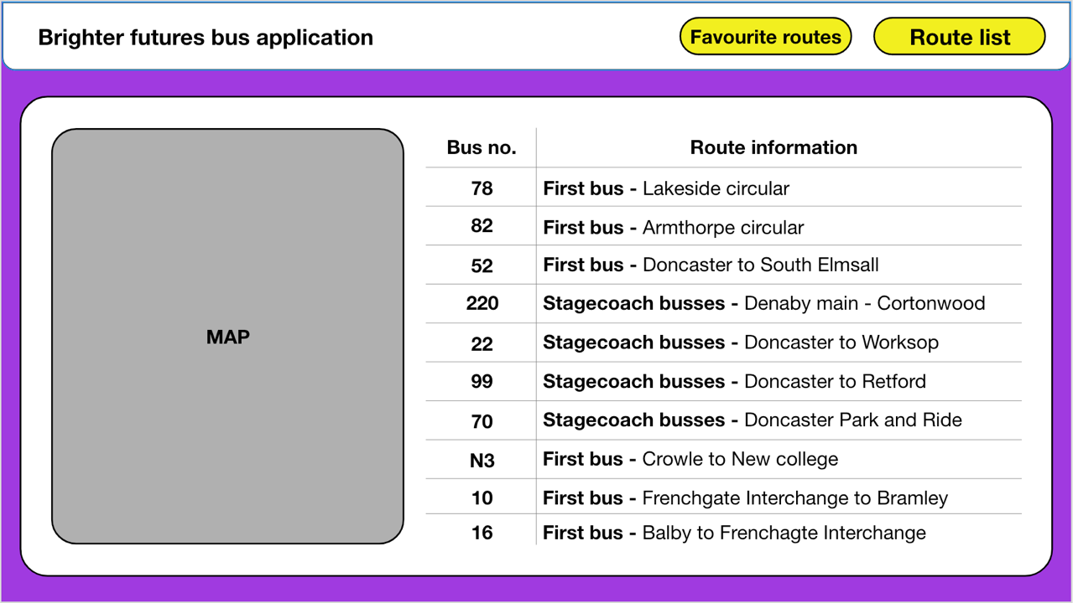

### Route information screen

Below is the route information screen – this screen will be very commonly used as it contains the timetable for the route, along with any other necessary information as and when it is required (delays, cancellations, etc.). If no other information is needed, it will simply display the route number, name, and a timetable below. As with most screens, this will have a navigation bar which contains buttons for the home screen, favourite routes, and the overall route list. There will also be a star icon, which can be clicked to favourite/unfavourite a bus route, which will add or remove it from the favourite routes list and screen.

**The timetable:**

The timetable displayed will have a few main elements to it. In the leftmost column, there will be the stop name, this can be clicked to bring up the street on google maps. Next to this column, there will be the times of busses from the start until the end. Occasionally, when times are consistent for a given period of time, then this will display placeholder text to make the timetable smaller. For example, if busses run every 30 minutes, it will display “then every 30 minutes until” then the next column will be the time which it continues until. Three examples of this can be seen in the wireframe below.

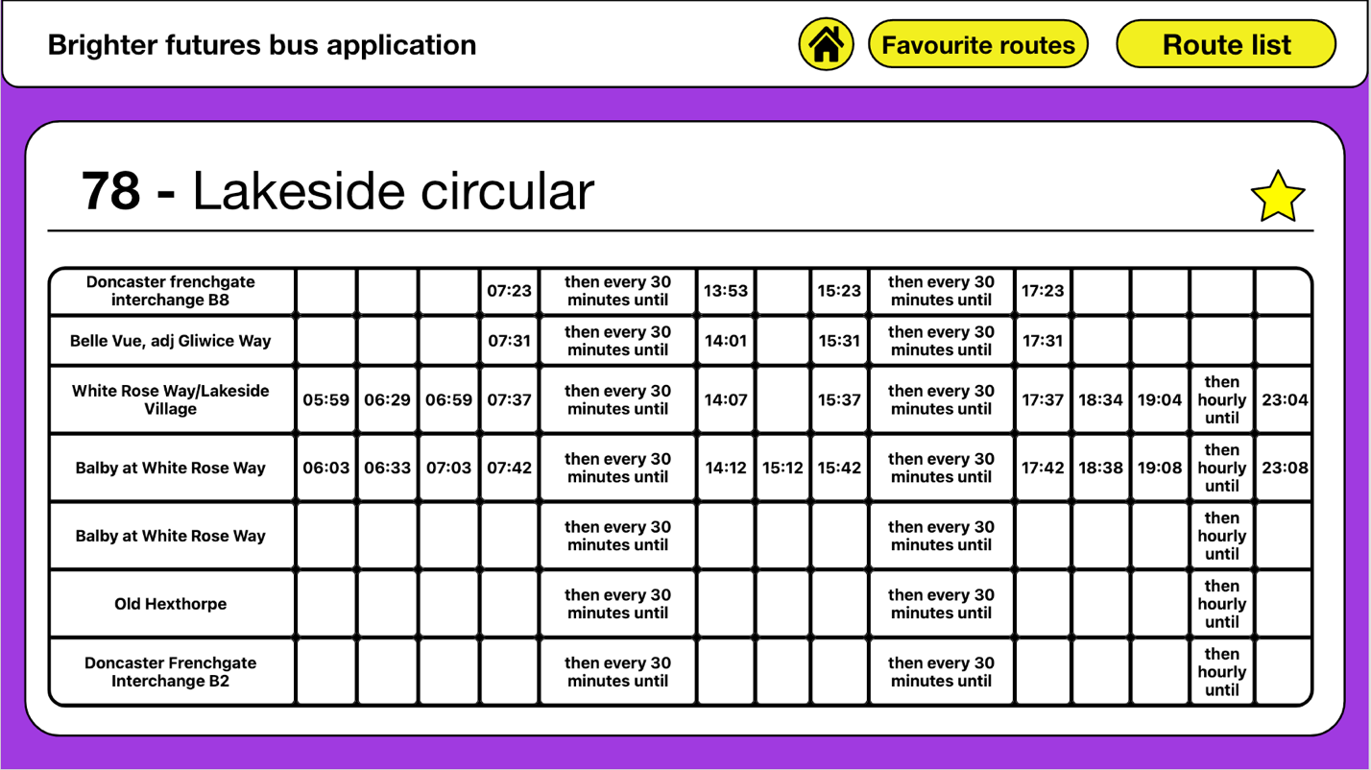

### Route list / favourite routes

The routes list and favourites screen are both extremely, looking identical except from the fact that the favourite routes screen will contain only favourited routes, whereas the route list contains both favourited and unfavourited routes.

**The table:**

The screen contains a table which contains 2 main elements for each item on the table. These two elements are the bus number and route information. The bus number is displayed in the leftmost column of the table and can be clicked in order to go to that routes route information screen. The other element of the table is basic route information – this is displayed next to the route number and contains the route name, the name of the company that runs the bus, and whether or not the route is favourited or not (as well as the ability to unfavourite said route on the favourite routes screen).

**The navigation bar:**

The navigation bars on these screens will have the standard two buttons that all iterations of the navigation bar have (favourite routes, as well as the route list button) in addition to a home screen button, which takes users back to the home screen. This is similar to all navigation bars which are not the home screen. The button to take the user back to this page will function as a way to get back to the top of the list without having to scroll through the entire list, it will also cause the page to reload which will ensure all information is as up to date as possible.

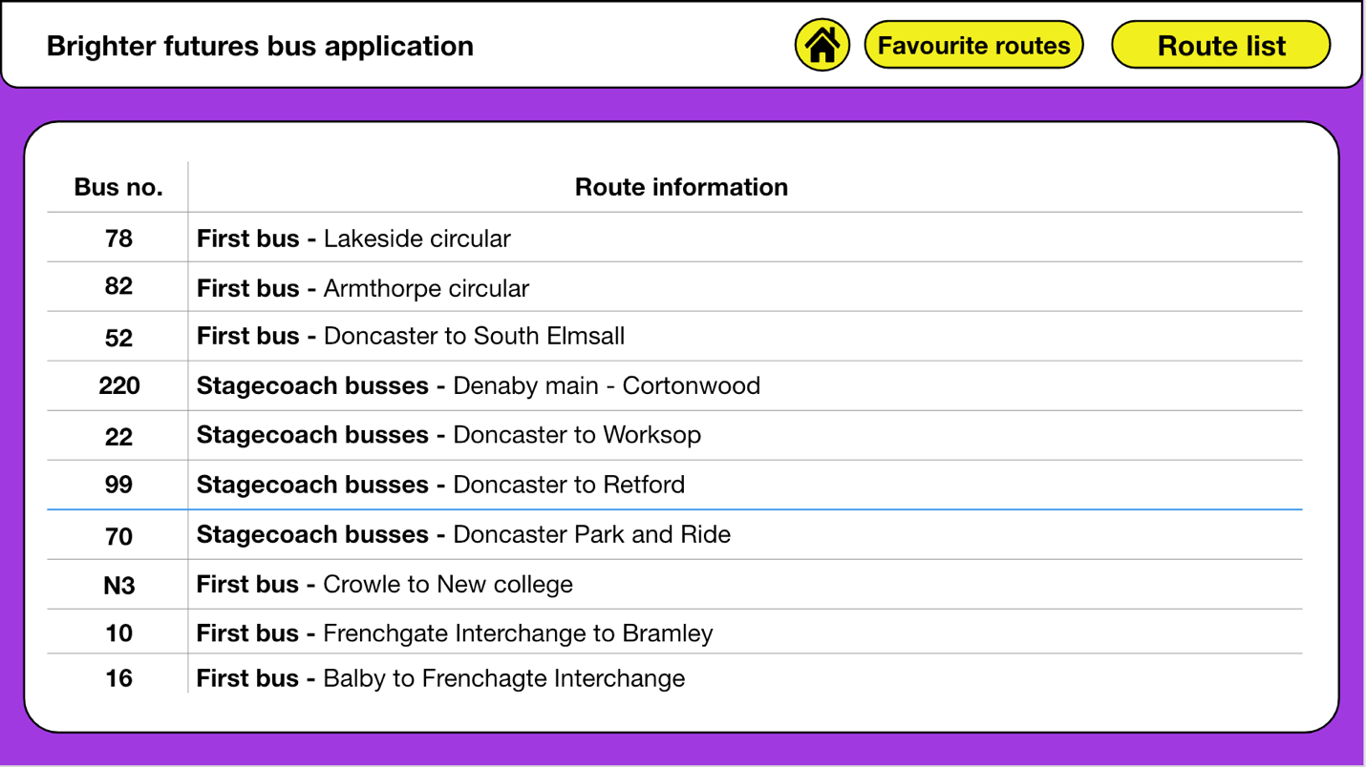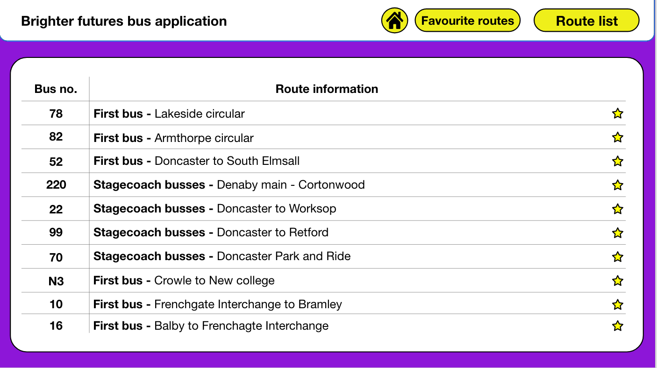

### Client feedback on designs

In order to ensure that they were up to the clients’ standard, I conducted a survey asking the client for feedback and potential changes to make to my designs in order to improve them from a user standpoint. I will then implement some of my changes to my designs and then show my progress and how this affects the overall product and completion of the various success criteria.

#### Main screen feedback and changes:

For the main screen, the client wished for some base designs to be changed, this was to do mainly with fonts and text styling. They want the titles for the tables to be both bold and underlined, rather than just bold. This is an easy implementation which we agree with. They would also like there to be an example map rather than just placeholder text, something else which we can easily implement and agree that it would help the stakeholders get a better feel for what the end product will actually look like.

##### The new main screen:

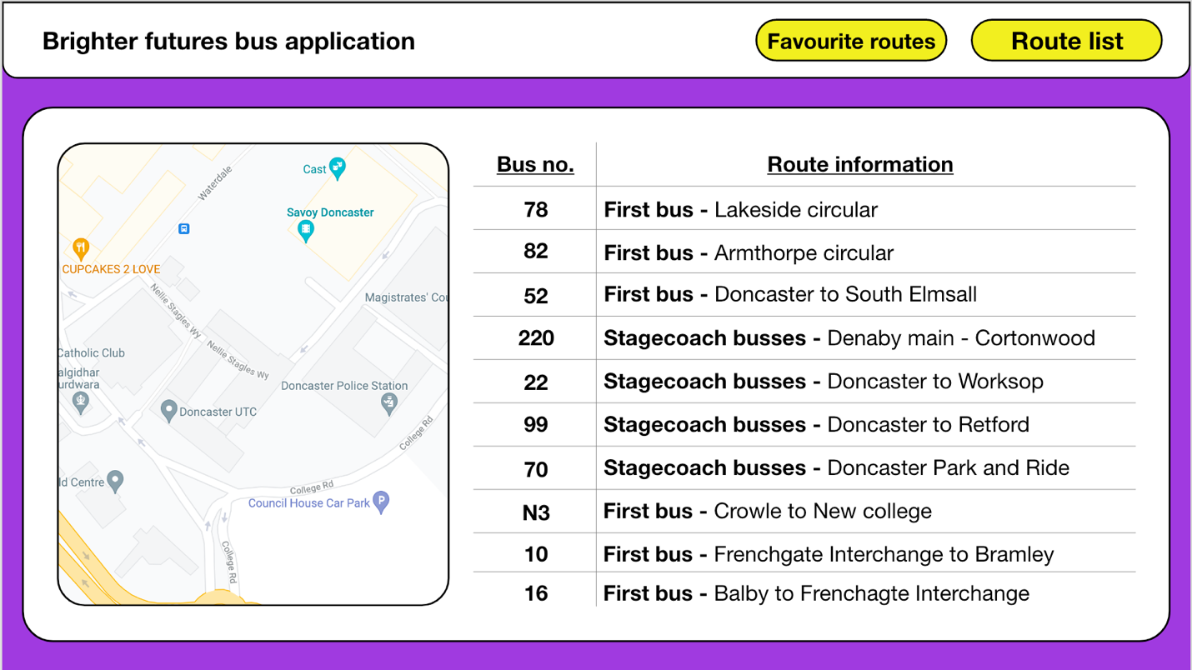

#### Route information screen feedback and changes:

The route information screen had one major complaint, and that was that (although in the example there was no additional information) the client felt that the section that would show additional information should still be included, then saying that none is required to the user. It will also notify the user that any additional information such as delays will be displayed there as soon as possible (this will likely require a page load to display).

##### The new route information screen:

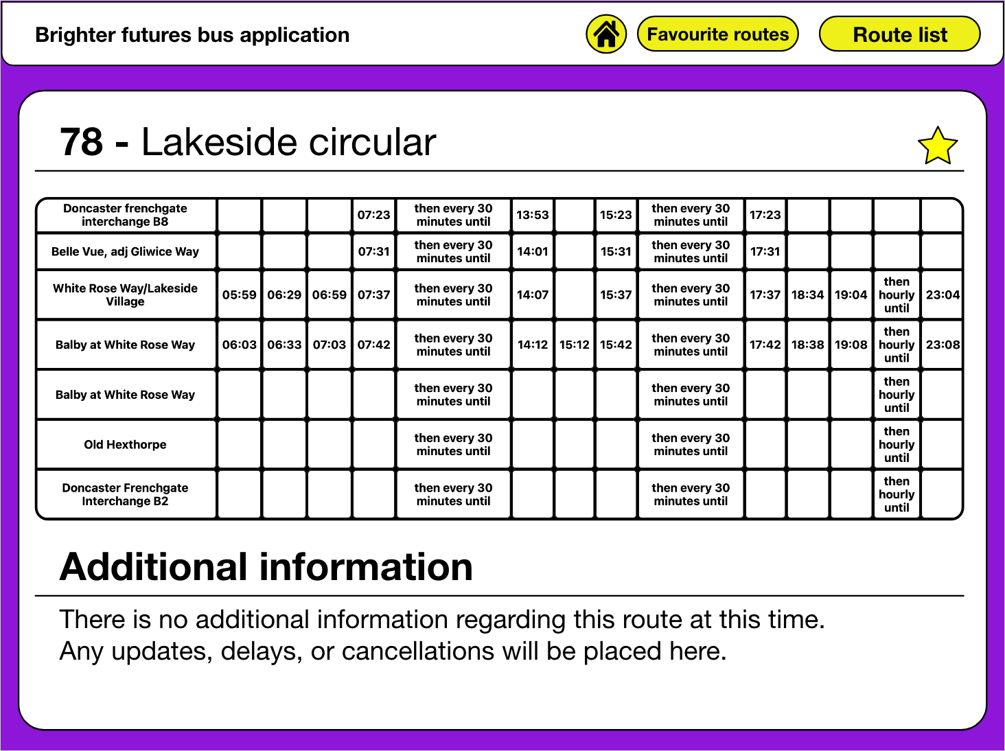

#### Route list / favourite routes screens feedback and changes:

Whilst the client was happy with the favourite routes screen, however, they had one main problem and piece of feedback that they felt would greatly improve user experience on the routes list screen. This is that the routes list screen does not show whether or not a route has been favourited or not. In order to change this and accommodate the clients’ needs, I will add a feature that looks similar to the stars that are on the favourite routes screen, enabling users to quickly see whether or not a route is favourited and then change the status if necessary. They would also like the table headings to be underlined in order to match the formatting of the home screen.

##### The new route list / favourite route screens:

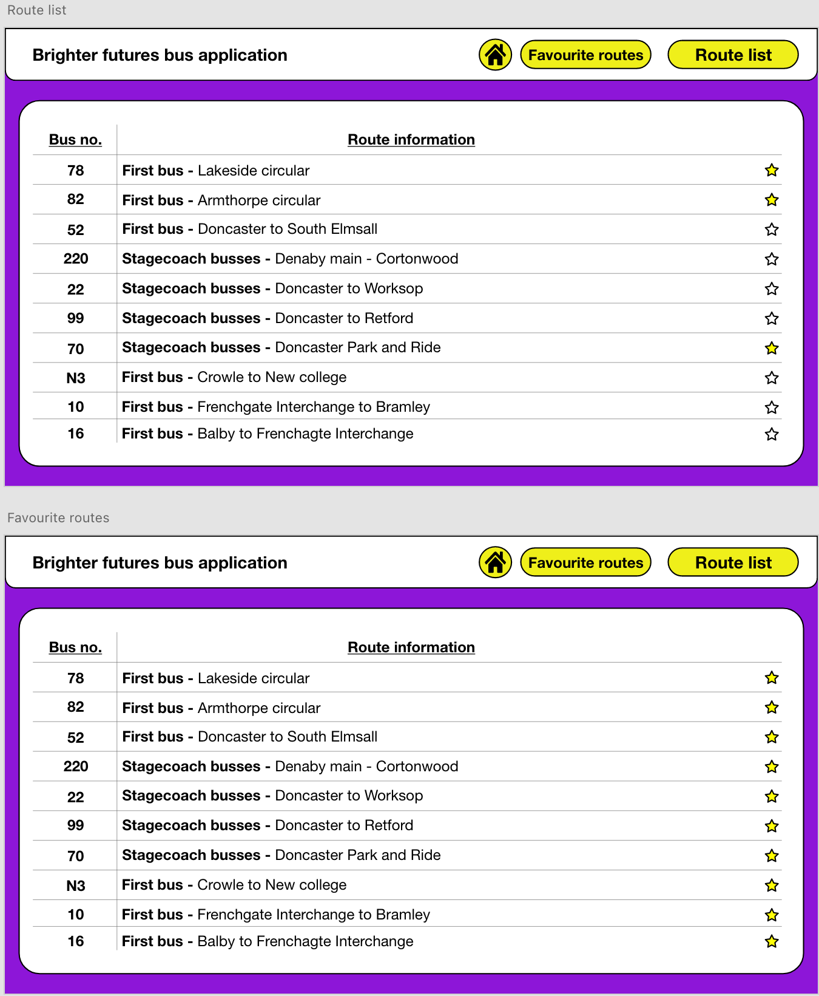

## Pseudocode

### Main app pseudocode

The main application will draw multiple files into one main file in order to make the process of development more streamline. However, for my pseudocode, I have put very simplified versions of the code into one file as the more simplistic code can be easily fit into one main file and there is no need to have multiple pseudocode files – only one for the main app, and one for the web scraper.

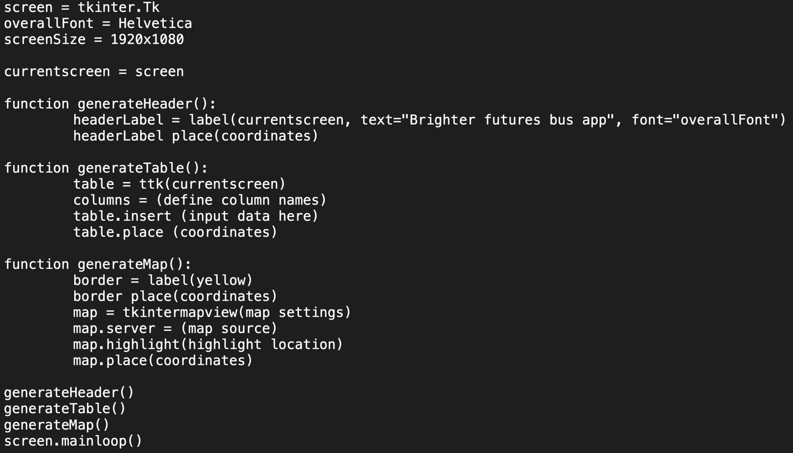

The above pseudocode is a rough interpretation of what my main screens code will look like – without the main computational elements to it. The pseudocode can be split up into 5 main sections; 3 functions, one section declaring the screen, and one section calling the functions (which does not need to be explained). The 3 functions should do as follows when fully coded:

1. Generate a header of the correct size at the top of the screen saying “Brighter futures bus app”
2. Generate a timetable or table of routes (yet to be decided based on which screens are accessed)
3. Generate a map using tkintermapview with a yellow border on the left of the screen.

### Distance calulator pseudocode

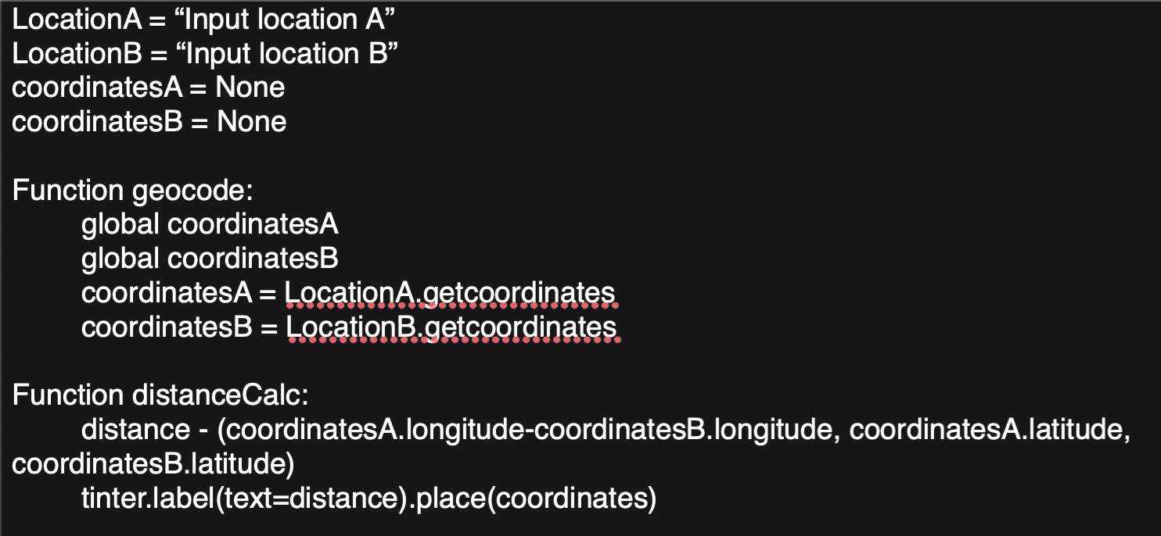

The above code is a distance calculator piece of pseudocode, though this is likely wildly inaccurate, as I have not yet researched geocoding or how to calculate distance using coordinates. However (though inaccurate), I believe that my code will be formatted roughly as shown above, with the following two functions:

1. A function responsible for getting 2 sets of coordinates, one set for the start location of the user, and one set for their desired destination
2. Another function responsible for calculating and displaying the distance between these two coordinates.

### Login screen

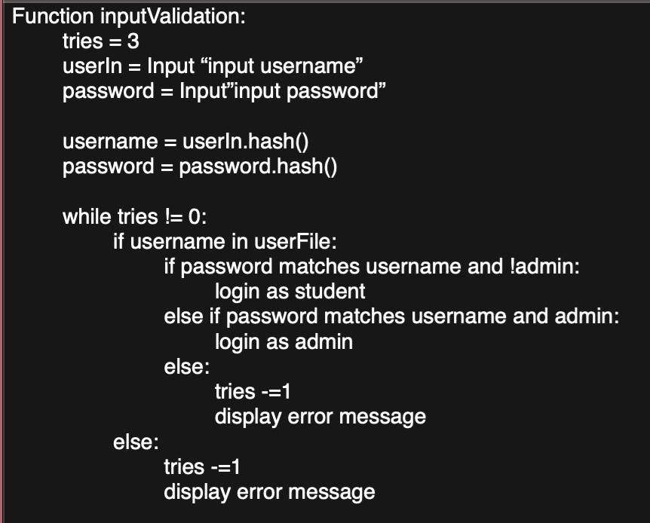

Above is a rough (and reasonably accurate) representation of what a console version of my application will look like. It consists of one function. This function begins by taking two inputs, a username and password. It then hashes these two inputs in order to compare them to the stored (and also hashed) usernames and their corresponding passwords. From here, the program loops while the user still has attempts available to log into the system. The username is checked first, and if it is present, then the password is also checked and must match. The program will either then login successfully as a student, login successfully as an admin, or reduce the remaining attempts by 1 and display an error message.

This pseudocode is reasonably accurate I believe, as I have made login scripts in the past, the only major difference I can see is that my final product will be in tkinter, whereas the above pseudocode is written more as a console application.

## Example code – proof of concept

### Map in tkinter

For my project, I need to be able to display a map of local bus routes as well as having this map be interactable with features such as zooming in and moving the camera around. In order to do this, I have used a python library specifically built for use with Tkinter in order to create interactive maps. This library is called TkinterMapView and enables you to get maps from the internet from a variety of sources. The code below is proof of concept and shows how I am able to create and customise a map and a border for the map.

##### Code overview

My code contains 4 key parts: the declaration of the function, the border creation and placement, the map settings, and the map placement.

**Declaration of the function:**

The entirety of the map generation is wrapped in a function, this means that I am able to call the function from various files (which I will need to as my program progresses) meaning that I won’t have to rewrite code and will ultimately save time and maintain consistency. The function currently has one parameter passed into it called “Location” which (when the function is called) will be replaced with a variable created earlier in my code called “HightlightedLocation” which contains a string which contains the required location where the marker needs to be placed. As this is stored as a variable, it means that you can change the location and update it in real time as and when needed. This can be modified in order to place markers at each stop when clicked by the user in the route information section.

**Border creation and placement:**

The second key aspect of the below code is the border creation that controls the border for my map. This code sets colour, width, height, and position of the border. The code is contained within lines 2,3, and 4 in the below code and each line does the following:

1. Creates an empty label with a yellow background.
2. Sizes the label to be just larger than the map, meaning the edges of the label can be seen, even though the label itself will be behind the map.
3. Places the border in the same location as the map, but behind the map.

With this code, I can create a border for the map, I could also in theory later adapt the code in order to have a border around any item in the program, not just the map. In the implementation stage, this will likely be its own function, with the ability to resize and relocate the border when calling the function, this means that the code can be easily reused and adapted for other purposes.

**Map settings:**

The second portion of the function is the map settings. This section is where each aspect of the map is defined such as its source, height, width, and where it will be. This part of the code will define the look of the map and will be able to be modified to create maps of any size, with a variety of settings being able to change both the look and feel of the map. This is where the value of “location” in the function declaration is used, and is set to the “highlightedLocation” variable, which in this example code is Doncaster. As it is input through the function declaration, any location can be passed into the function, meaning that I could bring up a map from anywhere around the world. This means that (although the app will only contain Doncaster-based busses to begin with) the application will be expandable in order to create apps for other locations and schools. The code itself takes up 3 lines, each configuring various aspects of the map and the information which it displays:

1. This uses the TkinterMapView library to create a window on the “screen” screen, with a width of 400, height of 600, and a corner radius of 0 (meaning it does not have rounded corners) and saves this information in the variable map_widget.
2. This takes the information from the map_widget variable and sets the server for the map (meaning the place it will draw the map imagery from), in this case, I am using Google maps to draw my data from, as it is the most commonly used service, and will thus be recognisable. It also defines the max zoom for the map, I found that 22 was a suitable value in order to obtain all necessary information from the map.
3. This final line utilises the earlier mentioned passed-through variable “Location” and uses this in order to set the focal location for the map. The focal location will be the location that is (by default) displayed at the centre of the map. Then, I have enabled the marker, which will add a marker to the location I have specified. This feature will also likely be how I add the bus stops to the bus routes, in order to make clear to the user where each stop is.

**Map placement:**

The map placement portion of the function is only one line, yet is arguably one of the most important. This section places down the map onto the screen, in order for the user to be able to see and interact with the map. There are three variables that are used by the program, relx, rely, and anchor. Relx is a variable that decides the positioning of the map based on the relative x position of the window (specified as a decimal between 0 and 1). Rely is a similar variable to relx, yet instead of deciding where on the x axis it is placed, it determines the location on the y axis (yet again relative between 0 and 1). The final variable (anchor) is there to determine which part of the map is the point that is moved along the x and y axis, with CENTER being the direct centre of the image meaning that the centre of the image will be (in this case) on 0.2 and 0.53 on the x and y axis respectively.

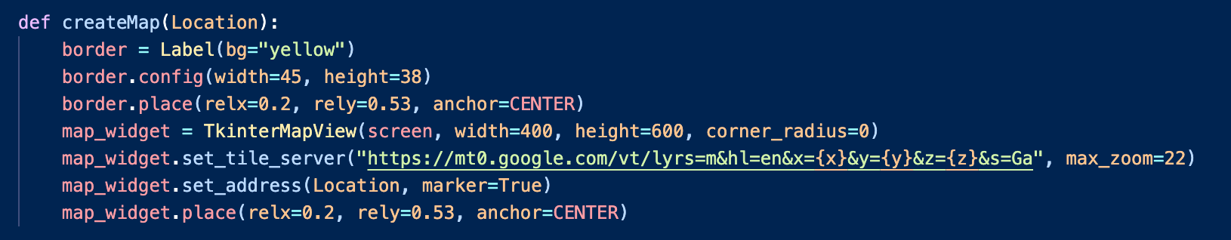

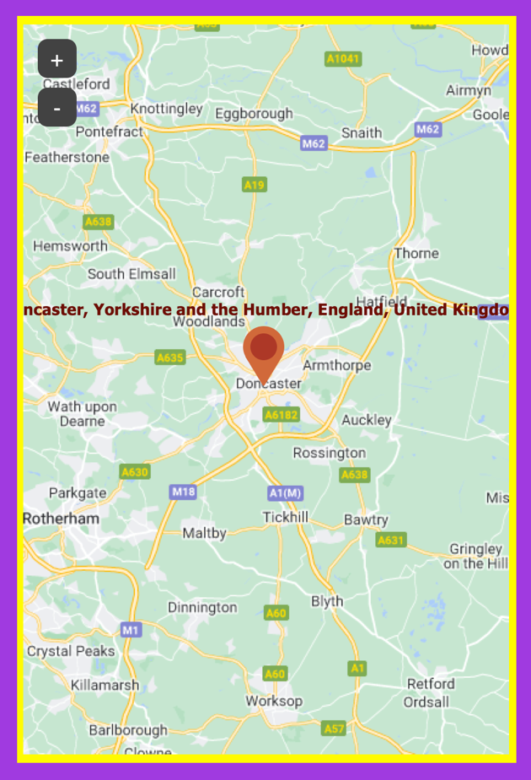

## Systems diagram – breaking down the problem

### Explain and justify

The diagram below shows the file and function structure of the program. I have split it up into 2 main sections: the login section, and the back-end section.

The log in section is then split into two further sections: input validation and UI placement. Input validation is two main computational segments, the user input section, and the section where you compare the username and password values. The user input section is based on the UI and connecting the UI to the back end. The UI section of login is then focused on defining and placing the UI variables.

The back end then has 5 key aspects as shown below.

#### The web scraper section

This section handles the gathering of HTML, parsing of data, and collection of all relevant data for later input into the file system. This section is broken down into gathering HTML, Scraping the dimensions of the table, and scraping the table data.

#### MAp generation

This section handles the map generation for the main page, as well as any other pages which may be necessary later in development. This is then split up into 2 main functions, setting the map parameters, and generating the map on the screen. Setting the parameters entails setting the tile server, the width, the starting location, and other things later to make the map more subject specific. The placement section involves the height and width of the map, along with the x and y positions.

#### Geocoding

The geocoding segment of my code is made for gathering locational data in a format which multiple algorithms can read (coordinates by latitude and longitude). This program gets the users location and their desired location as a string. This then is passed into a geocoding algorithm which takes the strings and converts them into latitude and longitude coordinates to be able to generate locations in a readable manner.

#### Timetable creation

The timetable creation relies on the web scraping function, it gathers the data from the database, then gathers the dimensions from the corresponding data file, then generates a timetable. The process of timetable generation is handled line by line, with each stop’s times being input on a line-by-line basis.

#### Data storage

The data storage section is broken down into 2 main sections, storing data, and storing dimensions for the timetables and route tables. When the data is gathered in other functions, the code will then store all the data needed in a necessary data file which corresponds to the table that the data relates to.

### Variables

The most used variables will be as followed:

* Map – stores the digital map for the main page and any other pages.
* Timetable – stores the timetable which can be modified for any other timetable needed for any bus route.
* pageName – stores the current primary page which elements will be added to .
* Table – the table that stores the list of route numbers and names.

### Lists

The most used lists I will have:

* Columns – an expanding list of strings which is later converted into a tuple representing each heading.
* tableDataList – this list stores all of the data that will go in a single row on the table.

### DIctionaries

The two dictionaries that I will need are as follows:

* userPassDict – stores all encrypted passwords relating to the corresponding encrypted username.
* newRouteInfo – stores all information input by the user about a new route. This includes the route name, number, and URL.

## Testing

|  |  |  |
| --- | --- | --- |
| Test desc | Test type (normal / extreme / erroneous) | Justify |
| User login using the correct data | normal | This aims to test that the user can correctly log into the system |
| user login using incorrect or no data | erroneous | This aims to show that the user cannot log in unless the correct information |
| Adding a route to the system | normal | this aims to show that an admin can correctly add a bus route |
| viewing a timetable | normal | the user should be able to view the timetable for a given bus route |
| test the web scraper using an incorrect link | erroneous | this will show that the web scraper needs |
| Testing the geocoding | normal | the user should be able to click on a stop which will allow them to then see a map showing how to get to the stop |

# C. Developing the coded solution (“The development story”)

## Phase 1 Work on the login screen

### User interface

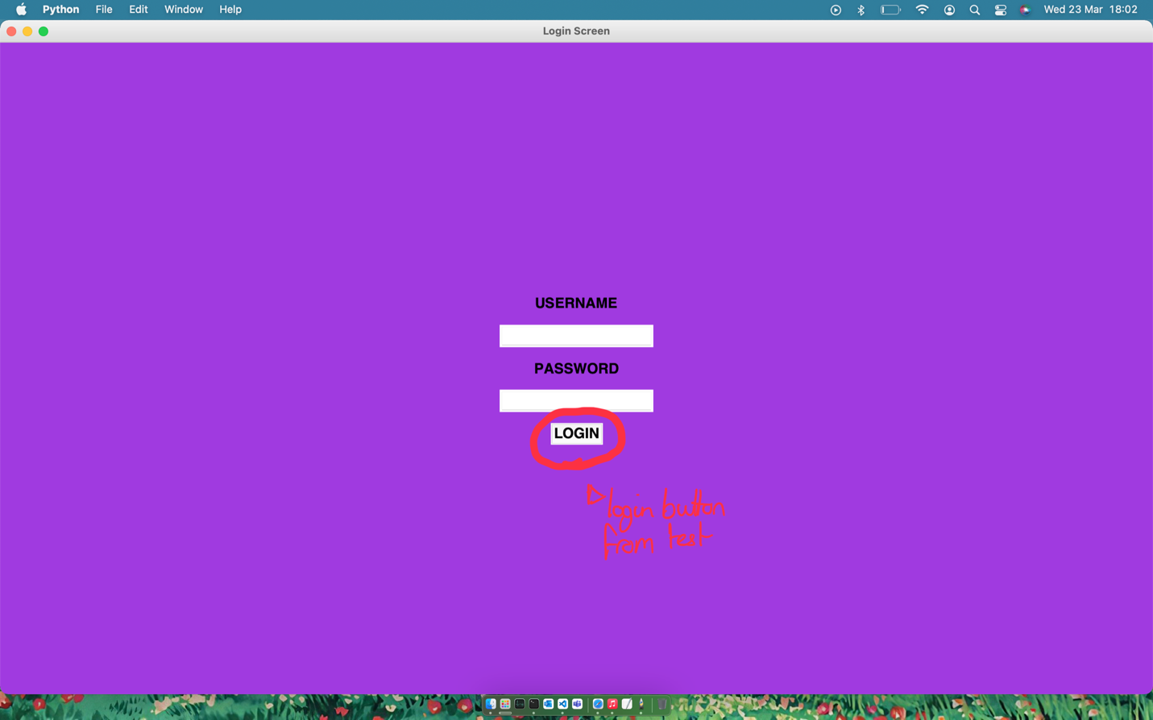

Shown above is the UI for my login screen, with the code above showing the code needed for the button creation, functionality, and placement. This page was the simplest to make as it was simply 2 entry fields, 2 labels, and a button, all positioned in the center with equal spacing between. This was the first draft of my login page, which has since been altered to look as follows:

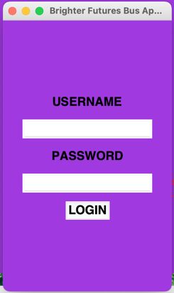

I found that this design is much better overall as it is smaller and takes up less of the screen, this means that there is less overall wasted space on the screen. However, to combat this, I then had to reposition the window to be in the center of the screen. This was done through the geometry configuration function in tkinter.

loginScreen.geometry("250x400+560+220")

above is the line of code used to make the window 250 by 400 pixels, then position it 560 pixels to the right and 220 pixels down.

*#LOGIN button*

loginButton = tkinter.Button(*text*="LOGIN", *background*="yellow", *activebackground*="#9b870c", *font*='Helvetica 18 bold', *command*=inputVal)

loginButton.place(*relx*=0.5, *rely*=0.7, *anchor*=CENTER)

This above code is setting the parameters for and placing the log in button. The command run is inputVal which will run through the inputs and compare them against what is required.

*#configures text boxes and their headings*

userLabel = tkinter.Label(*text*="USERNAME", *bg*="#8D16D8", *font*='Helvetica 18 bold')

passLabel = tkinter.Label(*text*="PASSWORD", *bg*="#8D16D8", *font*='Helvetica 18 bold')

userBox = tkinter.Entry()

passBox = tkinter.Entry(*show*="*")

This code configures the 2 labels and the 2 entry boxes needed, specifying their backgrounds and specifying that the password text box will show asterisks instead of whatever text is in, for privacy reasons.

*#places text boxes and their headings*

userLabel.place(*relx*=0.5, *rely*=0.3, *anchor*=CENTER)

userBox.place(*relx*=0.5, *rely*=0.4, *anchor*=CENTER)

passLabel.place(*relx*=0.5, *rely*=0.5, *anchor*=CENTER)

passBox.place(*relx*=0.5, *rely*=0.6, *anchor*=CENTER)

Here is the code which places all of the boxes, the relative x is always 0.5, meaning that all of the elements will be centred, there is then a 10% gap between each item, meaning that it is all evenly spaced throughout the screen, with the central item being in the center of the screen.

### Functionality

To implement functionality, I decided that the username and password should be encrypted using SHA256 encryption. In order to do this, I had to research how to implement the encryption using the website below:

<https://datagy.io/python-sha256/>

This website shows the base of how to use the hashlib module for encryption. I then used this as a base in order to encrypt my data and ensure that the data is secure and not easily accessible.

The login screens functionality is wrapped up into one central function called inputVal (short for input validation), it takes no extra parameters. This function takes the hashed values of the inputs for each text field and compares them to the stored username and password in order to validate login and determine the users’ permissions before the application is loaded (i.e.: administrative permissions).

userPassDict = {

"8c6976e5b5410415bde908bd4dee15dfb167a9c873fc4bb8a81f6f2ab448a918":"5994471abb01112afcc18159f6cc74b4f511b99806da59b3caf5a9c173cacfc5",

"264c8c381bf16c982a4e59b0dd4c6f7808c51a05f64c35db42cc78a2a72875bb":"264c8c381bf16c982a4e59b0dd4c6f7808c51a05f64c35db42cc78a2a72875bb"

}

These are the stored, encrypted values of the 2 example usernames and passwords in the program – there is an account for students and an account for the admin.

password=hashlib.sha256((passBox.get()).encode()).hexdigest()

This code takes the input of the password input box, encodes the data, and then runs it through SHA256 encryption, which can later be applied in comparison to the stored passwords. Similarly, this has been used in order to encrypt and compare the username.

At one point, I wanted to make all buttons in the UI yellow as shown below: 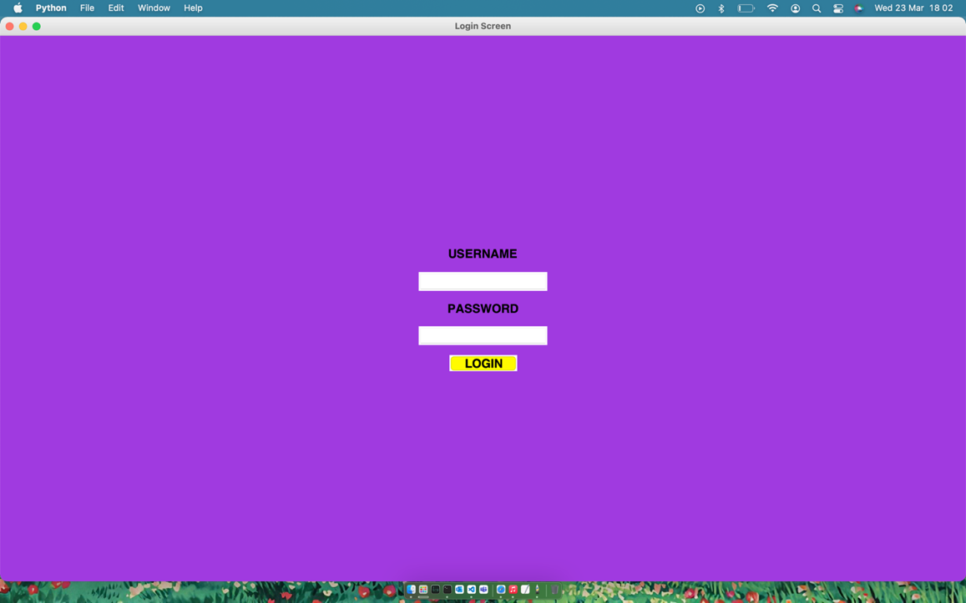

Despite the colouration working correctly, I later ran into implementation errors as a different module is needed for coloured buttons on macos. This meant that each coloured button could only have one command attached to it at any given time, meaning that some buttons needed to be white instead of yellow. Overall, I decided to simply remain using plain white buttons as it meant the UI was much more consistent throughout with the design language matching on each page whilst also still being functional.

*#checks for the username in the dictionary*

*if* username in userPassDict:

*if* userPassDict[username] == password:

*if* username=="8c6976e5b5410415bde908bd4dee15dfb167a9c873fc4bb8a81f6f2ab448a918":

mainApp.admin=True

print("Admin enabled")

loginScreen.destroy()

mainApp.__main__()

*else*:

*#removes 1 try, displays appropriate message*

loginTries-=1

invalidMessageText=("invalid username or password, you have", loginTries, "attempts remaining")

invalidMessage = tkinter.Label(*text*=invalidMessageText, *bg*='#8D16D8', *font*='Helvetica 18 bold', *fg*="red")

invalidMessage.place(*relx*=0.5, *rely*=0.35, *anchor*=CENTER)

*#if there are no tries remaining, the application closes*

*if* loginTries <=0:

loginScreen.quit()

*else*:

*#removes 1 try, displays appropriate message*

loginTries-=1

invalidMessageText=("invalid username or password, you have", str(loginTries), "attempts remaining")

*#refreshes and replaces invalid message*

invalidMessage = tkinter.Label(*text*=invalidMessageText, *bg*='#8D16D8', *font*='Helvetica 18 bold', *fg*="red")

invalidMessage.place(*relx*=0.5, *rely*=0.35, *anchor*=CENTER)

*if* loginTries <=0:

*#if there are no tries remaining, the application closes*

loginScreen.quit()

The above code compares the username and password and stored values to ensure that the correct usernames and passwords have been input. It checks the inputs 3 times and if it is incorrect each time, the application closes. Each time that the input is incorrect, it also displays an error message, along with the number of attempts remaining. On a successful input, the main screen is loaded. As well as this, if an admin account was used, the admin version of the page is loaded.

### Client feedback:

Overall, the client is happy with the login menu, it looks professional, responds correctly and as expected to the users input, and maintains the colour scheme present throughout the rest of the schools infrastructure. The client did however have one complaint, which I have not yet been able to rectify; when the error message comes up for an incorrect login, due to the size of the window, the text spills of the sides. In addition to this, the username text box is slightly covered by the background of the error label, both of these issues are shown below:

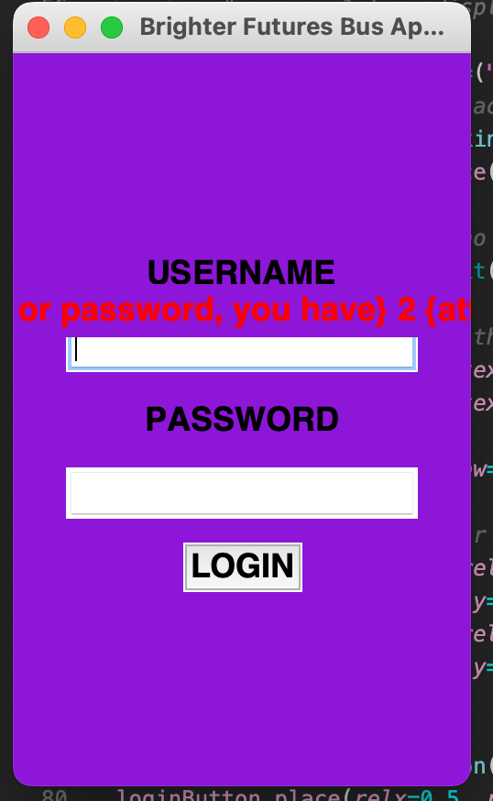

In order to fix this, I have made the window wider as well as taller. As shown below:

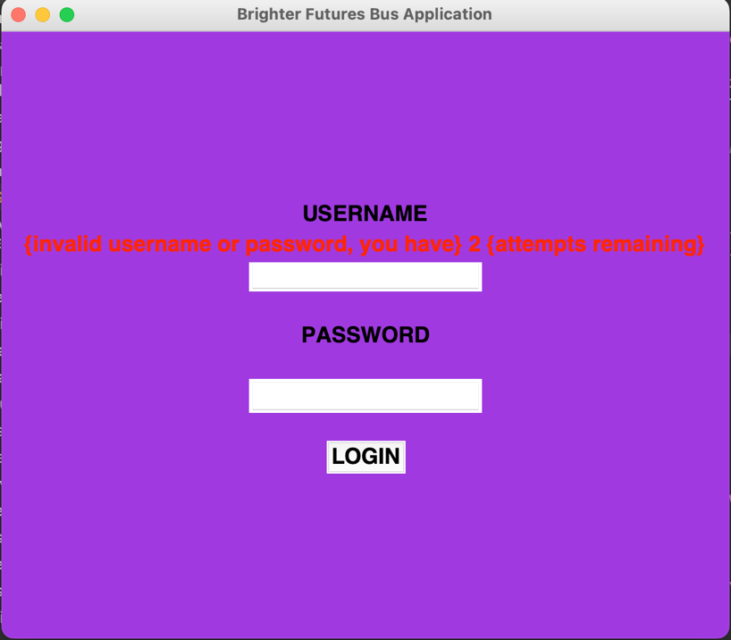

This change was made through changing the following line of code:

loginScreen.geometry("250x400+560+220")

To this:

loginScreen.geometry("600x500+450+170")

As a result of this change, the window remains centred, yet becomes both wider and taller, which makes more room for the various elements to be correctly spaced and displayed.

## Phase 2 Work on the User interface

### User interface

For my user interface, I decided to use the python module, tkinter. I have worked with this module in the past, so I already knew how to use it in reasonable detail, all that was left was to implement this into my project to create a base for my UI. I decided to do as much of the UI generation as possible in a single file, then calling functions from this file where needed in order to make creating new pages easier and quicker, as much of the work could be done by calling a function and defining some parameters. All of my configuring code is in the file configurePage.py, and it covers the UI generation of most pages.

*#configuers the screens header and places it*

def configHeader(*pageName*, *pageTitle*):

global myFont

*#configures the size and shape of the header, customisable for any page*

headerLabel = tkinter.Label(*pageName*, *text*=*pageTitle*)

headerLabel.config(*font*=myFont,*width*=150, *height*=2)

headerLabel.place(*relx*=0.5, *rely*=0, *anchor*=N)

*#configures a button to take the user back to the home screen*

homeButton=tkinter.Button(*pageName*, *text*="HOME", *background*="yellow", *activebackground*="#9b870c", *font*=myFont, *command*=lambda:[*pageName*.destroy(), mainApp.__main__()])

homeButton.place(*relx*=0.75, *rely*=0.025, *anchor*=CENTER)

*#configuration of the routes button - a button that takes the user to a list of all routes*

routesButton=tkinter.Button(*pageName*, *text*="ROUTES", *background*="yellow", *activebackground*="#9b870c", *font*=myFont, *command*=lambda:[*pageName*.destroy(), routes.routesPage()])

routesButton.place(*relx*=0.65, *rely*=0.025, *anchor*=CENTER)

*#configuration of the cancellations button - does not unclude .destroy as it opens in the browser, not tkinter*

cancellationsButton = tkinter.Button(*pageName*, *text*="CANCELLATION", *background*="yellow", *activebackground*="#9b870c", *font*=myFont, *command*=lambda:[webScraper.cancellations()])

cancellationsButton.place(*relx*=0.85, *rely*=0.025, *anchor*=CENTER)

This is the code I used in order to create the function for the header, this sets a large empty label that stretches across the width of the page, in order to be a background for a header, it then sets 3 buttons, a cancellation button, a home button, and a routes button I define my settings button as a separate function as this is only needed if you are logged in as an administrator. All of the functions used here are set as lambda commands, meaning they are not called as soon as the buttons are placed while still being able to take external parameters. Most of these functions simply open new windows and destroy the current in use window. All of these buttons are evenly spaced and sized the same.

def configSettingsButton(*pageName*):

settingsButton = tkinter.Button(*pageName*, *text*="SETTINGS", *background*="yellow", *activebackground*="#9b870c", *font*=myFont, *command*=lambda:[settingsTopLevel()])

settingsButton.place(*relx*=0.95, *rely*=0.025, *anchor*=CENTER)

Here is the code for the settings button, rather than destroying and creating a page, it simply creates a top level using the following settingsTopLevel() function:

def settingsTopLevel():

settingsPage = tkinter.Toplevel()

settingsPage.title("Brighter Futures Bus Application")

settingsPage.config(*bg*='#8D16D8')

settingsPage.geometry("960x540+250+150")

headerLabel = tkinter.Label(settingsPage, *text*="SETTINGS")

headerLabel.config(*font*=myFont,*width*=150, *height*=2)

headerLabel.place(*relx*=0.5, *rely*=0, *anchor*=N)

settings(settingsPage)

This top level creation function defines each aspect of the top level, including size and colour. On this top level, there are three buttons, two of which are defined here:

def settings(*pageName*):

logoutButton = tkinter.Button(*pageName*, *font*=myFont, *text*="LOGOUT", *command*=lambda:[logout(*pageName*)])

logoutButton.place(*relx*=0.5, *rely*=0.5, *anchor*=CENTER)

newRouteButton = tkinter.Button(*pageName*, *font*=myFont, *text*="NEW ROUTE", *command*=lambda:[newRoute()])

newRouteButton.place(*relx*=0.5, *rely*=0.6, *anchor*=CENTER)

This function adds the logout button, which simply calls the logout function, and the new route button calls the newRoute function, which will allow users to create and add new routes to the list of routes on the application by entering a route name, number, and URL.

def logout(*pageName*):

*pageName*.quit()

my logout function is extremely simple, it takes the current page name passed as a parameter, and quits the application, this will end all processes in the application. I didn’t need to create anything to large as whenever you restart the application, you are prompted to log in again.

My new route function however, is much larger, containing more complex code, as this involves the retrieval and saving of data.

To begin with I have written the following code:

routeList = open("routeList.txt", "a")

newRouteInfo = {

"Number":"",

"Name":"",

"URL":""

}

This opens the text file which stores the list of all routes in append mode, allowing me to add to the end of the text file. Then I create a dictionary, which is where I will be storing the route number, name, and URL in order to be able to easily store this data in order to write it to the text file, as well as being able to scrape the correct data.

*#config page*

newRoutePage = tkinter.Toplevel()

newRoutePage.title("Brighter Futures Bus Application")

newRoutePage.config(*bg*='#8D16D8')

newRoutePage.geometry("960x540+250+150")

*#^^ places in direct center of page*

*#config header*

headerLabel = tkinter.Label(newRoutePage, *text*="NEW ROUTE")

headerLabel.config(*font*=myFont,*width*=150, *height*=2)

headerLabel.place(*relx*=0.5, *rely*=0, *anchor*=N)

This is generic configuration code; it is similar to my earlier code, yet I decided to rewrite it as all of the titles and sizing for the headers and window was completely different. I also needed to write the geometry different, by adding x and y values, which then places the window in the centre of the page, rather than in the top left corner.

*#config entry fields*

routeNumber = tkinter.Entry(newRoutePage, *font*=myFont)

routeName = tkinter.Entry(newRoutePage, *font*=myFont)

routeURL = tkinter.Entry(newRoutePage, *font*=myFont)

Here is the code where I configure entry fields for the route number, route name, and route URL, this is similar to the login page, with them being simple Entry boxes, which are then placed evenly spread on the page.

After the placing the entry boxes, I wrote the following code:

def scrape():

*#scrapes web using given url and saves in new file with corresponding route number as file title*

webScraper.webScrape(newRouteInfo["URL"], newRouteInfo["Number"])

This is a function which configures a web scraper to run given the information stored as url and number in the new route information dictionary.

def setInformation():

*#validity check*

*if* routeName.get()!="" and routeNumber.get()!="" and routeURL.get()!="":

*#set dictionary values*

newRouteInfo["Name"]=routeName.get()

newRouteInfo["Number"]=routeNumber.get()

newRouteInfo["URL"]=routeURL.get()

routeList.write('\n')

routeList.write(newRouteInfo["Number"])

routeList.write('\n')

routeList.write(newRouteInfo["Name"])

print(newRouteInfo["Name"])

routeList.close()

scrape()

newRoutePage.destroy()

*else*:

displayError(newRoutePage, 0.5, 0.3, "1 or more text field(s) are empty, please correct and try again")

This function checks the validity of the information which has been entered to the entry fields, if there are some empty text fields, then the last 2 lines displays an error message using the displayError() function which alerts the user that 1 or more text field(s) are empty and that they must input the data correctly. If the boxes all have data in however, the following happens:

* The route dictionary name, number, and URL is saved based on the corresponding entry boxes.

newRouteInfo["Name"]=routeName.get()

newRouteInfo["Number"]=routeNumber.get()

newRouteInfo["URL"]=routeURL.get()

* Then the route number and name are written on the routeList text file, each on a new line so that the file can still be properly read in other python files.

routeList.write('\n')

routeList.write(newRouteInfo["Number"])

routeList.write('\n')

routeList.write(newRouteInfo["Name"])

* The route name is printed (for error finding purposes)

print(newRouteInfo["Name"])

* The text file is closed – as it is no longer needed.

routeList.close()

* The web scraper runs, collecting the necessary information about the input route from the given site.

scrape()

* The route adding page is destroyed.

newRoutePage.destroy()

At the end of this code I have written the following line of code:

confirmButton = tkinter.Button(newRoutePage, *font*=myFont, *text*="CONFIRM", *command* = lambda:[setInformation()]).place(*relx*=0.5, *rely*=0.7, *anchor*=CENTER)

it creates a button which calls the setInformation() function, meaning that the user can input the information and then confirm this through a button press.

For my page containing all of the routes on one page I have the current code:

def routesPage():

routePage = tkinter.Tk()

global myFont

*#calls page configuration functions*

configurePage.configure(routePage)

configurePage.configHeader(routePage, "Routes")

*#generates tables*

tables.tableSettings(700, 750, 0.5, 0.53)

tables.generateTable(routePage)

it uses configure page functions to create the base for the page, then tables functions in order to generate a table containing all of the available bus routes.

My main page is very similar in terms of UI generation and the code looks as follows:

def __main__():

global admin

*#creates an empty deafault tkinter screen*

mainScreen = tkinter.Tk()

def configMap():

distanceCalculator.coordGet("Bawtry Road")

distanceCalculator.routing()

fileName = 'file:///'+os.getcwd()+'/'+'map.html'

webbrowser.open_new_tab(fileName)

*#calls functions to configure the main page layout*

configurePage.configure(mainScreen)

configurePage.configHeader(mainScreen, "Main Screen")

*#calls both necessary functions to place the map onto the main screen*

mapGenerationCode.mapSettings(400, 600, "doncaster")

mapGenerationCode.generate(mainScreen)

*#code to refresh the map*

def resetMap():

*#calls both necessary functions to place the map onto the main screen*

mapGenerationCode.mapSettings(400, 600, "doncaster")

mapGenerationCode.generate(mainScreen)

mapButton = tkinter.Button(mainScreen, *font*=myFont, *text*="RESET POSITION", *command*=lambda:[resetMap()])

mapButton.place(*relx*=0.2, *rely*=0.9, *anchor*=N)

*#calls functions to generate the correct table*

tables.tableSettings(700, 750, 0.65, 0.53)

tables.generateTable(mainScreen)

*if* admin == True:

configurePage.configSettingsButton(mainScreen)

mainScreen.mainloop()

The main page contains all of the standard UI elements, a table for recently added routes, and a map to the side showing the Doncaster UTC (where the terminal will be and where students will access the program). It also checks to see if the user is an admin or not, generating the settings button if they are.

### Client feedback

Whilst from a user point of view, the project UI feels outdated due to the lack of rounded edges, and the bright purple and yellow colour scheme – the client is happy with this, as it matches the other systems that the school have in place currently, such as the use of the terminal the students use to sign in with on a daily basis, creating a feeling of consistency, which the client felt to be much more important.

## Phase 3 Work on the Web scraper

### Beginning my research

For my web scraper, I first had to look at how to make it – which began with researching various python modules. The module that I had heard the most about from other students and friends was beautiful soup. My research began with reading some documentation and example code to start to understand the limitations and benefits of using beautiful soup. I began on the following website:

<https://www.crummy.com/software/BeautifulSoup/bs4/doc/>

By reading this, I decided that beautiful soup was going to fit well in my project and work for what I needed, the basic collection of timetable data from a given website to later store and display within my application.

After this, I looked through some example code in order to better understand how to implement the various elements of the module and what data different things gathered. Below is said example code:

*import* requests

*from* bs4 *import* BeautifulSoup

*import* csv

URL = "http://www.values.com/inspirational-quotes"

r = requests.get(URL)

soup = BeautifulSoup(r.content, 'html5lib')

quotes=[] *# a list to store quotes*

table = soup.find('div', *attrs* = {'id':'all_quotes'})

*for* row *in* table.findAll('div', *attrs* = {'class':'col-6 col-lg-3 text-center margin-30px-bottom sm-margin-30px-top'}):

quote = {}

quote['theme'] = row.h5.text

quote['url'] = row.a['href']

quote['img'] = row.img['src']

quote['lines'] = row.img['alt'].split(" #")[0]

quote['author'] = row.img['alt'].split(" #")[1]

quotes.append(quote)

filename = 'inspirational_quotes.csv'

*with* open(filename, 'w', *newline*='') *as* f:

w = csv.DictWriter(f,['theme','url','img','lines','author'])

w.writeheader()

*for* quote *in* quotes:

w.writerow(quote)

From the above code, I can understand that you need to first define a URL, parse the content on the site, and then you can begin searching through the data in order to retrieve and store various elements. After I believed I could understand the various sections of this code, I began working on my programming in order to implement what I had learned in a context that would help me.

### Beginning my implementation

To begin with, I attempted to isolate an individual element from within my code.

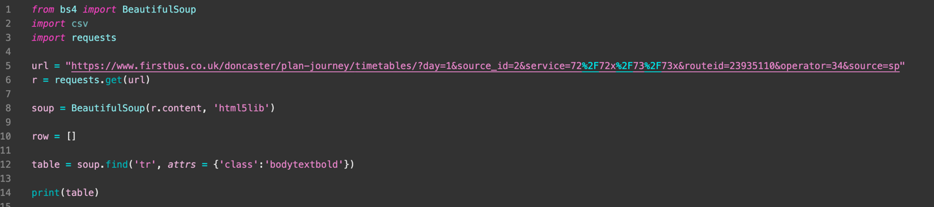

I began by writing the above code, which I believed would collect an individual element. However, instead The output was the entirety of the first row, not just the first element.



This is as I used both the wrong tag and the wrong class to collect data. Instead of searching in bodytextbold for the tr content, I needed to search for all td content, as this is where the times and stop locations are stored on the first website.

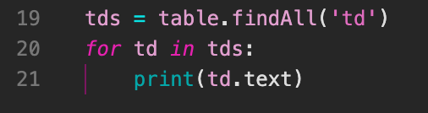

The above is modified code which prints out every all text that is contained within a td tag. Below is the first result of this code:

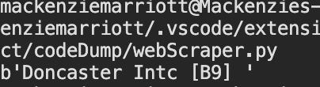

As seen above, this code will output all table data in the above format, which means that now I will be able to go through and collect the data where needed, storing it in a text file as it is collected. At first, I was going to store it as a csv file, but as I got more accustomed to implementing data into a tkinter treeview table, I believed that the information I collected would be better stored within a text file, as I could then simply go through line by line.

After implementing the storage of data, my code looked as follows:

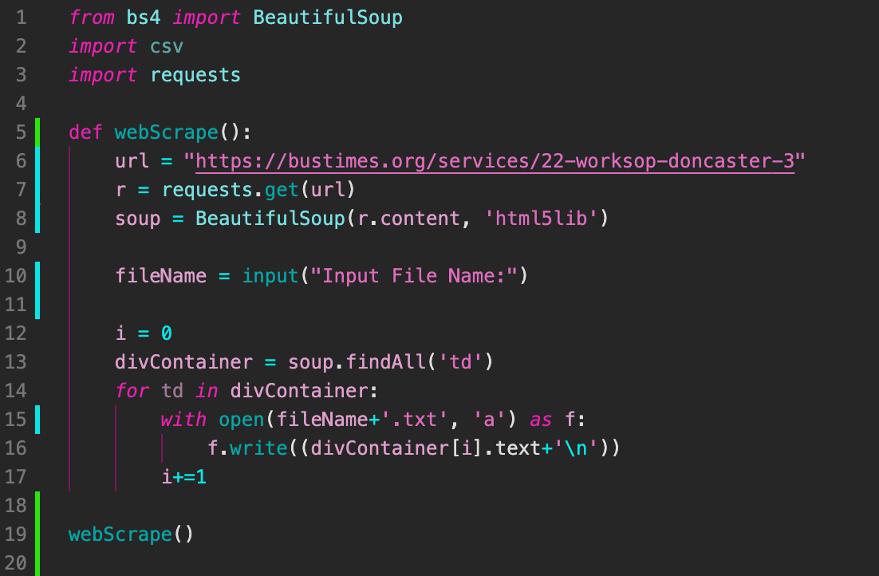

In this code, I had not yet determined a file naming system for the data, so I simply decided to let the user create a new text file to store the data in, later I would go to change this to a naming system that is created automatically based on some user input in the application that followed certain conventions. Once I got this code working and reasonably efficient, I began working on code that would find the dimensions of the given table in order to later format the table correctly.

Formatting the table would rely on 3 key aspects, the table width, height, and total number of values that need to be output. Getting the total amount of values was simple, as I would only need to rely on finding the length of the text file with all the elements in. however, getting the other dimensions for the timetable would prove to be more difficult.

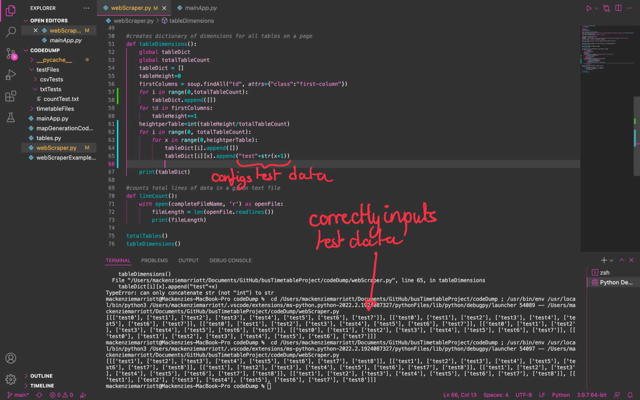

The above screenshot shows how I would go through the list, printing out a value from 0 to the width of the table, for the number of rows in the table, effectively creating a repeating grid in a 2-dimensional array. This took another earlier function into account, which found the total number of tables on the website – though in my later implementation I would find this was not needed. After this, I tried to add the relevant data to a list formatted like a timetable to be able to print out this information in an easy-to-read manner. The output looked like this:

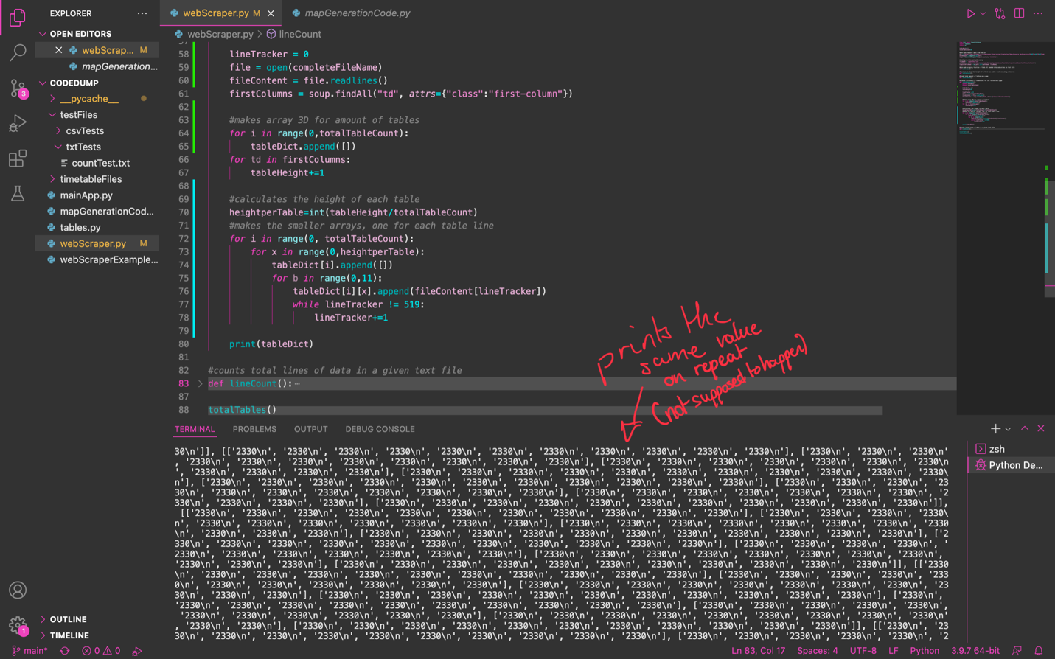

As you can see, though the correct amount of data is shown, the data displayed is almost completely wrong, with it simply repeating the same value throughout, which was not the intent. Eventually I fixed the code up and got the following as my end product:

### The end product

*from* bs4 *import* BeautifulSoup

*import* requests

*import* os

*import* webbrowser

*#table dimensions*

tableDict=[]

totalTableCount=0

widthPerTable=0

totalHeight = 0

heightPerTable = 0

*#array to store dimensions*

dimensionArray=[]

*#length of a given text file with stop time data*

fileLength = 0

*#declarations so values can be used later as globals in other functions*

completeFileName = ""

soup = None

*#main web scraping function - finds all needed data and writes to text file*

def webScrape(*routeURL*, *routeName*):

global completeFileName

global soup

*#gets and requests data from the url*

url = *routeURL*

urlRequest = requests.get(url)

soup = BeautifulSoup(urlRequest.content, 'html5lib')

*#configures file and path naming*

timeFileName = *routeName*+".txt"

dataFileName = *routeName*+"Data.txt"

pathName = (os.getcwd()+'/timetableFiles/txtFiles')

completeFileName = os.path.join(pathName, timeFileName)

*#finds all elements with tag 'td' and writes them into the text file*

tdValue = 0

tdContainer = soup.findAll('td')

openFile=open(completeFileName, 'w')

*# goes through each td in the list and writes each value to a new line on the text file*

*for* td *in* tdContainer:

openFile.write((tdContainer[tdValue].text+'\n'))

tdValue+=1

openFile.close()

totalTables()

tableHeight()

tableWidth()

lineCount()

tableData = [str(widthPerTable)+"\n", str(heightPerTable)+"\n", str(fileLength)]

tableDataFile = (os.path.join(pathName, dataFileName))

openFile = open(tableDataFile, 'w')

openFile.writelines(tableData)

openFile.close()

*#function to find the height of a first bus table - not including notes row*

def tableHeight():

global totalHeight

global heightPerTable

tableHeightContainer = soup.findAll('tr', *attrs*={"class": "table_alt"})

*for* tr *in* tableHeightContainer:

totalHeight+=1

tableHeightContainer = soup.findAll('tr', *attrs*={"class" : "table_alt"})

*for* tr *in* tableHeightContainer:

totalHeight+=1

*#calculates the average height of each table*

firstColumns = soup.findAll("td", *attrs*={"class":"first-column"})

*for* td *in* firstColumns:

heightPerTable+=1

heightPerTable=int(heightPerTable/totalTableCount)

*#counts the total number of columns in each table*

def tableWidth():

global widthPerTable

total=0

firstRow = soup.find("span", *attrs*={"class":"magenta_on"})

*for* i *in* range (1, (len(firstRow)+1)):

total+=1

total+=(totalTableCount)

widthPerTable = total+3

*#finds total amount of tables on a page - not used in end product (not needed)*

def totalTables():

global totalTableCount

totalTableCount = 0

tableCount = soup.findAll("tr", *attrs*={"class":"bodytextbold"})

*for* tr *in* tableCount:

totalTableCount+=1

*#creates dictionary of dimensions for all tables on a page - not used in end product (couldnt get accurate values)*

def fileInput():

global tableDict

global totalTableCount

global heightPerTable

tableDict = []

lineTracker = 0

file = open(completeFileName)

fileContent = file.readlines()

*#makes array 3D for amount of tables*

*for* i *in* range(0,totalTableCount):

tableDict.append([])

*#makes the smaller arrays, one for each table line*

*for* i *in* range(0, totalTableCount):

*for* x *in* range(0,heightPerTable):

tableDict[i].append([])

*for* b *in* range(0,11):

tableDict[i][x].append(fileContent[lineTracker])

*while* lineTracker != fileLength-1:

lineTracker+=1

*break*

*#counts total lines of data in a given text file*

def lineCount():

global fileLength

*with* open(completeFileName, 'r') *as* openFile:

fileLength = len(openFile.readlines())

*#makes empty arrays to function as dimensions for each table - not used in end product*

def tableDimensions():

global dimensionArray

global heightPerTable

*for* i *in* range(0, totalTableCount):

dimensionArray.append([])

dimensionArray[i].append(widthPerTable)

dimensionArray[i].append(heightPerTable)

print(dimensionArray)

*#used instaed of scraping the web to ensure low WIFI usage - this would cut bandwidth as its only accessed if/when needed*

*#table on the website is also extremely difficult to read through - making issues during development and data hard to display*

def cancellations():

*#takes user to website in order to*

webbrowser.open_new("https://www.firstbus.co.uk/doncaster/plan-journey/timetables/journey-cancellations")

'''

#finds out overall data

lineCount()

totalTables()

#calculates dimensions of timetables

tableHeight()

tableWidth()

tableDimensions()

#inputs timetable data to file and 3D array

fileInput()

'''

*#^^functions were called to test - no longer needed to be called, messes with the program when importing module*

'''

webScrape("https://www.firstbus.co.uk/doncaster/plan-journey/timetables/?day=1&source_id=2&service=72%2F72x%2F73%2F73x&routeid=23936179&operator=34&source=sp", "73")

totalTables()

tableWidth()

tableHeight()

'''

*#webScrape("https://www.firstbus.co.uk/doncaster/plan-journey/timetables/?day=1&source_id=2&service=87%2F87a%2F87b&routeid=23936181&operator=34&source=sp", "87")*

*#webScraper was running automatically with 73 route, slowing system down*

*#print(widthPerTable)*

*#print(heightPerTable)*

*#^^ test to show working web scraping*

The code I have above includes all tests commented out towards the end. This code is also implemented with the rest of my code, allowing it to be properly called when needed and storing the information. The main downside here is that not all of the code is needed or used, with some functions being completely inconsequential to the end product.

## phase 4 Distance calculator

### geocoding

In order to calculate the distance between 2 given points, I need to geocode the data. This is as code uses coordinates, rather than street names, in order to calculate distances by placing coordinates on a map and then following the quickest road from the start point to the destination. In order to geocode my data, I used the Nominatim portion of the geopy.geocoders module.

#### research

As I had never done any geocoding in any programming language, my first port of call was to research what exactly geocoding is, and then how to go on and do it in python. For a lot of this research, as well as related research, I used a website called medium. They have a great child website called towards data science, which effectively discusses various principles in data science and how to apply them in real world scenarios.

The specific page I used for my geocoding:

<https://towardsdatascience.com/geocode-with-python-161ec1e62b89>

This page discusses the geopy module and how to use and implement it in order to correctly obtain coordinates from a given position. This site uses the nominatim module as the example as it is built on top of open route services API, which is very commonly used as a free API alternative to similar Google services, whilst still maintaining almost all functionality. The site also goes through plotting various points onto a map or graph, which (while useful if I were to expand the program) I do not need for the base functionality of my program, though this may prove useful in future projects.

#### Implementation

The implementation for geocoding is reasonably simple and uses only 3 built in functions (for what I need).

* Nominatim() – a function which sets the user agent for the nominatim geocoder.
* Geocode() – a function which gets the latitude and longitude coordinates for a given location when passed as a string.
* .latitude and .longitude – functions which specify the latitude or longitude of a given set of coordinates.

As seen below, they are simple to implement and to get the coordinates as individual variables it only takes 3 simple lines of code. Errors only start to appear if the passed location is not found or formatted correctly. This error does come up at a later date as some of the stop names are not formatted in a way which is able to be geocoded by the nominatim geolocation service.

*#specifies which geolocation service to use (nominatim)*

geolocator = Nominatim(*user_agent*="alevel-application")

*#configures starting coordinates*

coords = geolocator.geocode("College Road Doncaster")

coordLat = coords.latitude

coordLong = coords.longitude

*#configures ending coordinates*

endCoords = geolocator.geocode(*endLocation*)

endCoordLat = endCoords.latitude

endCoordLong = endCoords.longitude

The above code specifies the service that I will use (nominatim) in order to geocode. In addition to this, I have to specify the “user agent” – which is effectively a key – that I am using. Then I geocode the coordinates from the school (Doncaster UTC on college road Doncaster) and store the latitude and longitude coordinates in order to be used later in comparison. After this, I geocode a given end location, which is yet again stored for the distance and route to be calculated and displayed.

All of my geocoding code is wrapped in a single function named “coordGet” with a variable passed in that I have referred to as “endLocation” which will be a string passed in representing the location name of the destination (in most cases this will be the target bus stop specified by the user.

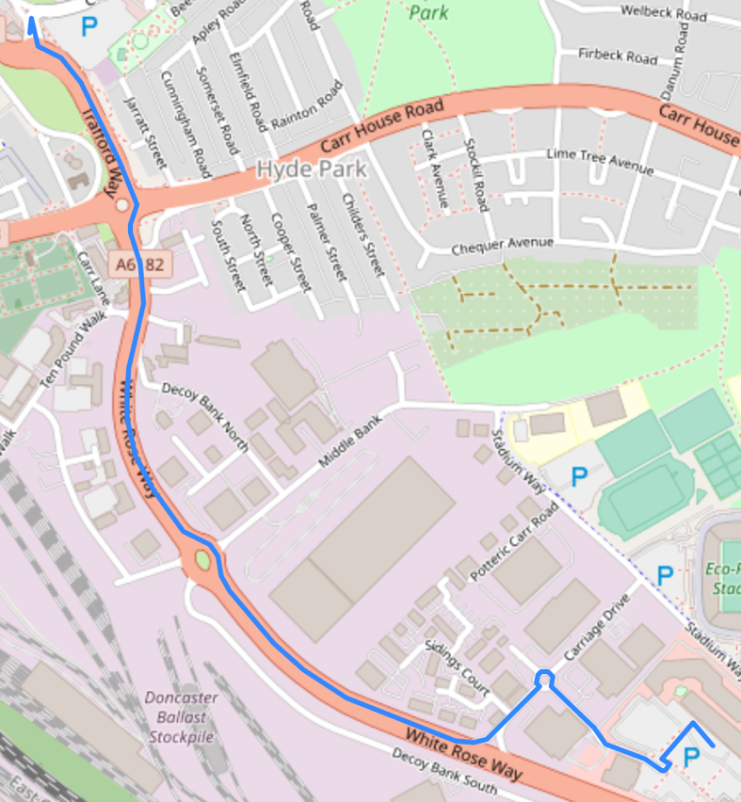

This is what the geocoding is used for and the product it creates when it has run, the coordinates at each end of the blue line are found through inputting data, although the line is drawn and calculated separately using other modules such as open route service and the folium module.

#### full geocoding implementation

*#geocode modules*

*from* geopy.geocoders *import* Nominatim

*#variables to store locational data*

*#starting long/lat*

coordLong = ""

coordLat = ""

*#ending long/lat*

endCoordLong = ""

endCoordLat = ""

*#takes address and converts to latitude and longitude to use in distance calculation*

def coordGet(*endLocation*):

*#starting coord lat/long*

global coordLat

global coordLong

*#ending coord lat/long*

global endCoordLat

global endCoordLong

*#specifies which geolocation service to use (nominatim)*

geolocator = Nominatim(*user_agent*="alevel-application")

*#configures starting coordinates*

coords = geolocator.geocode("College Road Doncaster")

coordLat = coords.latitude

coordLong = coords.longitude

*#configures ending coordinates*

endCoords = geolocator.geocode(*endLocation*)

endCoordLat = endCoords.latitude

endCoordLong = endCoords.longitude

### open route service

Open route service is a free alternative to services such as the google maps suite of APIs – allowing for very similar functionality to what Google offer, whilst also keeping development costs down – though it does have some limitations such as a lack of street view and a less user-familiar map UI, though I believe the functionality of the module and the trade-offs it comes with are worth the benefit in terms of development costs.

#### Research

For my research I used a different page on the “medium” website that I used for the geopy module. Though I used open route service in order to display my map on other screens in my application, here I needed to be able to interact more concisely with the map and save it as some form of file. This site helped massively, showing me how to properly utilise the open route service, as well as being able to save the product of my code in a html file – which I am then able to open in a web browser using the webbrowser module whilst also not needing an internet connection.

<https://medium.com/analytics-vidhya/measure-driving-distance-time-and-plot-routes-between-two-geographical-locations-using-python-39995dfea7e>

In addition to helping me learn more about the open route service module, this site went more in depth in regard to the folium module, which is a graphing module that I later implement in order to overlay the route from the start location to the end location.

#### Implementation

In order to implement my knowledge of the open route service, I also had to work with a python module called folium. Folium is primarily used for graphing purposes yet here I was able to draw a route from two points using data that I retrieved from open route service.

The first step in my implementation was to collect the directional data using the open route service client and save this information in a json file, which I could later read from in order to create the graph showing the user how to get to a given bus stop.

*#sets a list to the corresponding values for coordinates*

coords = ((coordLong, coordLat), (endCoordLong,endCoordLat))

client = openrouteservice.Client(*key*='5b3ce3597851110001cf62488cb4c056c9294a4ba1a5a37393b69413')

This code creates a list which contains the start and end locations longitude and latitude , defines a client key so that the open route service API can be called from.

*#calls from the API*

res = client.directions(coords)

*#tested json response*

*with*(open('test.json','+w')) *as* f:

f.write(json.dumps(res,*indent*=4, *sort_keys*=True))

This code then uses the client to find the directions from the first item in the ‘coords’ list to the last item. Then this is saved into a file called ‘test.json’. The naming of this file was flawed on my end as I wrote this code to test that it would work, then implementing and referring to the file as test.json later on, making it hard to go back and edit all of the references to this file across other python files. This was an oversight on my end yet I decided that my time was better going through and improving the rest of my code in order to get a working product, rather than sticking to naming conventions.

Here I tried using the data, but this was not possible as I needed to encode the information.

*#takes geometry from json, decodes it for use in map*

geometry = client.directions(coords)['routes'][0]['geometry']

decoded = convert.decode_polyline(geometry)

the above code finds the directions of the route, then decodes it into a polyline (a line with multiple points between the first and last) this means that it can then be overlayed onto a map.

m = folium.Map(*location*=[coordLat, coordLong],*zoom_start*=15, *control_scale*=True,*tiles*="openstreetmap")

*#creates and saves map*

folium.GeoJson(decoded).add_to(m)

m.save('map.html')

here is the code used in order to create the map to a bus stop in folium. The first section creates the settings for the folium map. This includes the starting coordinates (Doncaster UTC), the scaling of the map, where the map tiles are brought from, and then how zoomed in the map is. Through trial and error I found a zoom of 15 worked well.

The second portion of the above code (below the comment) adds the decoded locational data to a variable called “m”. “m” is then saved to a file called ‘map.html’ which is later used when bringing up the map to a given bus stop.

'''

coordGet("Thorne Road Doncaster")

routing()

^^order and example of how to run functions

'''

The above is an example of how to correctly call the functions, using thorne road Doncaster as an example location, getting these coordinates, then routing the coordinates afterwards. Calling in the incorrect order could lead to the wrong map being produced. The main problem with this code is that not all of the scraped locations are going to be recognisable strings. As well as this, there are some formatting issues on some timetables meaning that sometimes the first value in a table will not be a location, which is a problem when trying to find a specific location of a stop.

#### full mapping implementation

*#configures routing so that distance/time data can be taken*

def routing():

*#starting point coords*

global coordLong

global coordLat

*#end point coords*

global endCoordLat

global endCoordLong

*#sets a list to the corresponding values for coordinates*

coords = ((coordLong, coordLat), (endCoordLong,endCoordLat))

client = openrouteservice.Client(*key*='5b3ce3597851110001cf62488cb4c056c9294a4ba1a5a37393b69413')

*#calls from the API*

res = client.directions(coords)

*#tested json response*

*with*(open('test.json','+w')) *as* f:

f.write(json.dumps(res,*indent*=4, *sort_keys*=True))

*#takes geometry from json, decodes it for use in map*

geometry = client.directions(coords)['routes'][0]['geometry']

decoded = convert.decode_polyline(geometry)

*#configures map settings*

m = folium.Map(*location*=[coordLat, coordLong],*zoom_start*=15, *control_scale*=True,*tiles*="openstreetmap")

*#creates and saves map*

folium.GeoJson(decoded).add_to(m)

m.save('map.html')

## phase 5 – timetabling

### method planning

The base premise for my code here would be that I would use a “treeview” table, which is a simplistic way of creating tables that you can input into a tkinter window and that have a variety of functions built in. One of these functions that I would be using is the “OnDoubleClick” function, which let me execute certain functions when items in a given table were double clicked. From here I would in theory be able to go through the table element by element and add the corresponding data to the table.

#### learning how to create a treeview table

*from* tkinter *import* *

*from* tkinter *import* ttk

def createTable(*xPosition*, *yPosition*):

*#creates a frame that fills the screen to hold the table*

tableFrame = Frame()

tableFrame.place(*relx*=*xPosition*, *rely*=*yPosition*, *anchor*=CENTER)

myTable = ttk.Treeview(tableFrame)

*#creates list of columns*

myTable['columns'] = ('1', '2')

*#creates columns*

myTable.column("#0", *width*=0, *stretch*=NO)

myTable.column("1", *width*=400, *anchor*=CENTER)

myTable.column("2", *width*=400, *anchor*=CENTER)

*#creates headings*

myTable.heading("#0", *text*="")

myTable.heading("#1", *text*="odd numbers")

myTable.heading("#2", *text*="even numbers")

*#adds contents row by row on a loop*

i = 0

*while* i != 10:

i=i+1

*if* i/2==0:

i=i+1

*else*:

myTable.insert(*parent*='', *index*='end', *iid*=i, *text*="", *values*=(i, i+1))

i=i+1

myTable.pack()

This code is how I learnt how to make treeview tables in tkinter. It can be broken down into a few key sections:

*from* tkinter *import* *

*from* tkinter *import* ttk

These are the required modules for this functionality – tkinter, and a module within that called ttk, which is where all functions necessary for the creation of treeview tables is. Nothing actually functional happens in this section of the code.

def createTable(*xPosition*, *yPosition*):

*#creates a frame that fills the screen to hold the table*

tableFrame = Frame()

tableFrame.place(*relx*=*xPosition*, *rely*=*yPosition*, *anchor*=CENTER)

myTable = ttk.Treeview(tableFrame)

This portion of the code creates a frame to hold the treeview table, taking the x and y position of the frame as arguments in a function and then placing the frame in that place on the screen. The last above line then defines an example table called “myTable” as a ttk.Treeview table situated on “tableFrame” – the frame that was defined just above.

*#creates list of columns*

myTable['columns'] = ('1', '2')

*#creates columns*

myTable.column("#0", *width*=0, *stretch*=NO)

myTable.column("1", *width*=400, *anchor*=CENTER)

myTable.column("2", *width*=400, *anchor*=CENTER)

Here I am creating a tuple to store columns, this would later be an issue as I would need to create tables of varying sizes, and tuples are fixed but here it works. I created 2 columns (in addition to the default column “0”), then defining the anchor point and width of each. As I was not going to use column 0 I set its width to 0 so that only columns 1 and 2 would be displayed.

*#creates headings*

myTable.heading("#0", *text*="")

myTable.heading("#1", *text*="odd numbers")

myTable.heading("#2", *text*="even numbers")

Here is where I create headings for the top of each column, the headings here are “odd numbers” and “even numbers” respectively, as for the test that is all I was going to display. The parameters passed here are simply the column that you want to create the header for, then the text that you want to put into the column.

*#adds contents row by row on a loop*

i = 0

*while* i != 10:

i=i+1

*if* i/2==0:

i=i+1

*else*:

myTable.insert(*parent*='', *index*='end', *iid*=i, *text*="", *values*=(i, i+1))

i=i+1

myTable.pack()

This is the last portion of my code. Here until line 8 I am simply adding to the value “I”. after this, I then input the values of I and i+1 into each row, I do this when I is an odd value, meaning that each number is only displayed once. On the last line, I “pack” the table, meaning that it puts it within the frame.

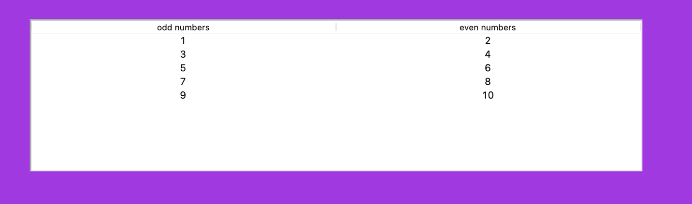

This is the end result of my example code placed on a plain purple background. As you can see the headings are correct and so are the values within the table.

### implementation

In my implementation of the treeview code I learnt, there were two instances of tables needing to be created. One of these was significantly easier than the other. The first instance that I chose to implement was the table which held the route names and numbers, which would be displayed on both the main page and the routes page.

#### routes table

def generateTable(*pageName*):

routeList = open('routeList.txt', 'r')

content=routeList.readlines()

tableFrame = Frame(*pageName*)

tableFrame.config(*height*=tableHeight, *width*=tableWidth)

tableFrame.place(*relx*=tableX, *rely*=tableY, *anchor*=CENTER)

timetable = ttk.Treeview(tableFrame)

timetable['columns']= ('1', '2')

timetable.column("#0", *width*=0, *stretch*=NO)

timetable.column("1", *width*=100, *anchor*=CENTER)

timetable.column("2", *width*=600, *anchor*=W)

timetable.heading("#0", *text*="")

timetable.heading("#1", *text*="route number")

timetable.heading("#2", *text*="route name")

def OnDoubleClick(*self*):

global selectedRoute

selectedItem = timetable.focus()

selectedRoute = timetable.item(selectedItem, "values")[0]

routeScreen.routeNumber=selectedRoute

*pageName*.destroy()

routeScreen.__main__()

timetable.bind("<Double-1>", OnDoubleClick)

i=0

*while* i<(len(content)-1) and i<20:

timetable.insert(*parent*='', *index*='end', *iid*=i+1, *text*="", *values*=(content[i], content[i+1]))

i+=2

timetable.pack()

The above code is all of the code I used in order to generate the table with the list of routes on it.

routeList = open('routeList.txt', 'r')

content=routeList.readlines()

this section is where I opened and read all lines from the text file which contains all of my routes and their corresponding numbers line by line, number then route name and stored this as the variable “content”. The next section after this is similar to the code I wrote when learning about treeview tables, I first created a frame to place the table. Then I created each column, defined its settings, and created the headings for the columns. From here on, my code began to differ substantially.

def OnDoubleClick(*self*):

global selectedRoute

selectedItem = timetable.focus()

selectedRoute = timetable.item(selectedItem, "values")[0]

routeScreen.routeNumber=selectedRoute

*pageName*.destroy()

routeScreen.__main__()

This is the function I call which enables me to execute code when elements in the timetable are double clicked. First off, I bring in the global variable ‘selectedRoute’ as I need to use this in other functions yet change the value here. I then check which item in the table is in focus using .focus(). From here, I set the selected route to the 0th value of the selected row using parameters in the .item() function. After this I set the route number in the routeScreen.py file to the selecte route number, then destroying the current page, and opening the route screen.

timetable.bind("<Double-1>", OnDoubleClick)

This code then binds the OnDoubleClick() function to double clicking the table.

i=0

*while* i<(len(content)-1) and i<20:

timetable.insert(*parent*='', *index*='end', *iid*=i+1, *text*="", *values*=(content[i], content[i+1]))

i+=2

timetable.pack()

This code follows a similar premise to displaying odd and even numbers, except instead of odd numbers, I am displaying the route number, and instead of even numbers, the route name. I display the 10 most recent routes, though I could modify this code so that all routes are displayed, which in hindsight would’ve been more useful for the user.

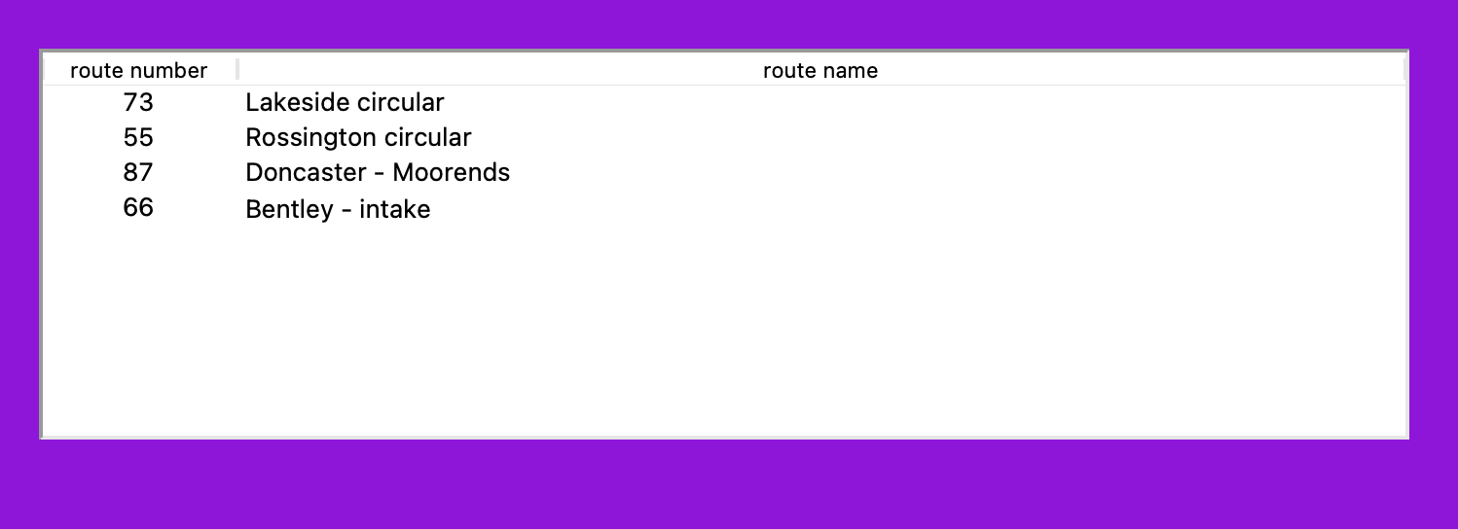

Here is the end result of the route table code, it displays each routes number and its name correctly, also allowing you to double click the route and be taken to the corresponding page. For example, if you double click the first item in the list, it opens the following page:

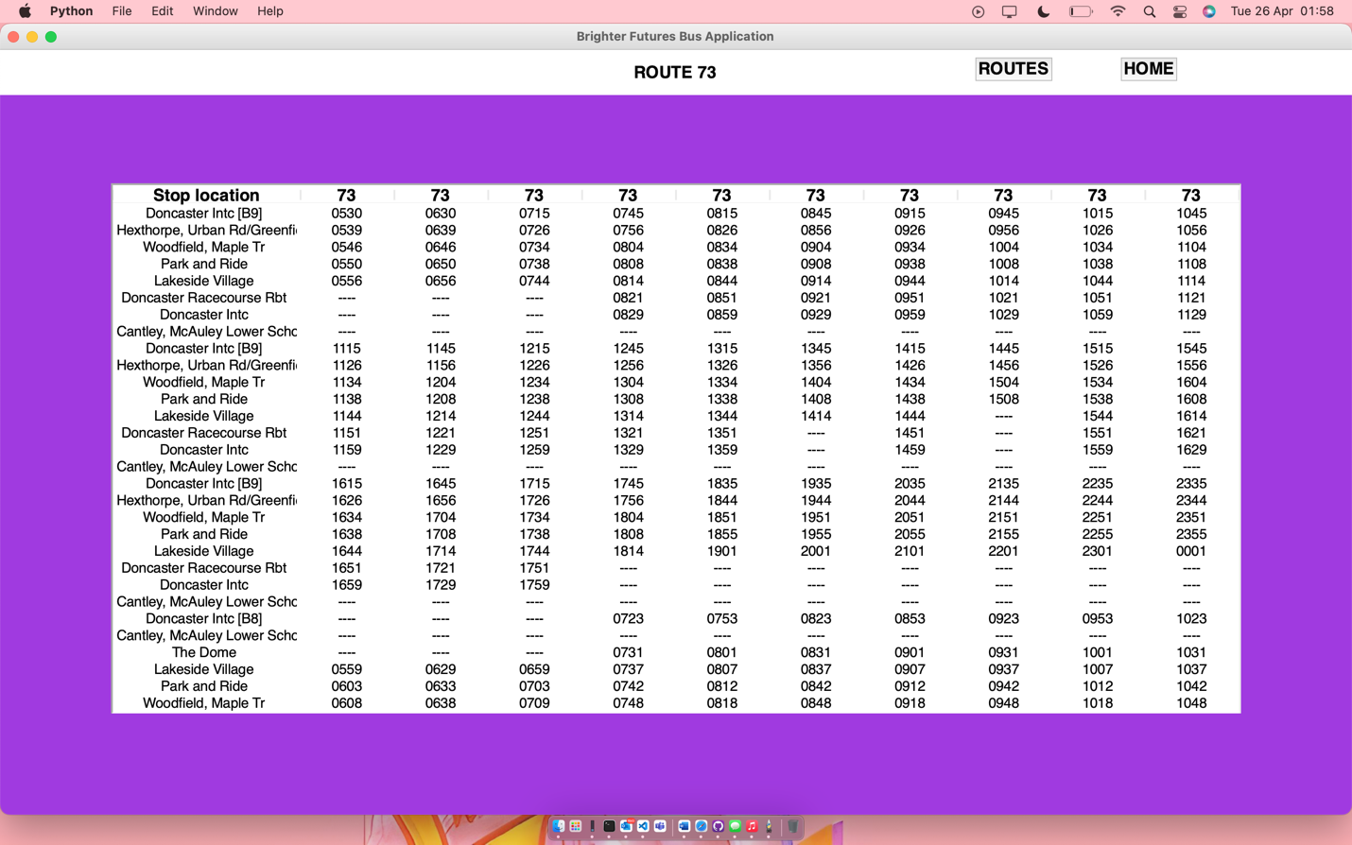

As I had already learnt about treeview tables in tkinter, the implementation here was simple, all I had to do extra was call other functions to open new pages, and read data from an external file.

#### The timetables

The timetables were so much more difficult to create than my route tables, this was due to the variation of them in size and the quantity of data being input. I had to create an algorithm capable of inputting all forms of data into a table the correct size, and have this size and data be modular so that it would for as many different routes as possible.



Eventually, this is the result of my code using the 73 bus route as an example.

*#configuring style for table contents*

tableContentsStyle = ttk.Style()

tableContentsStyle.configure("myStyle.Treeview", *font*='Helvetica 15')

*#configuring style for headings on tables*

tableStyle = ttk.Style()

tableStyle.configure("Treeview.Heading", *font*='Helvetica 18 bold')

This is the code I used in order to style my treeview tables, here I create a ttk ‘style’ which is then applied to various aspects of the treeview table. The first style configures the base for all of the text in the treeview table. The second style then configures for just the treeview headings. To fit the rest of my project, I went with size 15 Helvetica for the main data, with size 18, bold Helvetica for the headings. As you can see in the final image, this worked out well, with the headings being bold, and the table data being slightly smaller and regular.

tableContentsFileName = routeNumber

tableDataFileName = routeNumber

tableContentsFileName = re.findall(r'\d+', tableContentsFileName)

tableContentsFileName = (tableContentsFileName[0]+'.txt')

pathName = (os.getcwd()+'/timetableFiles/txtFiles')

completeFileName = os.path.join(pathName, tableContentsFileName)

tableFile = open(completeFileName, 'r')

tableInput = tableFile.readlines()

tableDataFileName = re.findall(r'\d+', tableDataFileName)

tableDataFileName = tableDataFileName[0]+'Data.txt'

tableDataFile=(os.path.join(pathName, tableDataFileName))

tableData = open(tableDataFile, 'r')

tableDataContents = tableData.readlines()

This code is then where I open the files responsible for the storage of table data and table contents. I went with a data storage model which would store the contents of each table separately from the timetable data such as the width, height, and amount of items in the table. In order to make this suitable for all operating systems, I use os.getcwd() in order to find the path, then joining it using os.path.join(). However, I have not been able to test this on a windows machine, only on a macOS machine. I store the text files using the naming convention that there will be a route number, then .txt for content, and Data.txt for the table data. After opening each file, I then read them, storing all of the necessary information in the variables ‘tableInput’ (for the table content) and ‘tableDataContents’ for the table data.

'''

print(tableData.readlines())

^^testing file output

'''

This is code I used to test out the table data readings, it consistently and reliably printed the correct timetable data for every table that I tested.

Here is where I ran into my aforementioned issue with columns being defined as a tuple. In order to get around this, I wrote the following code:

columns = []

*for* i *in* range (1, int(tableDataContents[1])+1):

columns.append(str(i))

timetable = ttk.Treeview(tableFrame, *style*="myStyle.Treeview", *height*=30)

timetable['columns']=columns

This code creates a list called columns and adds a number to the list for every number from 1 to the number of columns necessary as a string. Then when setting the timetable columns, I simply make the value of timetable[‘columns’] equal to the “columns” list. This means that I can produce timetables of varying width successfully. This was an issue that I originally thought would take a long time to solve, yet when it came to actually coding a fix, it didn’t take long at all, and the solution was very simple.

timetable.column("1", *width*=200, *anchor*=CENTER)

*for* i *in* range (2, int(tableDataContents[1])+1):

timetable.column(str(i), *width* = 100, *anchor*=CENTER)

In order to make my code more efficient, this is how I defined the settings for each of the columns, by looping through the number of columns there were, then defining the settings of each column in the loop using I converted to a string, rather than having to write out the definitions of an (in theory) infinite number of columns just in case a certain amount was needed. This means that each column will be the same size, regardless of the data that’s in it. The first column however is larger, as this is where the location name (and the longest piece of data) is stored.

timetable.heading("#1", *text*="Stop location")

*for* i *in* range (2, int(tableDataContents[1])+1):

timetable.heading("#"+str(i), *text*=routeNumber)

I used a similar premise here, except instead of column size, I had to define the column headings, with the first saying stop location, and each column afterwards having the heading name be the route number.

i=0

c=0

fileLength = tableDataContents

*#while loop in that inputs timetable data to the table*

*while* i < int(re.findall(r'\d+', fileLength[2])[0]):

b=0

tableDataList = []

*while* b < int(re.findall(r'\d+', tableDataContents[1])[0]):

*if* i==0:

tableDataList.append(tableInput[b+i])

*elif* b+i+int(re.findall(r'\d+', tableDataContents[1])[0]) <int(re.findall(r'\d+', tableDataContents[2])[0]):

tableDataList.append(tableInput[c+int(re.findall(r'\d+', tableDataContents[1])[0])])

c+=1

print(tableDataList)

b+=1

*#writes data to the file*

timetable.insert(*parent*='', *index*='end', *iid*=i, *text*="", *values*=tableDataList)

print(i)

print(re.findall(r'\d+', tableDataContents[1]))

i = i+int(re.findall(r'\d+', tableDataContents[1])[0])+1

def OnDoubleClick(*self*):

global routeNumber

selectedItem = timetable.focus()

selectedStop = timetable.item(selectedItem, "values")[0]

distanceCalculator.coordGet(selectedStop+" Doncaster")

distanceCalculator.routing()

fileName = 'file:///'+os.getcwd()+'/'+'map.html'

webbrowser.open_new_tab(fileName)

timetable.bind("<Double-1>", OnDoubleClick)

tableData.close()

tableFile.close()

timetable.pack()

The above code completely formats and inputs data into the timetable, this can be broken up into 2 key sections, the actual timetable data being added, and the double click function for the timetable.

Beginning with the double click function, writing this was very similar to the double click function for the routes table, yet here instead of opening a new page, I was opening a file in a web browser.

def OnDoubleClick(*self*):

global routeNumber

selectedItem = timetable.focus()

selectedStop = timetable.item(selectedItem, "values")[0]

distanceCalculator.coordGet(selectedStop+" Doncaster")

distanceCalculator.routing()

fileName = 'file:///'+os.getcwd()+'/'+'map.html'

webbrowser.open_new_tab(fileName)

This is the code which enables the double click functionality, it takes the selected item, then gets the coordinates and plots a route using the coordGet() and routing() functions from the distanceCalculator.py file. After this, I join file:/// (the beginning of file URLs) to the current working directory, + map.html (the name of the file). On the final line, I use the webbrowser module to open a new tab, with the contents of the tab being the map.html file with the path being stored as fileName. When bound, this double click opens the corresponding route as follows:



i=0

c=0

fileLength = tableDataContents

*#while loop in that inputs timetable data to the table*

*while* i < int(re.findall(r'\d+', fileLength[2])[0]):

b=0

tableDataList = []

*while* b < int(re.findall(r'\d+', tableDataContents[1])[0]):

*if* i==0:

tableDataList.append(tableInput[b+i])

*elif* b+i+int(re.findall(r'\d+', tableDataContents[1])[0]) <int(re.findall(r'\d+', tableDataContents[2])[0]):

tableDataList.append(tableInput[c+int(re.findall(r'\d+', tableDataContents[1])[0])])

c+=1

print(tableDataList)

b+=1

Here is a loop which goes through each item in the list of all necessary data. From here it then adds it all to a list to be later input into the timetable.

*#while loop in that inputs timetable data to the table*

*while* i < int(re.findall(r'\d+', fileLength[2])[0]):

b=0

tableDataList = []

This portion of the loop goes through while I is less than the total number of items in the timetable, setting the value of b to 0 and clearing the tableDataList list.

*while* b < int(re.findall(r'\d+', tableDataContents[1])[0]):

*if* i==0:

tableDataList.append(tableInput[b+i])

This then goes through for the width of the table, then if it is the very first value, inputting the first piece of table input data from the variable tableInput.

*elif* b+i+int(re.findall(r'\d+', tableDataContents[1])[0]) <int(re.findall(r'\d+', tableDataContents[2])[0]):

tableDataList.append(tableInput[c+int(re.findall(r'\d+', tableDataContents[1])[0])])

this loop is run if it is not the first value, this is as if it is not the first, I have to take the current location, then add the width of the table, in order to add the correct items to the list, this is repeated until the width of the table is reached.

timetable.insert(*parent*='', *index*='end', *iid*=i, *text*="", *values*=tableDataList)

i = i+int(re.findall(r'\d+', tableDataContents[1])[0])+1

Here I insert the table data list into the first row, then adding the width of the table to ‘I’, meaning it will then begin looping from the correct position. This process as a whole keeps repeating until the end of the data is reached meaning all values are input into the table.

#### errors

Whilst creating my algorithm for the timetable, I ran into numerous formatting errors, as well as data entry errors.

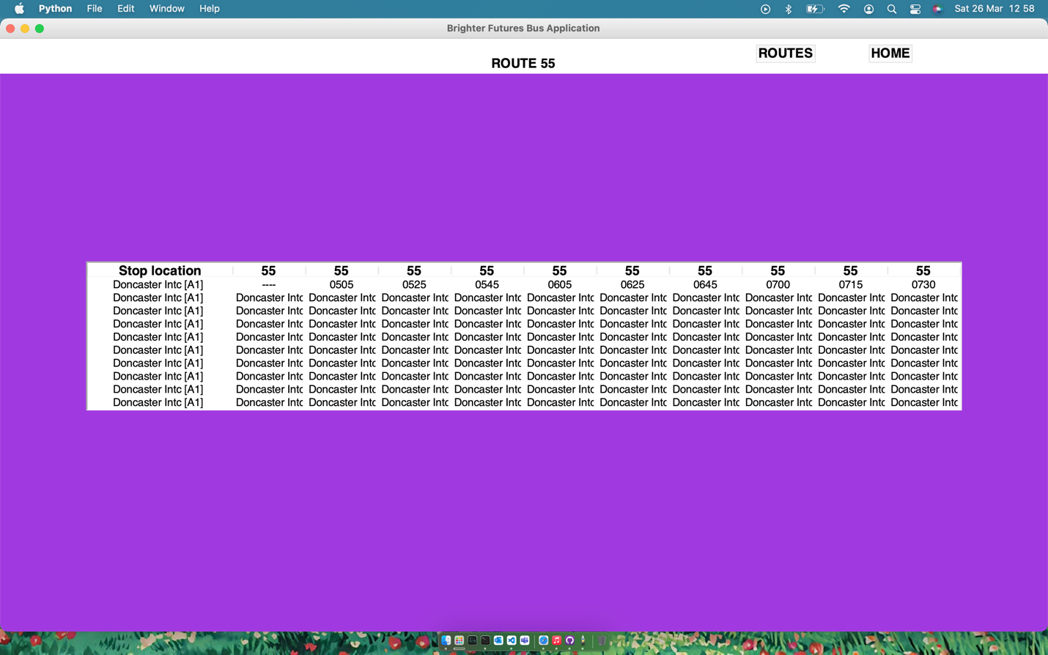

For example, here the first row would work perfectly fine, but then every row afterwards would only display the first stop name.

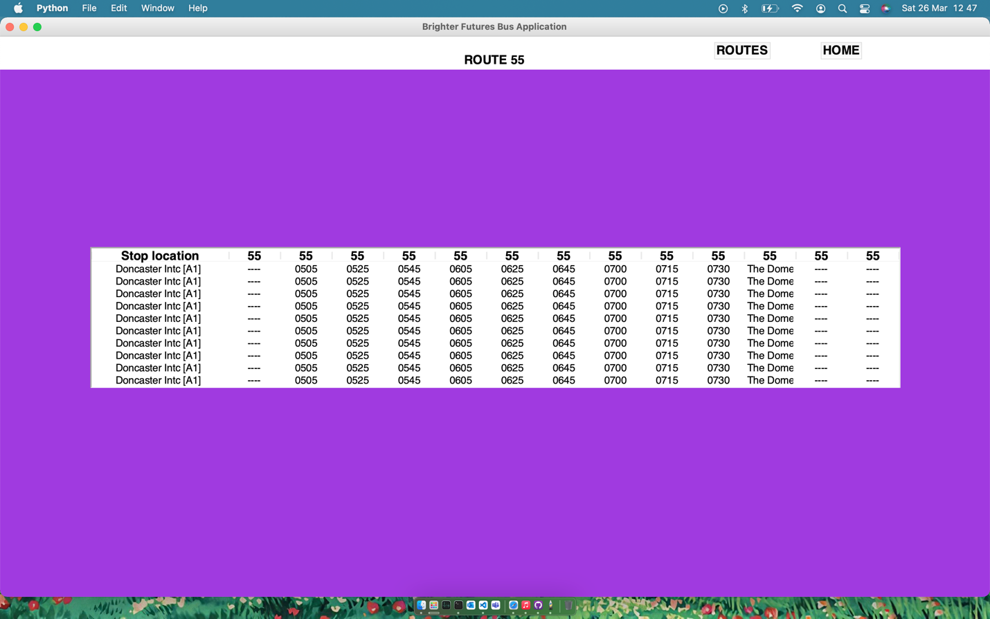

Here I ran into a similar problem, the correct number of values was being added to the table, yet it was just the same row again and again.

#prints the first row - 0 issues

if i == 0:

for b in range(i, int(re.findall(r'\d+', tableDataContents[1])[0])+i):

if b < int(re.findall(r'\d+', fileLength[2])[0]):

tableDataList.append(tableInput[b])

print(tableDataList)

else:

for b in range(i, int(re.findall(r'\d+', tableDataContents[1])[0])+i):

if b < int(re.findall(r'\d+', fileLength[2])[0]):

c+=1

for d in range (0, int(re.findall(r'\d+', tableDataContents[1])[0])):

tableDataList.append(tableInput[d+c])

print(tableDataList)

This is the code responsible for printing the same row again and again. I tried repeatedly to fix this code, yet in the end decided to start the algorithm from scratch in order to get a fresh perspective and look on the problem. Eventually, the code was fully working, producing the timetable with very minimal errors. Sometimes however, I would run into an issue where the data was incorrectly scraped, meaning the timetable width would be off. I also have an issue where some timetables have extra data added, meaning time values are shifted across by a given amount every so often.

#### the result of additional data being added to the table

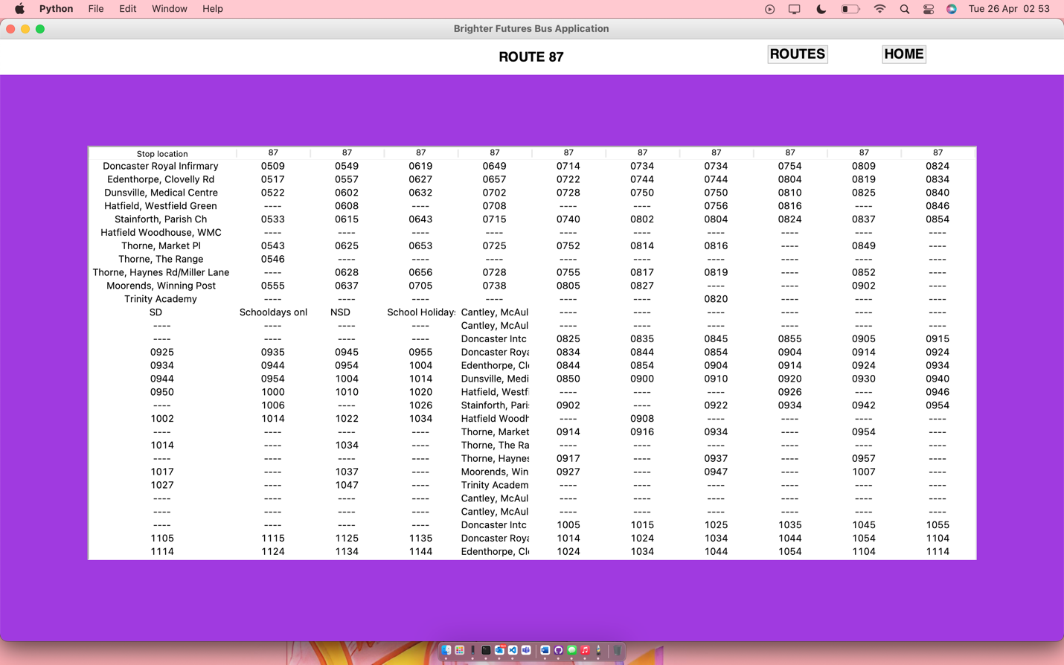

#### the result of incorrect web scraping

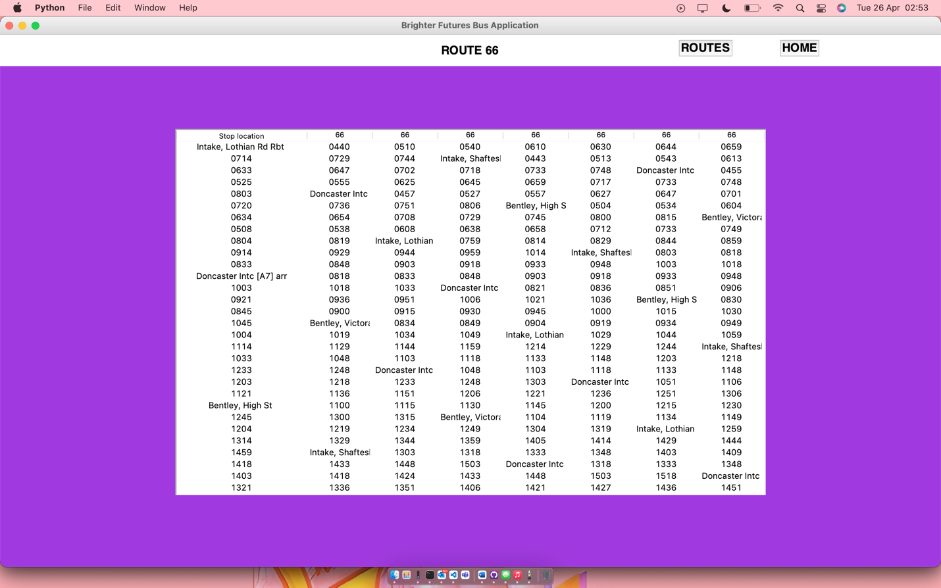

Though these issues are fixable, I did not find them until near the end of my development, and they would have needed an almost completely redesigned system for the web scraper, as it would need to filter out irrelevant data, as well as checking that data is clean 100% of the time.

#### Solved issues

Unfortunately, there is one large glitch in my code, this is to do with the displaying of maps using the tkinter map view. The map does not correctly generate after the individual timetable pages are closed, then the main page is reopened. This is as the timetable pages do not close correctly, meaning that (although the frame generates on the right location) the tiles aren’t placed correctly, meaning the map is completely blank.

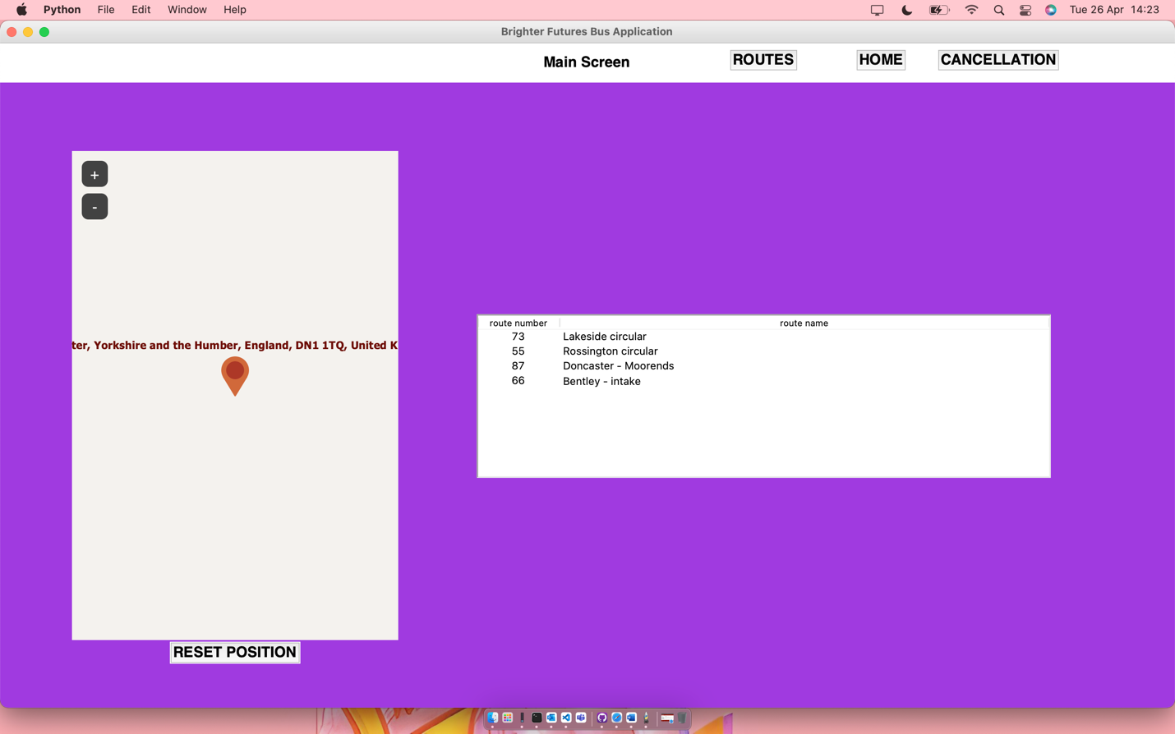

I originally tried to fix this issue with the following code (which is supposed to close the timetable windows). However, this was to no avail as despite this the windows still do not close, likely due to trying to close one or multiple windows with page names which are not necessarily named correctly in the defined variable.

homeButton=tkinter.Button(*pageName*, *text*="HOME", *background*="yellow", *activebackground*="#9b870c", *font*=myFont, *command*=lambda:[mainApp.__main__(), *pageName*.destroy()]).place(*relx*=0.85, *rely*=0.025, *anchor*=CENTER)

routesButton=tkinter.Button(*pageName*, *text*="ROUTES", *background*="yellow", *activebackground*="#9b870c", *font*=myFont, *command*=lambda:[routes.routesPage(), *pageName*.destroy()]).place(*relx*=0.75, *rely*=0.025, *anchor*=CENTER)

The above code generates the two buttons which are situated on the header, although they have the pageName.destroy() code as the linked command, similarly to other pages which have these commands.

Upon more thought and closer inspection, I believed it to be a logical error, and when comparing the commands above, I noticed they were slightly different to the header commands on the earlier made configuration file. Within this configuration file, I noticed that the command to destroy a page was called before generating the new page, yet in my route code, this was not the case. I was calling to destroy the page after generating the new page, which caused tkinter to try and destroy a page which did not exist and generate elements on two pages at once, which is not possible.

homeButton=tkinter.Button(*pageName*, *text*="HOME", *background*="yellow", *activebackground*="#9b870c", *font*=myFont, *command*=lambda:[*pageName*.destroy(), mainApp.__main__()]).place(*relx*=0.85, *rely*=0.025, *anchor*=CENTER)

routesButton=tkinter.Button(*pageName*, *text*="ROUTES", *background*="yellow", *activebackground*="#9b870c", *font*=myFont, *command*=lambda:[*pageName*.destroy(), routes.routesPage()]).place(*relx*=0.75, *rely*=0.025, *anchor*=CENTER)

After changing the code to what is shown above, my maps began generating correctly and the pages were also closing correctly, proving it to be a logical error, which is now fixed, making the code much more usable. As a result of me changing this code, the page now generates properly as shown below:

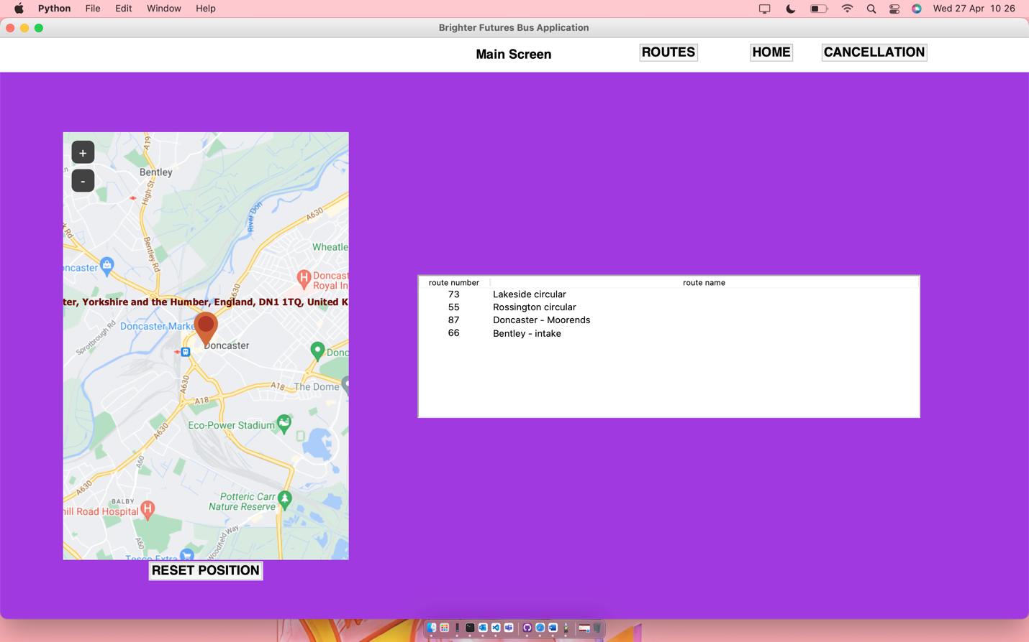

The above screenshot was taken after closing a timetable window, proving that the code works as originally intended, despite running into a large issue in development.

### Client feedback

Although the client would have preferred a product which managed to consistently display timetables for the user, regardless of the source, the client has accepted the limitations of development given the resources and timescale available to me as a developer. The client did however make one comment, they wanted to see the product be able to work for the other major bus company in the Doncaster area, stagecoach. Whilst I would have liked to accommodate this, it meant that I would have to build another web scraper, specifically for stagecoach busses, which I do not have the time for this late in development. Though this is unfortunate, it gives my product the potential to grow over time post development and gives me the hindsight which I can use in future projects to anticipate client needs and how I should develop my products accordingly.

## Phase 6 – map display

### research

I looked into multiple options when it came to displaying my map in my application. The first thing that I thought was to have a button to bring up a map in an external window such as a still image or a web browser. However, I did some research and found a tkinter module called tkintermapview, which allows users to add interactive maps onto tkinter windows, customising the aspects of them and allowing users to modify maps as they need with a variety of map sources available. I found this module when searching to see if there was a way of coding a map onto a tkinter window, which lead me to the following github page:

<https://github.com/TomSchimansky/TkinterMapView>

This github page is the creator of the module, it is extremely well written and has multiple examples of the functionality of the code, how to implement it into your project, and the result of this implementation. This allows me to become much more familiar with the code as a whole and letting me write up code that works for exactly what I need it to do.

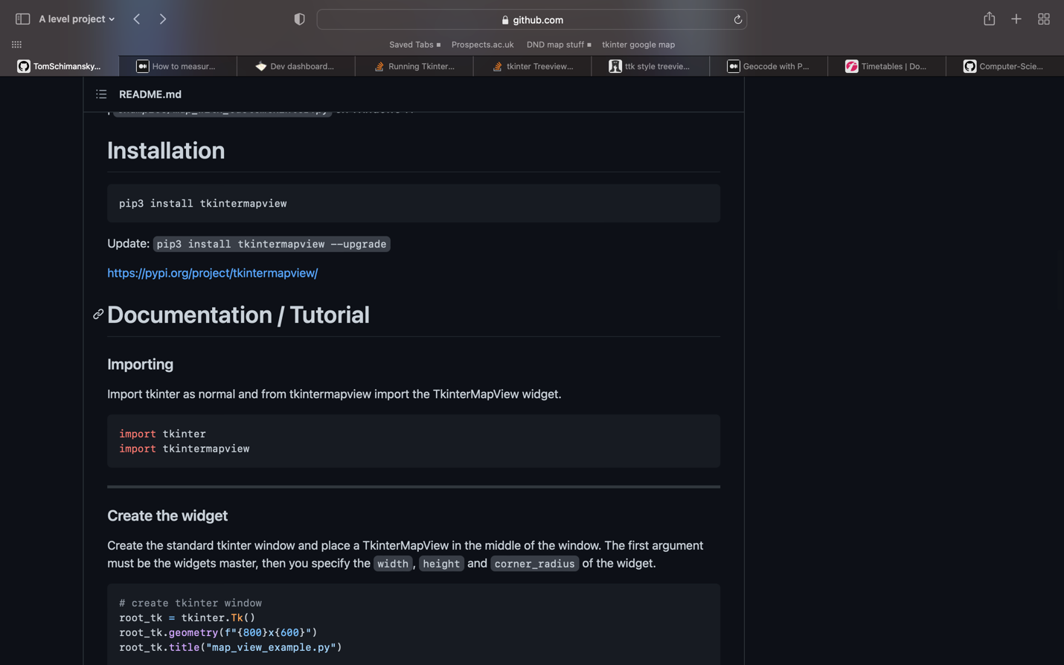

As seen above, the documentation runs through every aspect of the module, including its installation and how to import the module.

### Implementation

With my code, I decided to create a new file, with functions inside to create and define each aspect of my map, which would allow me to reuse the code across multiple files if needed. My code is comprised of 2 key functions, a function to define the parameters of the map such as size, and another function to generate the map, and set its sources.

*#configures settings for map height, width, and displayed location*

def mapSettings(*width*, *height*, *location*):

global windowWidth

global windowHeight

global Location

windowWidth = *width*

windowHeight = *height*

Location = *location*

This is the code which defines the settings of the map, including the location shown, map height, and map width. It sets these parameters as global variables, meaning that I can then refer to them in the generation function, whilst being able to define them separately.

The function takes 3 parameters, width, height, and location. Width and height are numerical values, such as standard tkinter widths and heights, meaning I can scale the window appropriately in comparison to my existing tkinter windows. Location however is a string which is taken to find the starting and marked location on the map when it is generated.

*#generates the actual map selecting source, location, and places the map*

def generate(*pageName*):

map_widget = TkinterMapView(*pageName*, *width*=windowWidth, *height*=windowHeight, *corner_radius*=0)

map_widget.set_tile_server("https://mt0.google.com/vt/lyrs=m&hl=en&x={x}&y={y}&z={z}&s=Ga", *max_zoom*=22) *# google normal*

map_widget.set_address(Location, *marker*=True)

map_widget.place(*relx*=0.2, *rely*=0.53, *anchor*=tkinter.CENTER)

This function generates the map, taking only one parameter, pageName, which is taken as a tkinter page when the function is called, and defines which tkinter page the map will be generated on. My map is defined as map_widget, which is created using the pageName parameter, I then set the width and height of the map to the previously set global variables from the previous function. After this, I set the tile server for the map widget, this is where my map draws its data from as a series of image tiles. I have used google here as (although I could have used open street view again) it is the map system which most people are familiar with. I have made a note of this as a comment next to the line of code. After this I have set the address (the starting and marked location of the map) to the previously defined global variable ‘Location’. Then I place the map in the position which I feel works the best with the rest of my UI, anchoring it at the center.

*#calls both necessary functions to place the map onto the main screen*

mapGenerationCode.mapSettings(400, 600, "doncaster")

mapGenerationCode.generate(mainScreen)

This is the code I have written in my UI script which sets and calls the map and produces the following outcome:

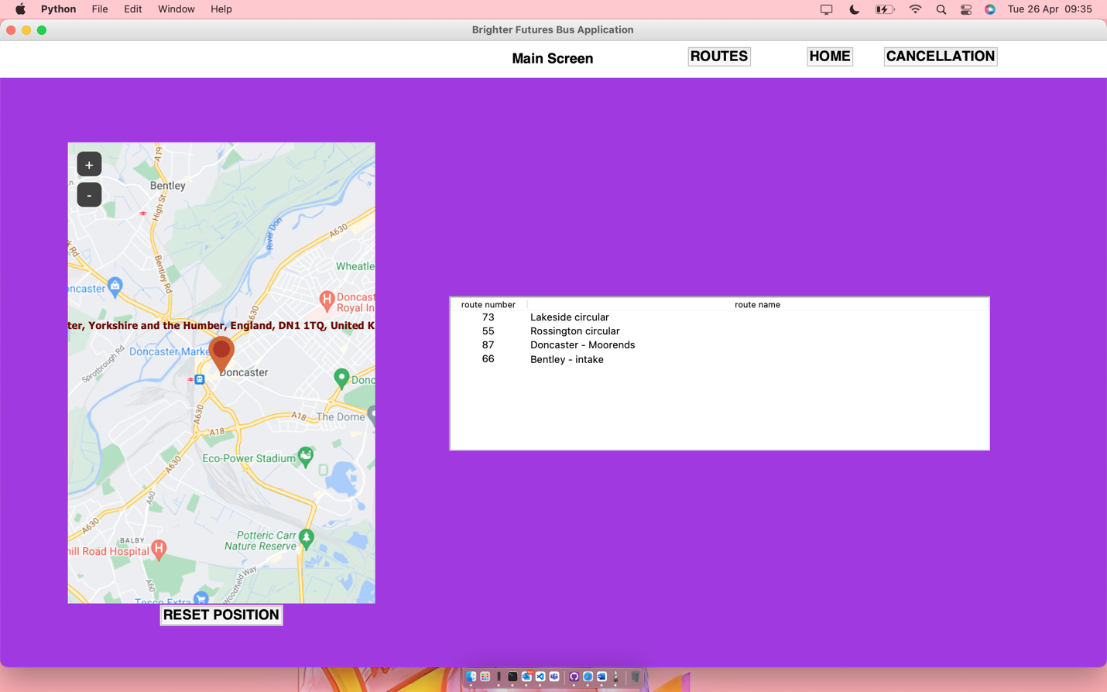

### Client feedback

The client has accepted what I have developed as a working solution for the map, with the reset position element being an added extra which was not originally planned in development and was there only for test purposes. However, we found that it was helpful for the user if they got lost whilst searching for another area, this function allows the users to easily regather their bearings in a location familiar to them.

Though they are happy with the solution as is, they wish for a yellow border to be added around the map and reset button to make these aspects seem framed as to fit the page better. I have gone back and added this feature in in order to accommodate what the client wants as it is a quick and simple fix which will not hinder any other aspects of my project.

Through adding the following code:

*#creates a border for the map*

borderLabel = tkinter.Label(mainScreen, *bg* = "yellow", *width*=45, *height*=40).place(*relx*=0.2, *rely*=0.55, *anchor*=CENTER)

I have created a border which contains both the map and the reset button and looks as follows:

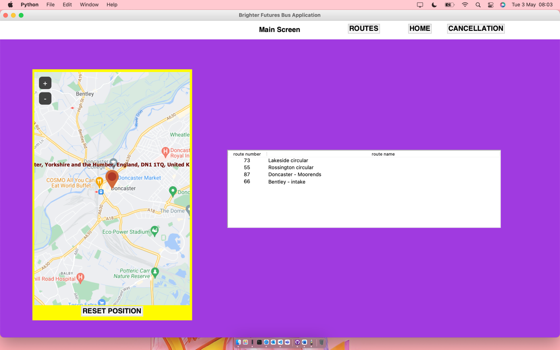

The client has deemed this as acceptable and has accepted this phase of the product.

## Validation

### Where do i use validation:

Throughout my project, I use validation in order to check that the data input to the system is both present and correct. Where possible I ensure that there is all of the necessary data input where needed before carrying out the corresponding function. Although I use validation however, to a degree the user has to also understand the program and use it correctly as some errors may still occur. I use validation for the following 3 things:

* The login system
* The new route system

### The login system

In my login system I use validation regularly. The first step is to ensure that when the user has pressed the login button, there is something in the text fields. If there is not the program should not progress past the login screen and the user should be made aware as to why. After data has been put in both boxes, I have to check the username that has been input against the dictionary containing the encrypted usernames and passwords. Assuming the username is correct, then I must check to see that the password they have input is both correct and corresponds to the username in the input field. Only when all of the above criteria are met can the user progress.

### The new route system

The new route system uses simple validation to make sure that there has been data input into the system before saving information regarding a new route. This means that users have to input data into all 3 boxes (route number, route name, and route URL) before the system adds anything to a database. If nothing is in these boxes, then nothing will be added to the database. Unfortunately at this time I do not have any solutions to ensure that the data that has been input is clean (the URL could be from anywhere or not even a URL at this point), yet this is a place where my product could improve or develop if given more time or an opportunity in the future for further development.

# D. Testing

## Test table from design

|  |  |  |  |
| --- | --- | --- | --- |
| Test desc | Test type (normal / extreme / erroneous) | Justify | comments |
| User login using the correct data | normal | This aims to test that the user can correctly log into the system | The user can correctly login using the student and admin accounts |
| user login using incorrect or no data | erroneous | This aims to show that the user cannot log in unless the correct information | The user will be logged out of the system after 3 failed attempts |
| Adding a route to the system | normal | this aims to show that an admin can correctly add a bus route | the administrator can add routes to the system using the correct links |
| viewing a timetable | normal | the user should be able to view the timetable for a given bus route | Both admins and students can correctly view the timetables for various routes |
| testing the web scraper using an incorrect link | erroneous | this will show that the web scraper needs | the admin can not correctly input a route to the database as the data source is incorrect |
| Testing the geocoding | normal | the user should be able to click on a stop which will allow them to then see a map showing how to get to the stop | the maps are displayed properly based on the stop selected |

## Screenshots of test results

### user login using the correct data

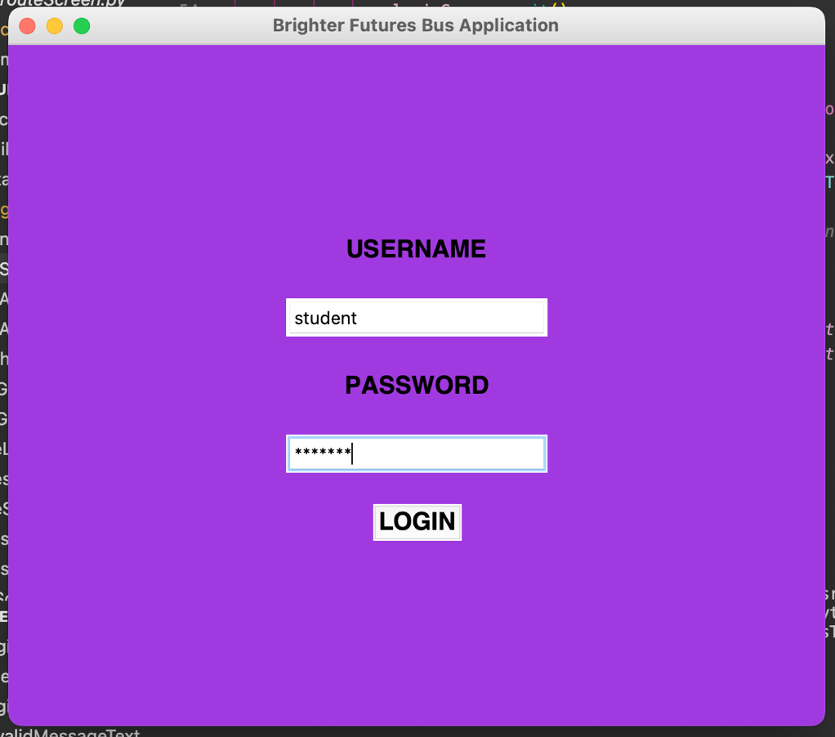

### Login using incorrect or no data

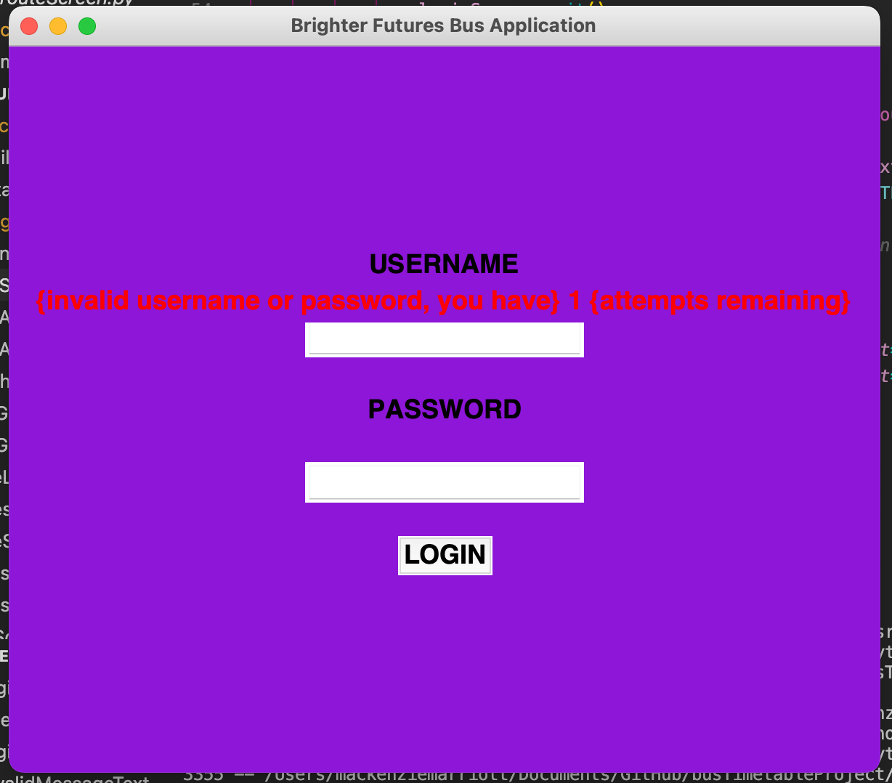

### Adding a route to the system

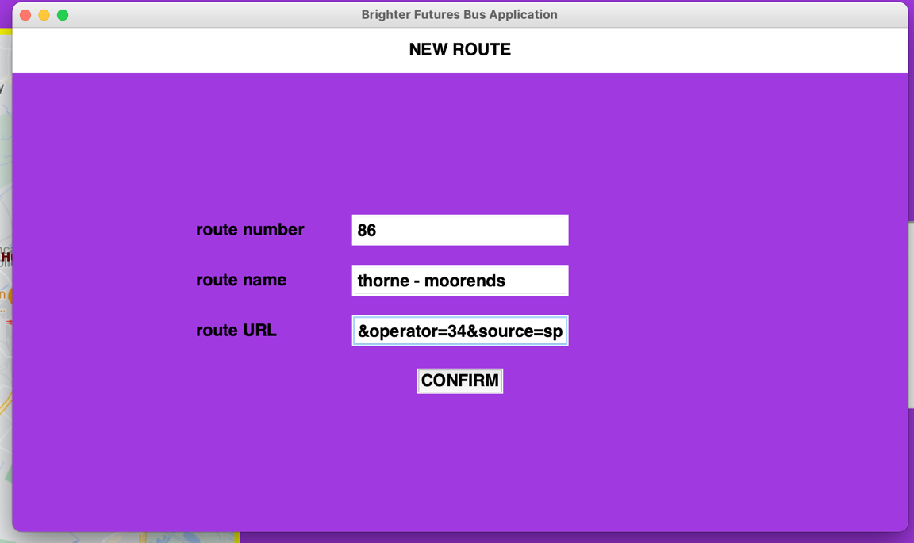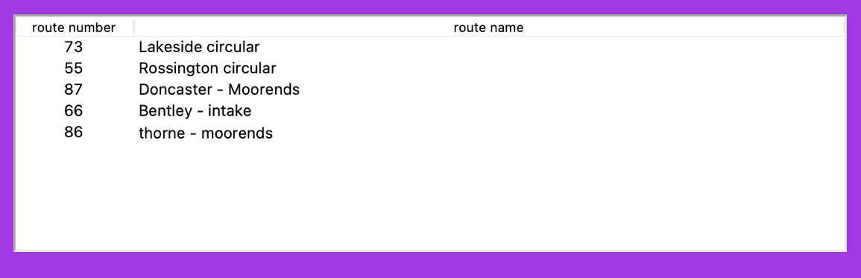

### Viewing a timetable

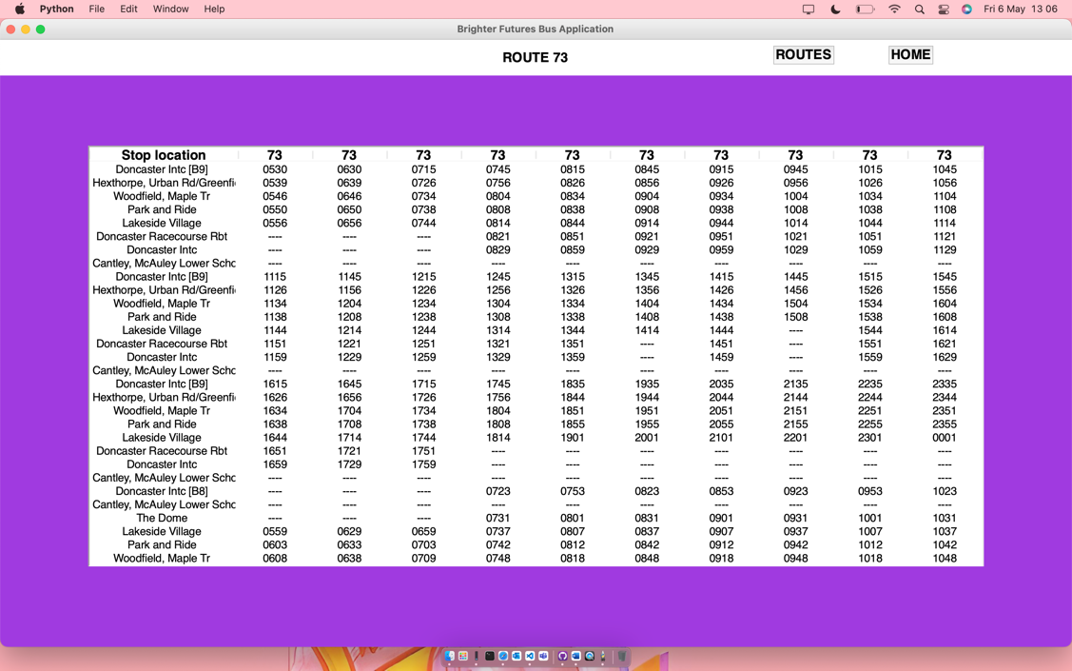

### Testing the web scraper using an incorrect link

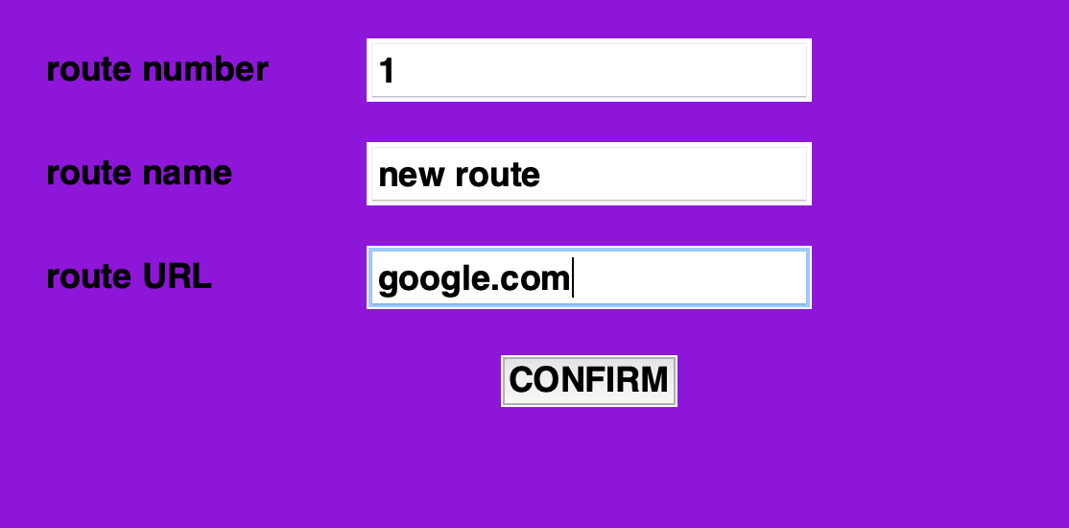

When confirmed, the above does nothing yet the new route is added to the list.

### Testing the geocoding

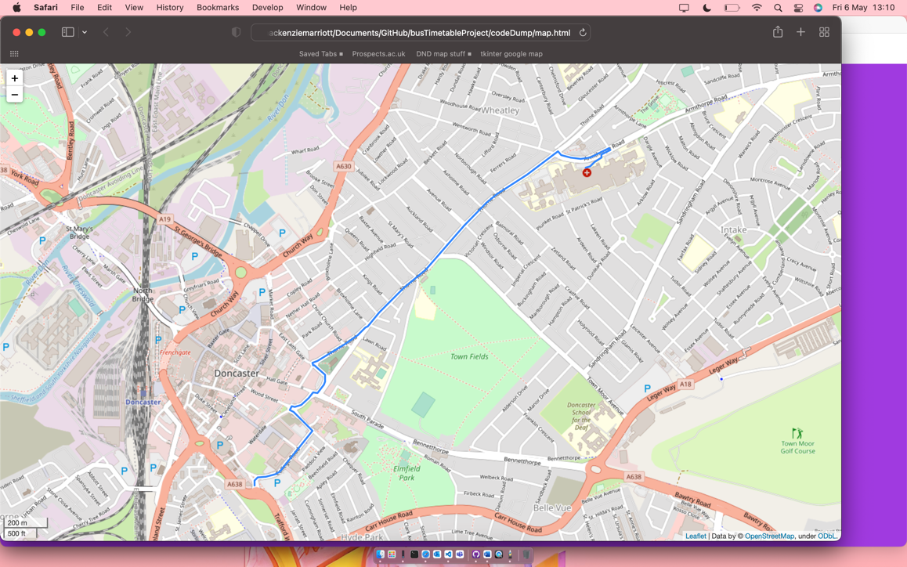

As shown above, the geocoding and route generation works correctly.

# E. Evaluation

### criteria met

|  |  |
| --- | --- |
| **Criteria** | **Met?** |
| Using a given data set – the app should be able to show the expected location of busses and whether or not they will arrive on time. | Yes – but not in the original planned way, now there is a list of cancellations and delays rather than having each bus be shown in real time. |
| Should be able to show who the driver of a bus is | No – I could not unfortunately get a hold of the correct API in order to see more in depth, specific information about a given bus. |
| Should be able to show when to leave to get to the bus on time | No – instead of this I have shown the user directly how to get from their location to the bus stop, rather than giving them a time estimate, as this was not feasible. |
| Should be able to update bus times if the timetable in the database changes | Yes – the timetables can be updated by the administrator, allowing for changes to be implemented if timetables change, whilst also saving WIFI bandwidth. |
| The app should be able to interact with a database in order to get reliable and relevant data. | Yes – the application interacts with files that store data which are scraped directly from the first bus website, meaning it is as relevant and accurate as feasibly possible. |
| The app needs to be able to scrape the required data in order to provide the most recent and most relevant information. | Yes – the app scrapes the web using a given URL when the timetables for a given bus route are added, meaning the data is up to date and accurate |

### Evidence

#### expected location of busses

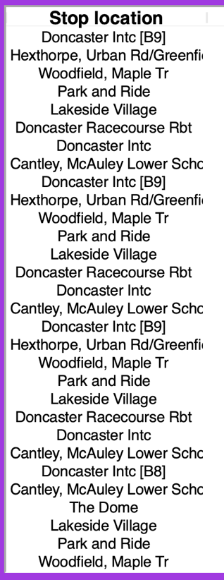

Above is the list of stops for a given bus route, this is where the busses are expected to be, you can click on a stop and get the exact location as shown below:

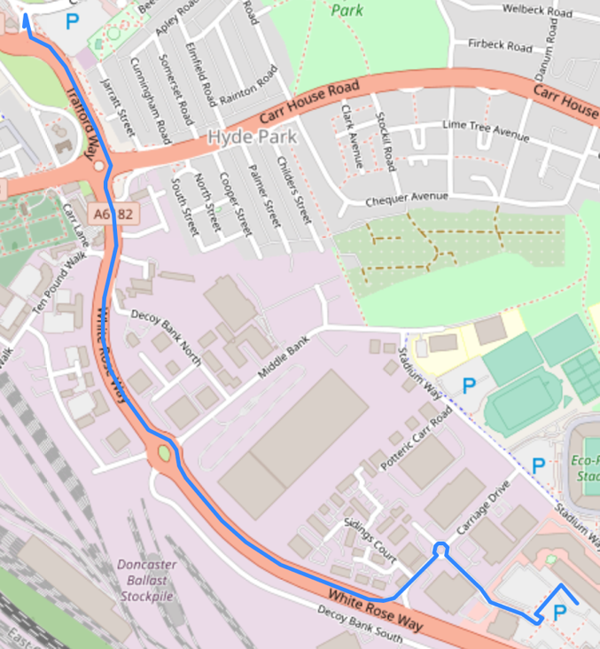

You can also click on a cancellations button, which takes you to a comprehensive list of all bus cancellations in the Doncaster area on first busses.

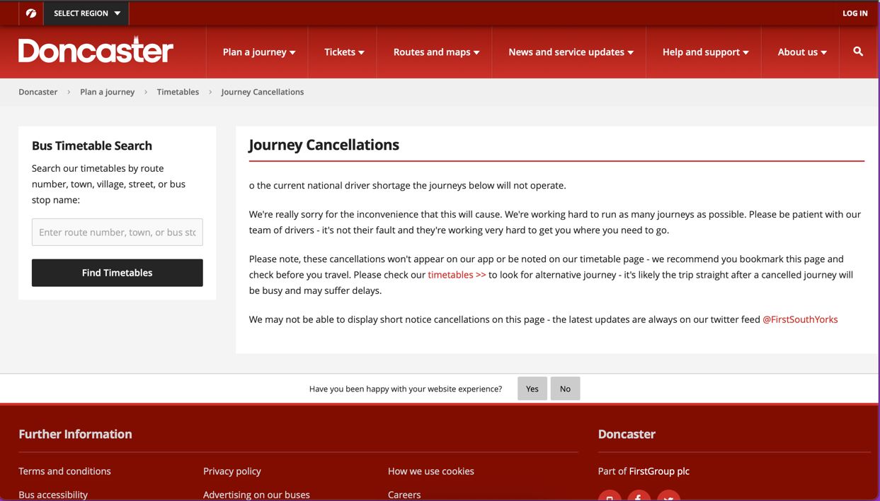

Usually, the user would be taken to the above webpage, which contains a list of all cancellations in the Doncaster area, however, as of writing this there are no cancellations, though during testing there were and this website reflected as such, providing a list of all of the relevant cancellations.

#### Expected walking time to a given stop

Though I did not complete this success criteria, I did come up with an alternative solution. Rather than doing the expected walking time to a given stop (which I could not access as a result of not being able to use google APIs). My solution was to show users exactly how to get from their current location to their desired stop, which looks as follows:



Although this was not my original plan, I believe that (circumstances permitting) it is a reasonable alternative solution as a whole.

#### updating the timetables

To update the timetables, the administrator effectively re-adds the bus route, meaning the web scraper will run again, picking up any changes to the bus timetable as a whole, so that when it is viewed it is as up to date as possible, provided that the administrator has recently updated the timetables.

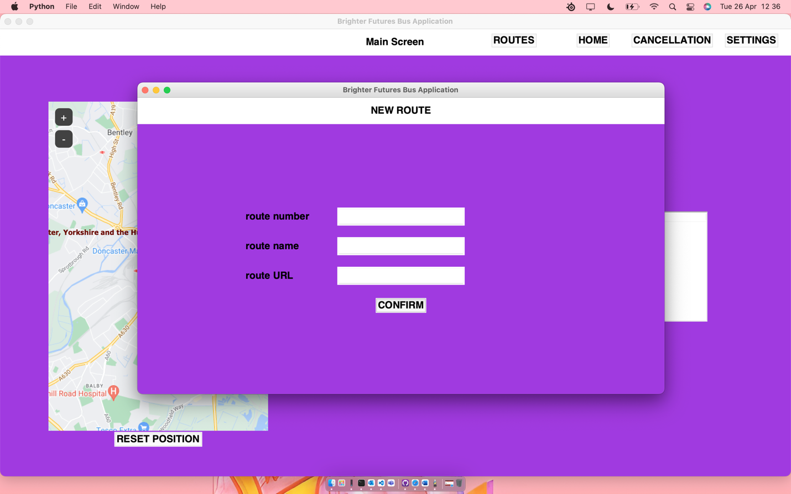

This is what the administrator sees when they are refreshing a route, it is the same page used to add a route, they are just re-inputting the same data again.

#### Interacting with a database to obtain data

My app does not use a traditional database, instead I have text files for each timetable, with each piece of data line by line, then a corresponding meta data file for things such as total number of lines and table width.

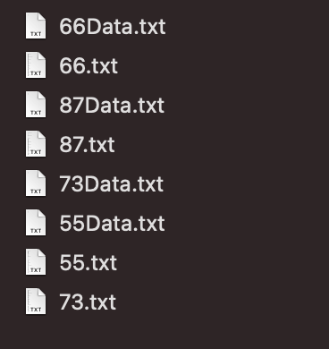

This is my database as of writing this, each bus route has its own text file, with a corresponding “Data” file with it.

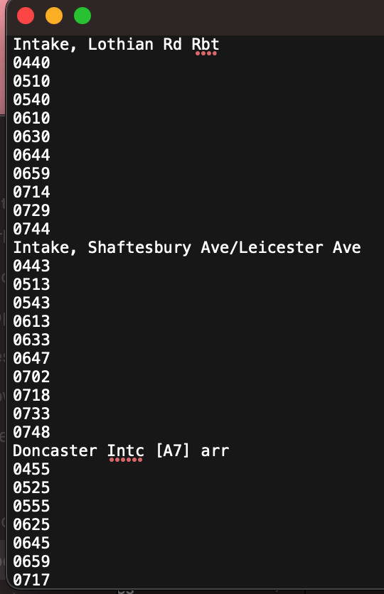

The text files look like this (using an excerpt from bus route 66 as an example) with the stop name, then each time a bus stops at that stop. The data files are much smaller than the timetable contents files and look as follows (once again using bus route 66 as an example):

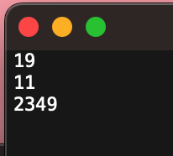

Though each data file has a line of irrelevant data, they also contain the total number of entries and the width of the table meaning the data file serves its intended purpose.

#### Scraping the required data

A large portion of my code is a web scraper, this web scraper goes through a given URL in order to obtain information with the ‘td’ tag, a tag which contains all of the relevant data I need for my project as all of the times and stop names are stored under this tag (though sometimes there is also redundant data).

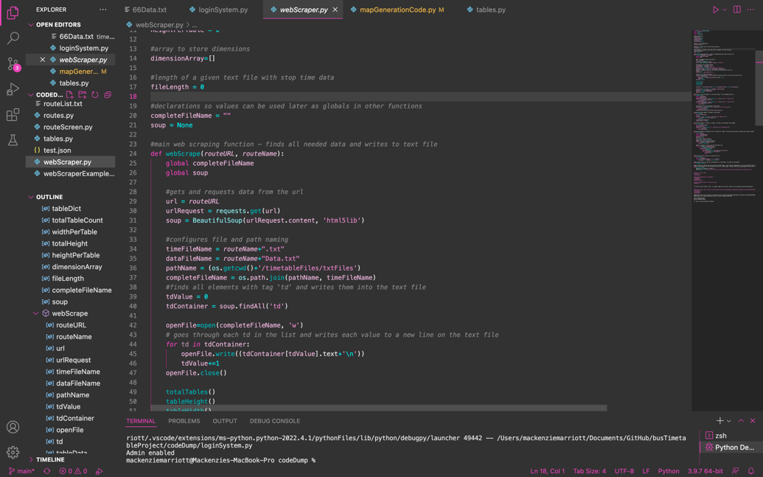

**The web scraper scrapes from here:**

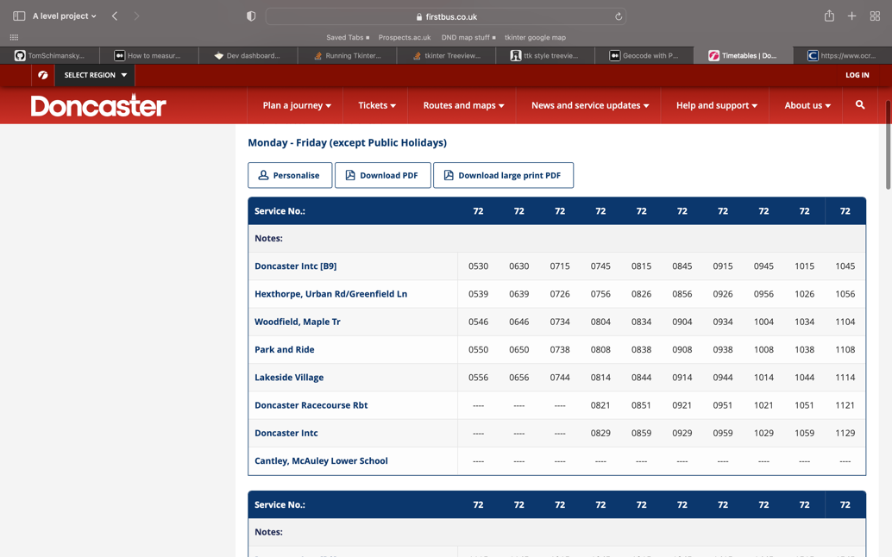

**The final timetable looks like this:**

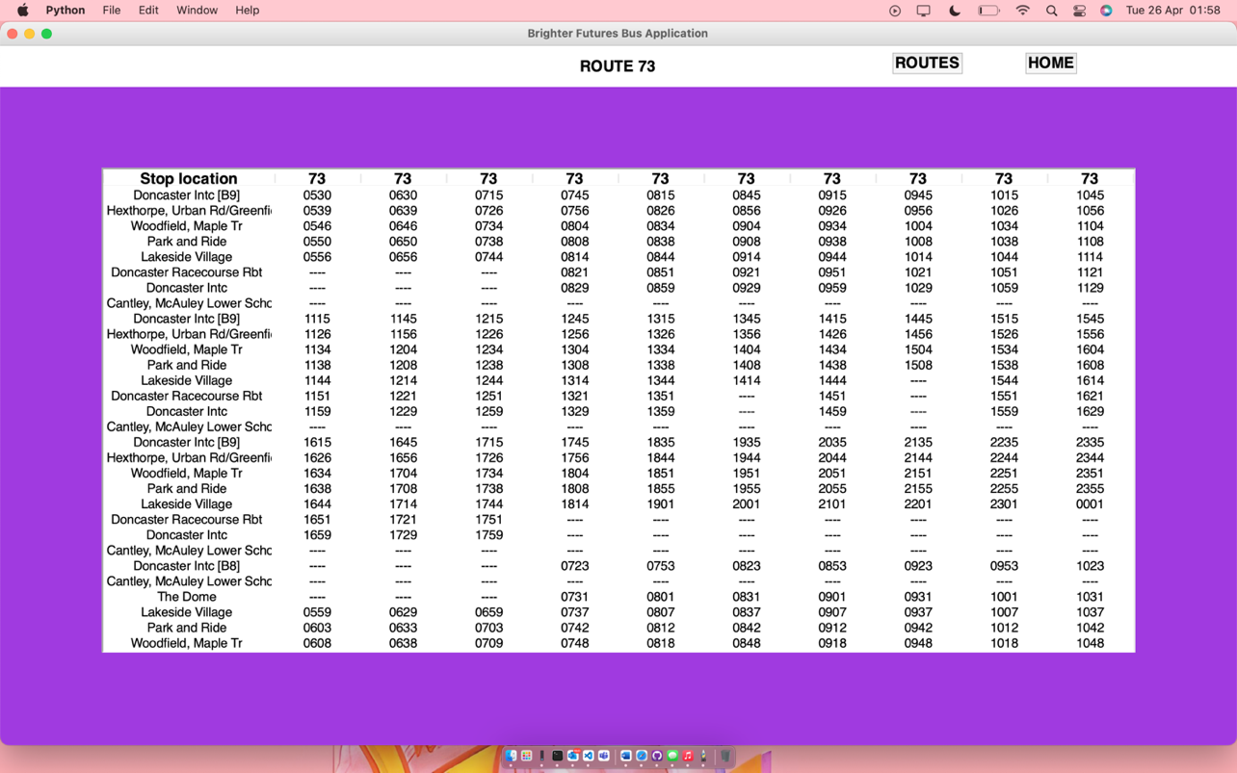

As shown above, the timetable is shown and formatted almost identically to the timetable above, yet in a more compact manner, meaning more information can be shown at the same time.

### Limitations of the project

#### limited sources

Due to the way a majority of timetable websites are made, there aren’t simple ways to be able to draw data from multiple different sites whilst also maintaining consistency in functionality and the visual aspects of the table. As a result, I decided to simply scrape from the most used public bus service in Doncaster, first busses. First have very well formatted timetables, regularly available information about cancellations, and well formatted stop information. When originally planning my project, I had anticipated being able to draw data from 2 websites – the first bus website, and bustimes.org which would have been able to allow me to cover all Doncaster busses, both stagecoach and first bus. However, the formatting on bustimes.org does not allow for me to properly draw my data up and the timetables end up without stop names at the front due to how the website is built and the HTML tags used.

If I had more time on my project, I could have created a new web scraper in addition to the one I currently have to use for an alternate source, which would allow me to gain more data from various bus companies, meaning that my application could have come closer to the original design and idea.

Similarly to this, if I had had more experience with the beautiful soup module and web scraping as a theory, then I likely would have been able to create the web scraper much quicker and more efficiently, allowing me to be able to create a web scraper which could scrape from multiple sources regardless.

#### Inconsistent pseudocode

Throughout development, I began to realise that the pseudocode that I had written in my design phase was not very detailed. The main reason for this is for some aspects of the code, I had never used some modules, meaning that I had no idea what to write or how to format my pseudocode logically. I also made multiple changes during development which meant that I had additional files or functions which I had not anticipated requiring when designing my coded solution.

#### Lack of API access

Through planning my project, I assumed I would have a number of APIs at my disposal, which would give me the ability to find out information such as the approximate number of people on a specific bus, as well as the driver of any given first bus in Doncaster. However, when it came to developing the product, most of these APIs were outdated and no longer used, with the few which were still running only being available to businesses and government. As a result of this, I had to turn to web scraping as the next viable option for data collection. Although I still managed to get the most important data (stop locations and times) I did not manage to collect more specific data such as a bus drivers name or a busses given location.

#### Lack of time developing other areas

A majority of my time coding was spent in 2 areas; the web scraping, and the generation of consistent timetables – the latter of which I only got working when data was formatted a specific way in the scraping stage. As a result of this, there were some features which I didn’t have time to develop which I would have liked. For example, I originally planned to have my app be able to alert users to when they should leave their house based on how far away they were from a given bus stop. The closest I managed to get to this feature within the deadline was showing them how to get from Doncaster UTC (where the terminal with the application would be) to a given stop.

### Overall evaluation

Although there are a number of holes in development and my solution is not as clean or efficient as I would have liked it, I am still happy with the outcome. This is as the base parts of my program, its core functionality, is as complete as I believe I would have ever been able to get it within my time and development constraints. I also have met most of my criteria from the analysis section of my documentation.

### Usability – sample user

I have used a sample user in order to test how usable my product is from a user point of view. This is as there is only so much that I can do during testing as I know how to use the program already, meaning that I am not really suitable for user level testing.

#### positive feedback

* The user liked how simple it was to navigate the menus, saying that everything felt natural to them and in the correct place.
* When given an admin account, the user was able to easily add and manage routes. They said that the system felt natural and was explained without outside sources.

#### negative feedback

* The user didn’t like the colour scheme, they said it felt ‘outdated’ and out of place, believing that a more modern colour scheme would better suit both the application as well as the target audience.
* They also believe that the user interface for viewing timetables, while effective and informative, is also very basic and feels cramped and almost overwhelming due to how dense the data is.

### Areas i succeeded on

* Fixing bugs quickly and decisively when they came up.
* Developing a coded solution which was as close to my specifications as possible.
* Maintaining close feedback with my client.

### Areas i could improve

* I could have looked more into the modules I was using in order to write better pseudocode.
* I could have checked which APIs I could actually use (which ones were up to date and accessible) before coming to rely on them
* I could have added more comments in my code to make it easier to read, as well as taking more screenshots of my code running and the various outcomes of tests.

# Project Appendixes

## Complete code listing

### MainApp.py

*import* tkinter

*from* tkinter *import* *

*import* tkinter.font *as* font

*import* webbrowser

*import* mapGenerationCode

*import* configurePage

*import* tables

*import* os

*import* distanceCalculator

*import* routeScreen

*import* time

myFont='Helvetica 18 bold'

admin = False

def __main__():

global admin

*#creates an empty deafault tkinter screen*

mainScreen = tkinter.Tk()

def configMap():

distanceCalculator.coordGet("Bawtry Road")

distanceCalculator.routing()

fileName = 'file:///'+os.getcwd()+'/'+'map.html'

webbrowser.open_new_tab(fileName)

*#calls functions to configure the main page layout*

configurePage.configure(mainScreen)

configurePage.configHeader(mainScreen, "Main Screen")

*#creates a border for the map*

borderLabel = tkinter.Label(mainScreen, *bg* = "yellow", *width*=45, *height*=40).place(*relx*=0.2, *rely*=0.55, *anchor*=CENTER)

*#calls both necessary functions to place the map onto the main screen*

mapGenerationCode.mapSettings(400, 600, "doncaster")

mapGenerationCode.generate(mainScreen)

*#code to refresh the map*

def resetMap():

*#calls both necessary functions to place the map onto the main screen*

mapGenerationCode.mapSettings(400, 600, "doncaster")

mapGenerationCode.generate(mainScreen)

mapButton = tkinter.Button(mainScreen, *font*=myFont, *text*="RESET POSITION", *command*=lambda:[resetMap()])

mapButton.place(*relx*=0.2, *rely*=0.9, *anchor*=N)

*#calls functions to generate the correct table*

tables.tableSettings(700, 750, 0.65, 0.53)

tables.generateTable(mainScreen)

'''

testButton = tkinter.Button(text="test", command=routeScreen.__main__).place(relx=0.5, rely=0.5)

^ test button to test connection to route screen, and changing of displayed information

'''

*if* admin == True:

configurePage.configSettingsButton(mainScreen)

'''

#test button

test = tkinter.Button(text="test", command=configMap)

test.place(relx=0.5, rely=0.05, anchor=CENTER)

'''

mainScreen.mainloop()

### Loginsystem.py

*import* tkinter

*from* tkinter *import* *

*import* tkinter.font

*import* hashlib

*import* mainApp

*import* configurePage

*import* tkmacosx

*#^^tkmacosx is unused - buttons do not work as expected*

loginScreen = Tk()

*#dictionary to store the hashed usernames and passwords*

userPassDict = {

"8c6976e5b5410415bde908bd4dee15dfb167a9c873fc4bb8a81f6f2ab448a918":"5994471abb01112afcc18159f6cc74b4f511b99806da59b3caf5a9c173cacfc5",

"264c8c381bf16c982a4e59b0dd4c6f7808c51a05f64c35db42cc78a2a72875bb":"264c8c381bf16c982a4e59b0dd4c6f7808c51a05f64c35db42cc78a2a72875bb"

}

*#variables for login validation*

loginTries = 3

invalidMessageText = ("invalid username or password, you have", loginTries, "attempts remaining")

invalidMessage = tkinter.Label(*text*=invalidMessageText, *bg*='#8D16D8', *font*='Helvetica 18 bold', *fg*="red")

*#all code to validate user input - including hashing values*

def inputVal():

*#imports necessary variables*

global userPassDict

global loginTries

global invalidMessageText

*#gets user input and stores as variables*

*#converts username input to hashed value*

username=hashlib.sha256((userBox.get()).encode()).hexdigest()

*#converts password input to hashed value*

password=hashlib.sha256((passBox.get()).encode()).hexdigest()

*#checks for the username in the dictionary*

*if* username in userPassDict:

*if* userPassDict[username] == password:

*if* username=="8c6976e5b5410415bde908bd4dee15dfb167a9c873fc4bb8a81f6f2ab448a918":

mainApp.admin=True

print("Admin enabled")

loginScreen.destroy()

mainApp.__main__()

*else*:

*#removes 1 try, displays appropriate message*

loginTries-=1

invalidMessageText=("invalid username or password, you have", loginTries, "attempts remaining")

invalidMessage = tkinter.Label(*text*=invalidMessageText, *bg*='#8D16D8', *font*='Helvetica 18 bold', *fg*="red")

invalidMessage.place(*relx*=0.5, *rely*=0.35, *anchor*=CENTER)

*#if there are no tries remaining, the application closes*

*if* loginTries <=0:

loginScreen.quit()

*else*:

*#removes 1 try, displays appropriate message*

loginTries-=1

invalidMessageText=("invalid username or password, you have", str(loginTries), "attempts remaining")

*#refreshes and replaces invalid message*

invalidMessage = tkinter.Label(*text*=invalidMessageText, *bg*='#8D16D8', *font*='Helvetica 18 bold', *fg*="red")

invalidMessage.place(*relx*=0.5, *rely*=0.35, *anchor*=CENTER)

*if* loginTries <=0:

*#if there are no tries remaining, the application closes*

loginScreen.quit()

*#configures text boxes and their headings*

userLabel = tkinter.Label(*text*="USERNAME", *bg*="#8D16D8", *font*='Helvetica 18 bold')

passLabel = tkinter.Label(*text*="PASSWORD", *bg*="#8D16D8", *font*='Helvetica 18 bold')

userBox = tkinter.Entry()

passBox = tkinter.Entry(*show*="*")

*#places text boxes and their headings*

userLabel.place(*relx*=0.5, *rely*=0.3, *anchor*=CENTER)

userBox.place(*relx*=0.5, *rely*=0.4, *anchor*=CENTER)

passLabel.place(*relx*=0.5, *rely*=0.5, *anchor*=CENTER)

passBox.place(*relx*=0.5, *rely*=0.6, *anchor*=CENTER)

*#LOGIN button*

loginButton = tkinter.Button(*text*="LOGIN", *background*="yellow", *activebackground*="#9b870c", *font*='Helvetica 18 bold', *command*=inputVal)

loginButton.place(*relx*=0.5, *rely*=0.7, *anchor*=CENTER)

'''

loginButton = Button(text="LOGIN", background="yellow", activebackground="#9b870c", font='Helvetica 18 bold', command=inputVal)

loginButton.place(relx=0.5, rely=0.7, anchor=CENTER)

'''

configurePage.configure(loginScreen)

loginScreen.geometry("600x500+450+170")

*#^^places in centre of*

'''

loginScreen.geometry("250x400")

^^ places in top left, not centre

'''

loginScreen.mainloop()

### distanceCalculator.py

*#routing modules*

*import* openrouteservice

*from* openrouteservice *import* convert

*import* json

*import* folium

*#geocode modules*

*from* geopy.geocoders *import* Nominatim

*#variables to store locational data*

*#starting long/lat*

coordLong = ""

coordLat = ""

*#ending long/lat*

endCoordLong = ""

endCoordLat = ""

*#takes address and converts to latitude and longitude to use in distance calculation*

def coordGet(*endLocation*):

*#starting coord lat/long*

global coordLat

global coordLong

*#ending coord lat/long*

global endCoordLat

global endCoordLong

*#specifies which geolocation service to use (nominatim)*

geolocator = Nominatim(*user_agent*="alevel-application")

*#configures starting coordinates*

coords = geolocator.geocode("College Road Doncaster")

coordLat = coords.latitude

coordLong = coords.longitude

*#configures ending coordinates*

endCoords = geolocator.geocode(*endLocation*)

endCoordLat = endCoords.latitude

endCoordLong = endCoords.longitude

*#configures routing so that distance/time data can be taken*

def routing():

*#starting point coords*

global coordLong

global coordLat

*#end point coords*

global endCoordLat

global endCoordLong

*#sets a list to the corresponding values for coordinates*

coords = ((coordLong, coordLat), (endCoordLong,endCoordLat))

client = openrouteservice.Client(*key*='5b3ce3597851110001cf62488cb4c056c9294a4ba1a5a37393b69413')

*#calls from the API*

res = client.directions(coords)

*#tested json response*

*with*(open('test.json','+w')) *as* f:

f.write(json.dumps(res,*indent*=4, *sort_keys*=True))

*#takes geometry from json, decodes it for use in map*

geometry = client.directions(coords)['routes'][0]['geometry']

decoded = convert.decode_polyline(geometry)

*#configures map settings*

m = folium.Map(*location*=[coordLat, coordLong],*zoom_start*=15, *control_scale*=True,*tiles*="openstreetmap")

*#creates and saves map*

folium.GeoJson(decoded).add_to(m)

m.save('map.html')

'''

coordGet("Thorne Road Doncaster")

routing()

^^order and example of how to run functions

'''

### configurepage.py

*import* tkinter

*from* tkinter *import* *

*from* tkinter *import* font

*import* routes

*import* mainApp

*import* webScraper

myFont = "Helvetica 18 bold"

*#configures the base settings for every page on the app*

def configure(*pageName*):

*pageName*.config(*bg*='#8D16D8')

*pageName*.title("Brighter Futures Bus Application")

*pageName*.geometry("1920x1080")

*#configuers the screens header and places it*

def configHeader(*pageName*, *pageTitle*):

global myFont

*#configures the size and shape of the header, customisable for any page*

headerLabel = tkinter.Label(*pageName*, *text*=*pageTitle*)

headerLabel.config(*font*=myFont,*width*=150, *height*=2)

headerLabel.place(*relx*=0.5, *rely*=0, *anchor*=N)

*#configures a button to take the user back to the home screen*

homeButton=tkinter.Button(*pageName*, *text*="HOME", *background*="yellow", *activebackground*="#9b870c", *font*=myFont, *command*=lambda:[*pageName*.destroy(), mainApp.__main__()])

homeButton.place(*relx*=0.75, *rely*=0.025, *anchor*=CENTER)

*#configuration of the routes button - a button that takes the user to a list of all routes*

routesButton=tkinter.Button(*pageName*, *text*="ROUTES", *background*="yellow", *activebackground*="#9b870c", *font*=myFont, *command*=lambda:[*pageName*.destroy(), routes.routesPage()])

routesButton.place(*relx*=0.65, *rely*=0.025, *anchor*=CENTER)

*#configuration of the cancellations button - does not unclude .destroy as it opens in the browser, not tkinter*

cancellationsButton = tkinter.Button(*pageName*, *text*="CANCELLATION", *background*="yellow", *activebackground*="#9b870c", *font*=myFont, *command*=lambda:[webScraper.cancellations()])

cancellationsButton.place(*relx*=0.85, *rely*=0.025, *anchor*=CENTER)

def configSettingsButton(*pageName*):

settingsButton = tkinter.Button(*pageName*, *text*="SETTINGS", *background*="yellow", *activebackground*="#9b870c", *font*=myFont, *command*=lambda:[settingsTopLevel()])

settingsButton.place(*relx*=0.95, *rely*=0.025, *anchor*=CENTER)

def settingsTopLevel():

settingsPage = tkinter.Toplevel()

settingsPage.title("Brighter Futures Bus Application")

settingsPage.config(*bg*='#8D16D8')

settingsPage.geometry("960x540+250+150")

headerLabel = tkinter.Label(settingsPage, *text*="SETTINGS")

headerLabel.config(*font*=myFont,*width*=150, *height*=2)

headerLabel.place(*relx*=0.5, *rely*=0, *anchor*=N)

settings(settingsPage)

def settings(*pageName*):

logoutButton = tkinter.Button(*pageName*, *font*=myFont, *text*="LOGOUT", *command*=lambda:[logout(*pageName*)])

logoutButton.place(*relx*=0.5, *rely*=0.5, *anchor*=CENTER)

newRouteButton = tkinter.Button(*pageName*, *font*=myFont, *text*="NEW ROUTE", *command*=lambda:[newRoute()])

newRouteButton.place(*relx*=0.5, *rely*=0.6, *anchor*=CENTER)

def logout(*pageName*):

*pageName*.quit()

def newRoute():

routeList = open("routeList.txt", "a")

newRouteInfo = {

"Number":"",

"Name":"",

"URL":""

}

*#config page*

newRoutePage = tkinter.Toplevel()

newRoutePage.title("Brighter Futures Bus Application")

newRoutePage.config(*bg*='#8D16D8')

newRoutePage.geometry("960x540+250+150")

*#^^ places in direct center of page*

*#config header*

headerLabel = tkinter.Label(newRoutePage, *text*="NEW ROUTE")

headerLabel.config(*font*=myFont,*width*=150, *height*=2)

headerLabel.place(*relx*=0.5, *rely*=0, *anchor*=N)

*#config entry fields*

routeNumber = tkinter.Entry(newRoutePage, *font*=myFont)

routeName = tkinter.Entry(newRoutePage, *font*=myFont)

routeURL = tkinter.Entry(newRoutePage, *font*=myFont)

*#place entry fields*

routeNumber.place(*relx*=0.5, *rely*=0.4, *anchor*=CENTER)

routeName.place(*relx*=0.5, *rely*=0.5, *anchor*=CENTER)

routeURL.place(*relx*=0.5, *rely*=0.6, *anchor*=CENTER)

*#config entry labels*

tkinter.Label(newRoutePage, *font*=myFont, *text*="route number", *bg*='#8D16D8').place(*relx*=0.2, *rely*=0.4, *anchor*=W)

tkinter.Label(newRoutePage, *font*=myFont, *text*="route name", *bg*='#8D16D8').place(*relx*=0.2, *rely*=0.5, *anchor*=W)

tkinter.Label(newRoutePage, *font*=myFont, *text*="route URL", *bg*='#8D16D8').place(*relx*=0.2, *rely*=0.6, *anchor*=W)

def scrape():

*#scrapes web using given url and saves in new file with corresponding route number as file title*

webScraper.webScrape(newRouteInfo["URL"], newRouteInfo["Number"])

def setInformation():

*#validity check*

*if* routeName.get()!="" and routeNumber.get()!="" and routeURL.get()!="":

*#set dictionary values*

newRouteInfo["Name"]=routeName.get()

newRouteInfo["Number"]=routeNumber.get()

newRouteInfo["URL"]=routeURL.get()

routeList.write('\n')

routeList.write(newRouteInfo["Number"])

routeList.write('\n')

routeList.write(newRouteInfo["Name"])

print(newRouteInfo["Name"])

routeList.close()

scrape()

newRoutePage.destroy()

*else*:

displayError(newRoutePage, 0.5, 0.3, "1 or more text field(s) are empty, please correct and try again")

def displayError(*pageName*, *posX*, *posY*, *errorMessage*):

errorLabel = tkinter.Label(*pageName*, *bg*="#8D16D8", *fg*="red", *font*=myFont, *text*=*errorMessage*).place(*relx*=*posX*, *rely*=*posY*, *anchor*=CENTER)

*#confirmation button*

confirmButton = tkinter.Button(newRoutePage, *font*=myFont, *text*="CONFIRM", *command* = lambda:[setInformation()]).place(*relx*=0.5, *rely*=0.7, *anchor*=CENTER)

### routes.py

*import* tkinter

*from* tkinter *import* *

*from* tkinter *import* font

*import* configurePage

*import* tables

myFont = "'Helvetica 18 bold'"

def routesPage():

routePage = tkinter.Tk()

global myFont

*#calls page configuration functions*

configurePage.configure(routePage)

configurePage.configHeader(routePage, "Routes")

'''

#tests label placement

testLabel = tkinter.Label(routePage, text="test")

testLabel.place(relx=0.5, rely=0.5, anchor=CENTER)

'''

*#generates sample table*

tables.tableSettings(700, 750, 0.5, 0.53)

tables.generateTable(routePage)

### routeScreen.py

*import* tkinter

*from* tkinter *import* *

*from* tkinter *import* ttk

*import* mainApp

*import* routes

*import* os

*import* distanceCalculator

*import* re

*import* webbrowser

myFont = 'Helvetica 18 bold'

routeNumber = "73"

def __main__():

*#timetable config info*

tableHeight = 400

tableWidth = 300

tableX = 0.5

tableY = 0.52

*#0.52 to account for the headingof width 2, anchor N (means it takes rel 0.02 off the top)*

*#cannot use below functions from configurePage.py - causes circular input*

def configHeader(*pageName*, *headerText*):

headerLabel = tkinter.Label(*pageName*, *text*=*headerText*, *font*=myFont, *width*=150, *height*=2).place(*relx*=0.5, *rely*=0, *anchor*=N)

homeButton=tkinter.Button(*pageName*, *text*="HOME", *background*="yellow", *activebackground*="#9b870c", *font*=myFont, *command*=lambda:[*pageName*.destroy(), mainApp.__main__()]).place(*relx*=0.85, *rely*=0.025, *anchor*=CENTER)

routesButton=tkinter.Button(*pageName*, *text*="ROUTES", *background*="yellow", *activebackground*="#9b870c", *font*=myFont, *command*=lambda:[*pageName*.destroy(), routes.routesPage()]).place(*relx*=0.75, *rely*=0.025, *anchor*=CENTER)

def configurePage(*pageName*):

*pageName*.title("Brighter Futures Bus Application")

*pageName*.config(*bg*="#8D16D8")

*pageName*.geometry("1920x1080")

*#importing tables.py would cause circular import - added modified function here instead*

def generateTimetable(*pageName*, *tableX*, *tableY*, *tableHeight*, *tableWidth*):

*#configuring style for table contents*

tableContentsStyle = ttk.Style()

tableContentsStyle.configure("myStyle.Treeview", *font*='Helvetica 15')

*#configuring style for headings on tables*

tableStyle = ttk.Style()

tableStyle.configure("Treeview.Heading", *font*='Helvetica 18 bold')

tableContentsFileName = routeNumber

tableDataFileName = routeNumber

tableContentsFileName = re.findall(r'\d+', tableContentsFileName)

tableContentsFileName = (tableContentsFileName[0]+'.txt')

pathName = (os.getcwd()+'/timetableFiles/txtFiles')

completeFileName = os.path.join(pathName, tableContentsFileName)

tableFile = open(completeFileName, 'r')

tableInput = tableFile.readlines()

tableDataFileName = re.findall(r'\d+', tableDataFileName)

tableDataFileName = tableDataFileName[0]+'Data.txt'

tableDataFile=(os.path.join(pathName, tableDataFileName))

tableData = open(tableDataFile, 'r')

tableDataContents = tableData.readlines()

'''

print(tableData.readlines())

^^testing file output

'''

tableFrame = Frame(*pageName*)

tableFrame.config(*height*=*tableHeight*, *width*=*tableWidth*)

tableFrame.place(*relx*=*tableX*, *rely*=*tableY*, *anchor*=CENTER)

columns = []

*for* i *in* range (1, int(tableDataContents[1])+1):

columns.append(str(i))

timetable = ttk.Treeview(tableFrame, *style*="myStyle.Treeview", *height*=30)

timetable['columns']=columns

timetable.column("#0", *width*=0, *stretch*=NO)

timetable.column("1", *width*=200, *anchor*=CENTER)

*for* i *in* range (2, int(tableDataContents[1])+1):

timetable.column(str(i), *width* = 100, *anchor*=CENTER)

timetable.heading("#0", *text*="")

timetable.heading("#1", *text*="Stop location")

*for* i *in* range (2, int(tableDataContents[1])+1):

timetable.heading("#"+str(i), *text*=routeNumber)

i=0

c=0

fileLength = tableDataContents

*#while loop in that inputs timetable data to the table*

*while* i < int(re.findall(r'\d+', fileLength[2])[0]):

b=0

tableDataList = []

'''

#prints the first row - 0 issues

if i == 0:

for b in range(i, int(re.findall(r'\d+', tableDataContents[1])[0])+i):

if b < int(re.findall(r'\d+', fileLength[2])[0]):

tableDataList.append(tableInput[b])

print(tableDataList)

# prints the second row (some issues so far)

else:

for b in range(i, int(re.findall(r'\d+', tableDataContents[1])[0])+i):

if b < int(re.findall(r'\d+', fileLength[2])[0]):

c+=1

for d in range (0, int(re.findall(r'\d+', tableDataContents[1])[0])):

tableDataList.append(tableInput[d+c])

print(tableDataList)

# code that didnt really work - just kept repeating the same line again and again

'''

*while* b < int(re.findall(r'\d+', tableDataContents[1])[0]):

*if* i==0:

tableDataList.append(tableInput[b+i])

*elif* b+i+int(re.findall(r'\d+', tableDataContents[1])[0]) <int(re.findall(r'\d+', tableDataContents[2])[0]):

tableDataList.append(tableInput[c+int(re.findall(r'\d+', tableDataContents[1])[0])])

c+=1

print(tableDataList)

b+=1

*#writes data to the file*

timetable.insert(*parent*='', *index*='end', *iid*=i, *text*="", *values*=tableDataList)

print(i)

print(re.findall(r'\d+', tableDataContents[1]))

i = i+int(re.findall(r'\d+', tableDataContents[1])[0])+1

'''

timetable.insert(parent='', index='end', iid=0, text="", values=("Doncaster Interchange", "1000"))

timetable.insert(parent='', index='end', iid=1, text="", values=("Lakeside Village", "1000"))

'''

def OnDoubleClick(*self*):

global routeNumber

selectedItem = timetable.focus()

selectedStop = timetable.item(selectedItem, "values")[0]

distanceCalculator.coordGet(selectedStop+" Doncaster")

distanceCalculator.routing()

fileName = 'file:///'+os.getcwd()+'/'+'map.html'

webbrowser.open_new_tab(fileName)

timetable.bind("<Double-1>", OnDoubleClick)

tableData.close()

tableFile.close()

timetable.pack()

routePage = tkinter.Tk()

*##\n needed as route data brings text files new line declaration, meaning text will be uncentered*

configHeader(routePage,'\n'+ "ROUTE "+str(routeNumber))

configurePage(routePage)

generateTimetable(routePage, tableX, tableY, tableWidth, tableHeight)

routePage.mainloop()

### tables.py

*from* tkinter *import* *

*from* tkinter *import* ttk

*import* distanceCalculator

*import* os

*import* webbrowser

*import* routeScreen

tableHeight = 0

tableWidth = 0

tableX = 0

tableY = 0

selectedRoute = ""

def tableSettings(*height*, *width*, *x*, *y*):

global tableHeight

global tableWidth

global tableX

global tableY

tableHeight=*height*

tableWidth=*width*

tableX=*x*

tableY=*y*

def generateTable(*pageName*):

routeList = open('routeList.txt', 'r')

content=routeList.readlines()

tableFrame = Frame(*pageName*)

tableFrame.config(*height*=tableHeight, *width*=tableWidth)

tableFrame.place(*relx*=tableX, *rely*=tableY, *anchor*=CENTER)

timetable = ttk.Treeview(tableFrame)

timetable['columns']= ('1', '2')

timetable.column("#0", *width*=0, *stretch*=NO)

timetable.column("1", *width*=100, *anchor*=CENTER)

timetable.column("2", *width*=600, *anchor*=W)

timetable.heading("#0", *text*="")

timetable.heading("#1", *text*="route number")

timetable.heading("#2", *text*="route name")

def OnDoubleClick(*self*):

global selectedRoute

distanceCalculator.coordGet("Bawtry Road")

distanceCalculator.routing()

selectedItem = timetable.focus()

selectedRoute = timetable.item(selectedItem, "values")[0]

routeScreen.routeNumber=selectedRoute

*pageName*.destroy()

routeScreen.__main__()

timetable.bind("<Double-1>", OnDoubleClick)

i=0

*while* i<(len(content)-1) and i<20:

timetable.insert(*parent*='', *index*='end', *iid*=i+1, *text*="", *values*=(content[i], content[i+1]))

i+=2

timetable.pack()

'''

for i in range(0, len(content)):

timetable.insert(parent='', index='end', iid=i+1, text="", values=(content[i], content[i+1]))

'''

### webscraper.py

*from* tkinter *import* *

*from* tkinter *import* ttk

*import* distanceCalculator

*import* os

*import* webbrowser

*import* routeScreen

tableHeight = 0

tableWidth = 0

tableX = 0

tableY = 0

selectedRoute = ""

def tableSettings(*height*, *width*, *x*, *y*):

global tableHeight

global tableWidth

global tableX

global tableY

tableHeight=*height*

tableWidth=*width*

tableX=*x*

tableY=*y*

def generateTable(*pageName*):

routeList = open('routeList.txt', 'r')

content=routeList.readlines()

tableFrame = Frame(*pageName*)

tableFrame.config(*height*=tableHeight, *width*=tableWidth)

tableFrame.place(*relx*=tableX, *rely*=tableY, *anchor*=CENTER)

timetable = ttk.Treeview(tableFrame)

timetable['columns']= ('1', '2')

timetable.column("#0", *width*=0, *stretch*=NO)

timetable.column("1", *width*=100, *anchor*=CENTER)

timetable.column("2", *width*=600, *anchor*=W)

timetable.heading("#0", *text*="")

timetable.heading("#1", *text*="route number")

timetable.heading("#2", *text*="route name")

def OnDoubleClick(*self*):

global selectedRoute

distanceCalculator.coordGet("Bawtry Road")

distanceCalculator.routing()

selectedItem = timetable.focus()

selectedRoute = timetable.item(selectedItem, "values")[0]

routeScreen.routeNumber=selectedRoute

*pageName*.destroy()

routeScreen.__main__()

timetable.bind("<Double-1>", OnDoubleClick)

i=0

*while* i<(len(content)-1) and i<20:

timetable.insert(*parent*='', *index*='end', *iid*=i+1, *text*="", *values*=(content[i], content[i+1]))

i+=2

timetable.pack()

'''

for i in range(0, len(content)):

timetable.insert(parent='', index='end', iid=i+1, text="", values=(content[i], content[i+1]))

'''

## Running instructions

Assuming all of the necessary modules are present, the program should be run starting with the loginSystem.py file. From here there are 2 options:

1. The first option is that you can login as an admin (username – “admin” password – “12345”) this will give you access to all of the applications features plus the settings menu.
2. The second option is to login as a student, this removes access to the settings menu as students should not be able to add new bus routes as they could break the system or add the same route repeatedly, creating redundant data. (username and password – “student”)

The entire program should be accessible from here on out.